The team “INIT GCT” from Government College of Technology won the AICTE-ECI-ISTE Chhatra Viswhakarma Awards - 2018 for the project titled “SMART IRRIGATION SYSTEM”. The team scored 3rd position by presenting an innovative solution / prototype under the theme “Empowerment of Villages Through Technologies”

Team Members: Dr.A.Meena Kowshalya (Mentor),
Hari Prasath S (IV year CSE),
Sathya Priyan K (III year CSE),
Indresh P (III year CSE),
Ashish Sasidharan (III year ECE).
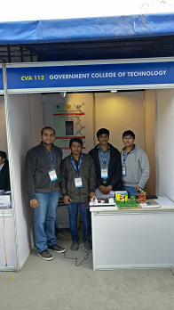

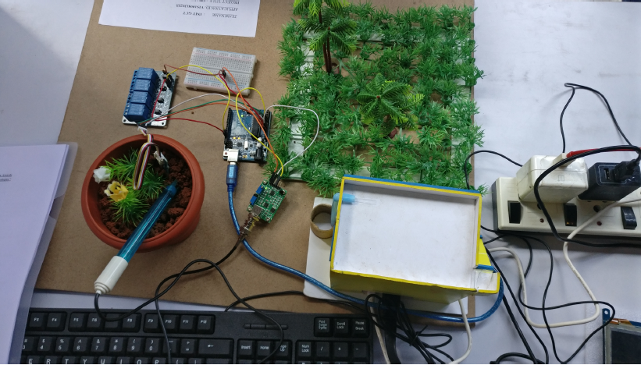

WINNER OF NATIONAL CONVENTION OF 2ND AICTE-ECI-ISTE VISWHAKARMA AWARDS 2018 FOR THE PROJECT TILTED “SMART IRRIGATION SYSTEM”

The farm fields of farmers are situated miles away from their home. Sometimes they need to go to their fields for several times in a day to start and stop the irrigation water pumps. Power is yet a limited resource in many of the parts of the villages around India. Farmers cannot come to the field often and they find difficult to protect the crops from the unconditional rain. No one stop solution exists for power, unconditional natural calamities and water problems. Also, pests in paddy crops are nightmares for farmers stealing their sleeps. Through this project “Smart Irrigation System” develop a device that can monitor the moisture content of the soil and turn on the water pump automatically whenever the moisture drops below a threshold value. The pests around the paddy crops are monitored through motion sensors and reverted to the farmers to necessary action. The setup is selected for its real-time, user-friendliness, flexibility and availability at low cost. The technology allows users to use smart mobile (via app) to control farm field activities through Internet/Wireless Network. The main aim of this project is to demonstrate the economic feasibility of advanced computerized production technologies. Failure loop handle back is designed to rectify the failures. Currently, we are exploring mini drones to monitor and control pests. Also, the external power supply is to be replaced by solar power.
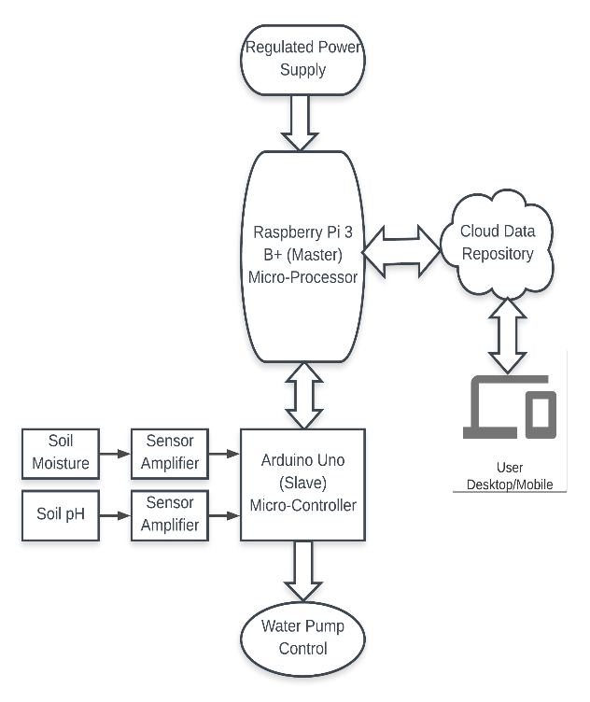

Team Members: Dr.A.Meena Kowshalya (Mentor),Hari Prasath S (IV CSE), Sathya Priyan K (III CSE), Indresh P (III CSE), Ashish Sasidharan (III ECE)

