Concrete Scanner with Corrosion Analyser
Scope of the Equipment:
- The all-in-one solution for rebar assessment and corrosion analysis.

About the Equipment:
- Profometer touch screen with illustrative display and assisted workflow
- Profometer Corrosion interface box Ready to connect half cell electrodes to Profometer unit
- Advanced cover meters and rebar locators based on the eddy current pulse induction principle
- Assisted scan of any surface regardless of its size and geometry
- Single line scan, multi-line scan, area scan and cross scan facilities.
- Universal probe and detachable ruggedized cart with wireless path measuring system
- Most versatile half-cell potential solution
- Unique wheel electrodes allow the fastest and most efficient on site testing
- Complies with international standards
Applications of the Equipment:
- Used for Non Destructive Testing of concrete.
- Analyse corrosion problems in RCC related works.
- Detect the soundness/quality of RCC
- Carryout the stability assessment of structures
- Predict the rebar location, quality and rate of corrosion in the structures

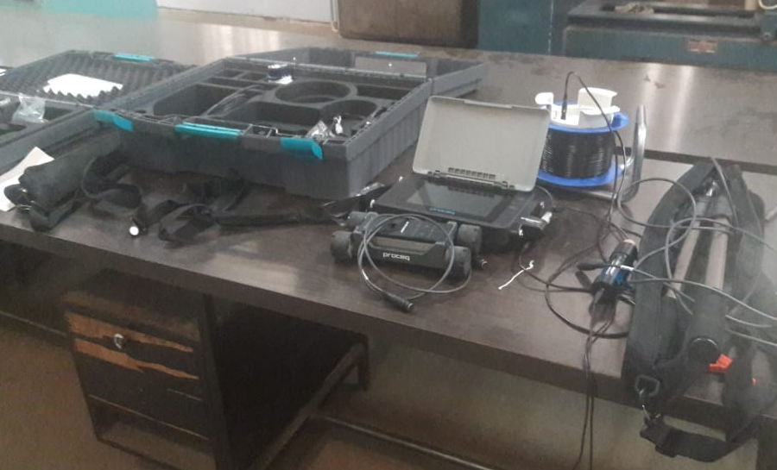

Silver Schmidt Digital Rebound Hammer

Scope of the Equipment:
- NDT measuring instrument for a rapid assessment of the condition of a concrete structure

About the Equipment:
- The forward and the rebound velocity of the hammer mass are both measured in close proximity to the point of impact. The rebound value requires no angular correction.
- The new measurement principle and the design of the mechanics enable the Proceq Hammer to outperform its predecessors.
- A larger number of measurement points can be easily collected by the instrument and automatically evaluated according to statistical criteria.
Applications of the Equipment:
- Concrete uniformity testing
- Concrete compressive strength estimation
- Concrete screening test to identify core locations

Rebar Locator

Scope of the Equipment:
- To find the position of steel reinforcement bars in concrete structures and to measure their concrete cover.

About the Equipment:
- The eddy current pulse induction principle is the only imaging technology not influenced by concrete composition and humidity, which leads to a high cover accuracy under every scenario
- The fully integrated Profoscope for quick and easy rebar detection.
- It is the easiest and fastest ways for detecting reinforcing bar in concrete. It is widely used before coring or drilling holes to find “safe spots”.
Applications of the Equipment:
- Used to indicate rebar direction and location when drilling and cutting concrete core for most other non-destructive investigations.
- Give an indication of the depth of concrete cover.

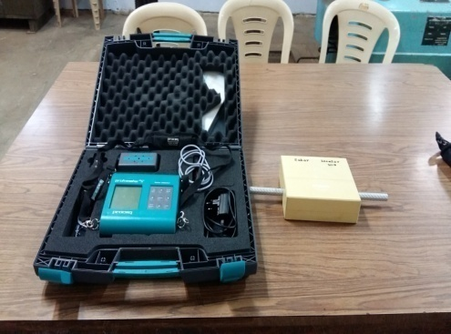

Ultrasonic Pulse Velocity Concrete Testing Apparatus
Scope of the Equipment:
- To evaluate material properties, to locate voiding or damage in concrete structural elements and to measure the depths of cracking in concrete.
About the Equipment:
- Designed to be used on-site in harsh environments
- Settings directly accessible on measuring screen
- On board storage and review of waveforms
- Automatic and manual triggering and user adjustable trigger threshold
Applications of the Equipment:
- Used to measure the homogeneity of a concrete
- Predict the presence of voids, cracks or other internal imperfections or defects
- Find the changes in the concrete which may occur with time (i.e. due to the cement hydration) or damage from fire, frost or chemical attack
- Determine the quality of the concrete in relation to specified standard requirements.
