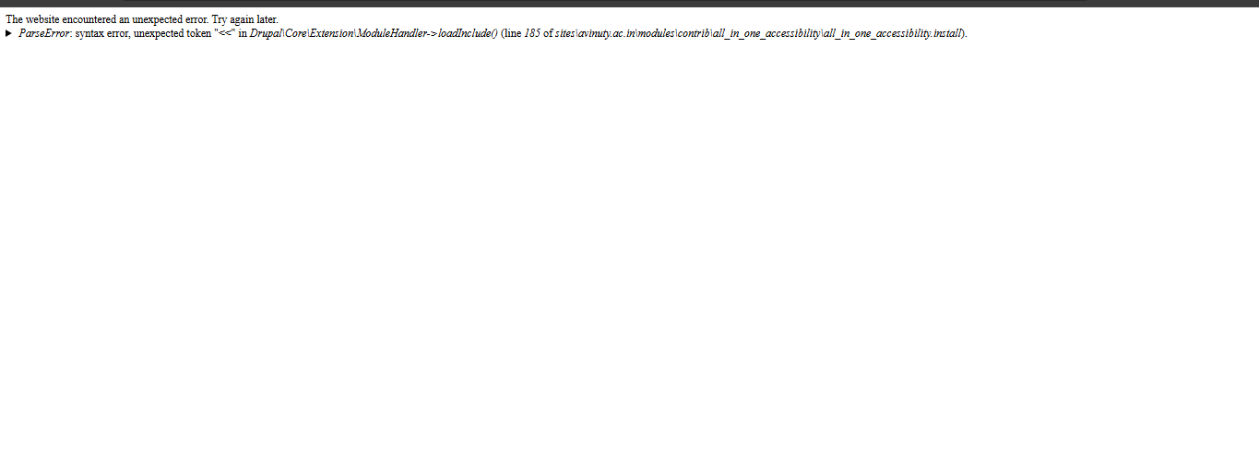

GO TO
-> drupalnew\sites\avinuty.ac.in\modules\contrib\all_in_one_accessibility
-> Inside this all_in_one_accessibility.install open this file in line 185 remove this
<<<<<<< HEAD
$response = curl_exec($curl);
=======
>>>>>>> 40001bc5128d21925d6b30d0de1c70f8b364a74a
and keep like the below Screenshot
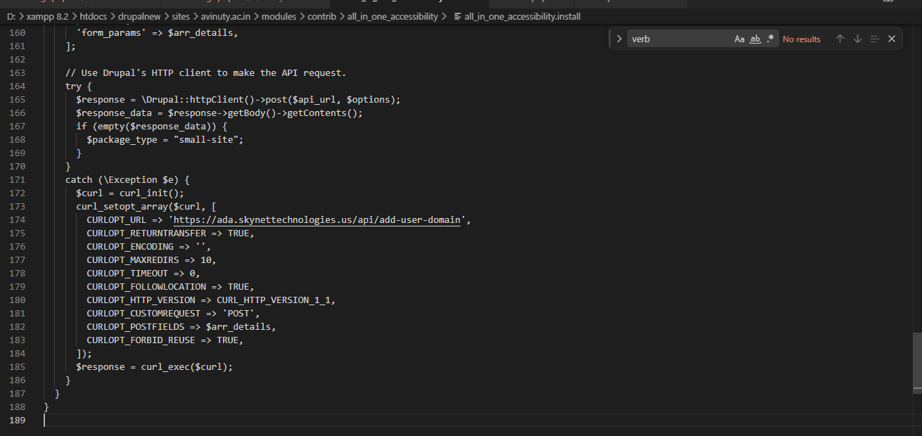

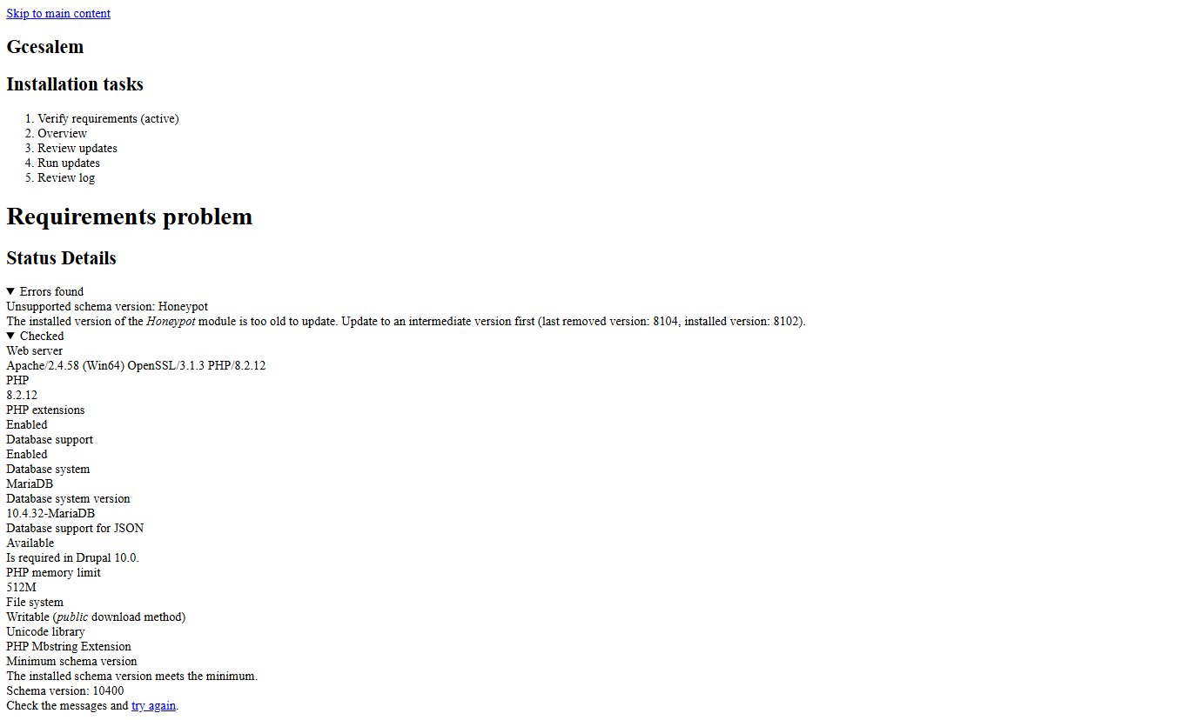

-> Download Honeypot 2.1.4 (not 2.2.2).
-> then give update.php after that give update the latest version of the honeypot

