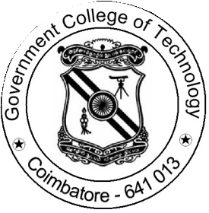

SOCIETY OF AUTOMOTIVE ENGINEERS
OFFICE BEARERS:
Faculty Advisor

Dr. S. PERIYASAMY
Associate Professor in Mechanical Engineering Phone: 8754030606

Addnl. Faculty Advisor

Dr. A. SASIKUMAR
Assistant Professor in Production Engineering Phone: 9486575333
Student’s Vice Chair-Person

Mr. HARI RAJ A

Final year Mechanical Engineering

Phone: 8608338750
Student’s Chair-Person

Mr. GOBI V
Final Year Mechanical
Engineering
Phone: 9894355097
Student’s Joint Secretary
Mr. PARTHIBAN V

Third Year Mechanical Engineering

Phone: 9566765527
Student’s Secretary

Mr. PARAS NEERAJ KUMAR
Final Year Mechanical Engineering
Phone: 9867321993
Student’s Joint Treasurer

Mr. MANSOOR MOHAMED

Third Year Electronics and Instrumentation Engineering

Phone: 6383095487
Student’s Treasurer

Mr. VARSHA B
Final Year Production Engineering
Phone: 6369084818
Membership Count
Total Count | Male (27) | Female (07) | Total (34)
Mechanical Engineering | 16 | 01 | 17
Production Engineering | 02 | 03 | 05
Electrical and Electronics Engineering | 05 | 01 | 06
Electronics and Instrumentaion Engineering | 04 | 01 | 05
Electronics and Communication Engineering | Nil | Nil | Nil
Computer Science Engineering | Nil | Nil | Nil
Industrial Bio Technology | Nil | 01 | 01

