List of students participated in inter – institute events (2019-2020)

S.No. | Name | Institute | Event | Event Level | Prize / Participation
1 | 1611187  Shanmugaraj B | Anna university Zonal tournaments | Cricket | Within State | Runner
2 | 1611172  Prakash C | Anna university Zonal tournaments | Cricket | Within State | Runner
3 | 1811L20  Shyam Sundar S | Sri Krishna College of Technology, Coimbatore | Cube Crash | Within State | Second Prize
4 | 1811L20  Shyam Sundar S | Sri Krishna College of Technology, Coimbatore | CAD Pro | Within State | First Prize
5 | 1811L20  Shyam Sundar S | Sri Krishna College of Technology, Coimbatore | Paper Presentation | Within State | First Prize
6 | 1811L20  Shyam Sundar S | Sri Krishna College of Technology, Coimbatore | Googly | Within State | First Prize
7 | 1811167  Paul Daniel J | Government College of Engineering, Salem | Technoblaze 20.0  BIS Hacker | Within  State | First prize
8 | 1811172  Pratheesh B | Government College of Engineering, Salem | Technoblaze 20.0  The Last Surveyor | Within State | Second prize
9 | 1811190  Sanjay I | Government College of Engineering, Salem | Technoblaze 20.0  Photography | Within State | First prize
10 | 1811190  Sanjay I | Government College of Engineering, Salem | Technoblaze 20.0  BIS Hacker | Within State | Third prize
11 | 1711148  Monoj S | GCT Coimbatore | High Jump | Within State | First prize
12 | 1711101  Abinaya Sri M | Eversendai | Innovative erection methodologies of steel  structures conducted by Eversendai | Outside State | Participation
13 | 1711112  Dharshini M | IIT Madras | Workshop: Construction Automation | Within State | Participation
14 | 1711114  Dhivya Bharathi N | IIT Madras | Tekla Workshop Case study PPT, Sustainable Design  Challlenge | Within State | Participation
15 | 1711115  Divya Dharshni R | CEG, Anna University, Chennai | Workshop: Innovation erection methodologies of steel structures conducted by Eversendai,  Civilisation-20 | Within State | Participation
16 | 1711311  Ragavi M | PSG Tech, Coimbatore | Low cost housing PPT  in PSG ITech, workshop | Within State | Participation
17 | 1711314  Vennmayuuri T | Kings College of Engineering, Thanjavur | Quiz, Code cracking, National level  technical symposium | Within State | Participation
18 | 1711501  Shunmugasurya S | KDK College Nagpur | Webinar(Steel Structure - A Limit State Approach ) | Outside State | Participation
19 | 1811110  Anusuya Lakshmi P | Kongu Engineering College, Perundurai | CEANS 2K20  INCH BY INCH | Within state | Participation
20 | 1811116  Dharineesh Kumar K | Kongu Engineering College, Perundurai | CEANS 2K20  Dug out  Print it blue  Tech Buzz | Within state | Participation
21 | 1811118  Dharshini Priya C M | Kongu Engineering College, Perundurai | CEANS 2K20  Paper presentation  Heap It Up | Within state | Participation
22 | 1811125  Gopika S | Kongu Engineering College, Perundurai | CEANS 2K20  Print it blue | Within state | Participation
23 | 1811127  Gowtham M | Kongu Engineering College, Perundurai | CEANS 2K20  Dug out  Print it blue  Tech Buzz | Within state | Participation
24 | 1811128  Harini A | Kongu Engineering College, Perundurai | CEANS 2K20  Dug out  Inch by Inch | Within state | Participation
25 | 1811132  Hashir Musafar S | Kongu Engineering College, Perundurai | CEANS 2K20  Paper presentation | Within state | Participation
26 | 1811134  Jeevitha R | Kongu Engineering College, Perundurai | CEANS 2K20  Dug out  Print it blue  Tech Buzz | Within state | Participation
27 | 1811L20  Shyam Sundar S | Kongu Engineering College, Perundurai | CEANS 2K20  Paper presentation | Within state | Participation
28 | 1811167  Paul Daniel J | Government College of Engineering, Salem | Technoblaze 20.0  All events | Within state | Participation
29 | 1811172  Pratheesh B | Government College of Engineering, Salem | Technoblaze 20.0  All events | Within state | Participation
30 | 1811176  Princy S | Government College of Engineering, Salem | Technoblaze 20.0  All events | Within state | Participation
31 | 1811182  Ranjitha S | Government College of Engineering, Salem | Technoblaze 20.0  All events | Within state | Participation
32 | 1811198  Shobhika V | Government College of Engineering, Salem | Technoblaze 20.0  All events | Within state | Participation
33 | 1811200  Sivagnanasambantham G | Government College of Engineering, Salem | Technoblaze 20.0  All Events | Within state | Participation
34 | 1811201  Soundariya S P | Government College of Engineering, Salem | Technoblaze 20.0  All Events | Within state | Participation
35 | 1811201  Sowmiya M | Government College of Engineering, Salem | Technoblaze 20.0  All Events | Within state | Participation

List of students participated in inter – institute events (2020-2021)

S.No | Name | Institute | Event | Level | Prize /Participation
1 | 1911136  Karthika T | Kumaraguru College  of Technology, Coimbatore | BID TO CONSTRUCT | Within State | Second Prize
2 | 1911138  Kavipriya A | Kumaraguru College  of Technology, Coimbatore | BID TO KONSTRUCT | Within State | First Prize
3 | 1911116  Dhivya S R | Dr.N.G.P.Institute of Technology, Coimbatore | Flood and Drought mapping using GIS  (Webinar) | Within State | First Prize
4 | 1711166  Prakash B | Rathinam technical campus | Quiz | Within State | Participation
5 | 1711192  Sujithra M | CIT, Coimbatore | Webinar | Within State | Participation
6 | 1711191  Sowmiya P | GCE, Tirunelveli | Biotechnology application | Within State | Participation
7 | 1711191  Sowmiya P | SRM, Chennai | Webinar | Within State | Participation
8 | 1711203  Venilla M | Siaghad college, Pune | Webinar | National | Participation
9 | 1711192  Sujithra M | GCE, Tirunelveli | Webinar | Within State | Participation
10 | 1711192  Sujithra M | GCE, Tirunelveli | Traffic stimulation | Within State | Participation
11 | 1711203  Venilla M | SRM, Chennai | Webinar | Within State | Participation
12 | 1711191  Sowmiya P | Francis Xaiver college | Webinar | Within State | Participation
13 | 1711173  Preetha P S | Siaghad college,Pune | Webinar | Within State | Participation
14 | 1711176  Priyadharashini P | Siaghad college,Pune | Webinar | Within State | Participation
15 | 1711203  Venilla M | Hindustan college | Concrete technology | Within State | Participation
16 | 1711173  Preetha P S | Hindustan college | Concrete technology | Within State | Participation
17 | 1711176  Priyadharashini P | Hindustan college | Concrete technology | Within State | Participation
18 | 1711313  Sultan Ashief Raja S | Hindustan college | Concrete technology | Within State | Participation
19 | 1711176  Priyadharashini P | SRM, Chennai | Webinar | Within State | Participation
20 | 1711173  Preetha P S | SRM,Chennai | Webinar | Within State | Participation
21 | 1711313  SultanAshief Raja S | SRM,Chennai | Webinar | Within State | Participation
22 | 1711313  SultanAshief Raja S | Siaghad college,Pune | Bridge engineering | National | Participation
23 | 1711L20  Snowlin Winslet G | Hindustan college | Environmental impact assessment | Within State | Participation
24 | 1711176  Priyadharashini. | Hindustan college | Environmental impact assessment | Within State | Participation
25 | 1711163  Nithishprathap R | Hindustan college | Webinar | Within State | Participation
26 | 1711204  Vinitha R | Hindustan college | Webinar | Within State | Participation
27 | 1711193  Sundarbalan S | Hindustan college | Webinar | Within State | Participation
28 | 1711187  Sindhu.M | Hindustan college | Webinar | Within State | Participation
29 | 1711185  selvi.S | Hindustan college | Webinar | Within State | Participation
30 | 1711187  Sindhu M | St. Joseph college | Seismic analysis | Within State | Participation
31 | 1711187  Sindhu M | Dr.N.G.Pcollege | Webinar series | Within State | Participation
32 | 1711187  Sindhu M | Government College of Technology, Coimbatore | Advances in concrete composites, webinar | Within State | Participation
33 | 1711190  Sivapriya.S | Francis Xavier's College | Impact on special concrete | Within State | Participation
34 | 1711L20  Snowlin Winslet G | Hindustan college | Recent trend in concrete technology, webinar | Within State | Participation
35 | 1711L20  Snowlin Winslet G | Government College of Technology, Coimbatore | International webinar on advances in concrete composites | Within State | Participation
36 | 1711204  Vinitha R | Ramco Institute | Environmental impact assessment | Within State | Participation
37 | 1711190  Sivapriya S | Dr.NGP college | Webinar | Within State | Participation
39 | 1711177  Rajkrishnan B | Government College of Technology, Coimbatore | International webinar on advances in concrete composites | Within state | Participation
40 | 1711206  Yoga Arasazagan P | Government College of Technology, Coimbatore | International webinar on advances in concrete composites | Within state | Participation
41 | 1811110  Anushya Lakshmi M | Government College of Technology, Coimbatore | International webinar on advances in concrete composites | Within state | Participation
42 | 1811129  Harini S | Government College of Technology, Coimbatore | International webinar on advances in concrete composites | Within state | Participation
43 | 1811L24  Thejoram C | Government College of Technology, Coimbatore | International webinar on advances in concrete composites | Within state | Participation
44 | 1811144  Kouthama R | Government College of Technology, Coimbatore | International webinar on advances in concrete composites | Within state | Participation
45 | 1811161  Nandhakumaran P | Government College of Technology, Coimbatore | International webinar on advances in concrete composites | Within state | Participation
46 | 1811164  Niranchana M | Government College of Technology, Coimbatore | International webinar on advances in concrete composites | Within state | Participation
47 | 1811172  Pratheesh B | Government College of Technology, Coimbatore | International webinar on advances in concrete composites | Within state | Participation

List of students participated in inter – institute events (2021-2022)

S.No | Name | Institute | Event | Level | Prize/  Participation
1 | 1911197  Smrithi L | CEG Anna university, Chennai | Project Display  (Topic–Swing Bridge) | Within State | Second Prize
2 | 1911197  Smrithi L | CEG Anna university, Chennai | Precast Concrete Structures  (Workshop) | Within State | First Prize
3 | 1911197  Smrithi L | CEG Anna university, Chennai | New Products in Sustainable Construction (Workshop) | Within State | Second Prize
4 | 1911198  Sneha T | CEG Anna university, Chennai | Project Display  (Topic–Swing Bridge) | Within State | Second Prize
5 | 1911198  Sneha T | CEG Anna university, Chennai | New Products in Sustainable Construction (Workshop) | Within State | First Prize
6 | 1911201  Subhasshini M | CEG Anna university, Chennai | Project Display | Within State | First Prize
7 | 1911117  Elakkiya S | CEG Anna university, Chennai | Scope and opportunities in  EIA(workshop),  Visual loop | Within State | Second prize
8 | 1911L13  SanjithM | CEG Anna university, Chennai | Technoblaze (technical Symposium) | Within State | First Prize
9 | 1911163  Karthika T | Kumaraguru College of Technology, Coimbatore | Bid To Konstruct | Within state | First Price
10 | 1911197  Smrithi L | CEG Anna university, Chennai | Building Information Modelling (Workshop) | WithinState | Participation
11 | 1911198  Sneha.T | CEG Anna university, Chennai | Building Information Modelling (Workshop) | WithinState | Participation
12 | 1911197  Smrithi L | CEG Anna university, Chennai | Reveal The Civil | WithinState | Participation
13 | 1911197  Smrithi L | CEG Anna university, Chennai | Archi Buildo | WithinState | Participation
14 | 1911197  Smrithi L | CEG Anna university, Chennai | ECOQUIZ | WithinState | Participation
15 | 1911198  Sneha T | CEG Anna university, Chennai | Building Information Modelling (Workshop) | WithinState | Participation
16 | 1911198  Sneha T | CEG Anna university, Chennai | Precast Concrete Structures (Workshop) | WithinState | Participation
17 | 1911198  Sneha T | CEG Anna university, Chennai | Reveal The Civil | WithinState | Participation
18 | 1911198  Sneha T | CEG Anna university, Chennai | Archi Buildo | WithinState | Participation
19 | 1911198  Sneha T | CEG Anna university, Chennai | ECO QUIZ | WithinState | Participation
20 | 1911201  Subhasshini M | CEG Anna university, Chennai | New Products in SustainableConstruction  (Workshop) | WithinState | Participation
21 | 1911201  Subhasshini M | CEG Anna university, Chennai | Building Information Modelling (Workshop) | WithinState | Participation
22 | 1911201  Subhasshini M | CEG Anna university, Chennai | Reveal The Civil | WithinState | Participation
23 | 1911201  Subhasshini M | CEG Anna university, Chennai | Archi Buildo | WithinState | Participation
24 | 1911201  Subhasshini M | CEG Anna university, Chennai | ECO QUIZ | WithinState | Participation
25 | 1911106  Aswin  KarthickP | CEG Anna university, Chennai | Precast Concrete Structures (Workshop) | WithinState | Participation
26 | 1911107  Aswin  KumarA | CEG Anna university, Chennai | Precast Concrete Structures (Workshop) | WithinState | Participation
27 | 1911132  JeevapriyanS | CEG Anna university, Chennai | Precast Concrete Structures (Workshop) | WithinState | Participation
28 | 1911122  HarishKumarS | CEG Anna university, Chennai | Precast concrete structures (workshop) | WithinState | Participation
29 | 1911122  HarishKumarS | CEG Anna university, Chennai | New products in sustainable construction  (workshop) | WithinState | Participation
30 | 1911112  DeepikaT | M. Kumarasamy College of Engineering, Karur | Scope and opportunities in  EIA (workshop) | WithinState | Participation
31 | 1911120  HariniG | M. Kumarasamy College of Engineering, Karur | Scope and opportunities in  EIA (workshop) | WithinState | Participation
32 | 1911113  DhanalakshmiR | M. Kumarasamy College of Engineering, Karur | Scope and opportunities in  EIA (workshop) | WithinState | Participation
33 | 1911155  MyvizhiR | M. Kumarasamy College of Engineering, Karur | Scope and opportunities in  EIA (workshop) | WithinState | Participation
34 | 1911149  Mohamed Shakeel R | IIT Research Institute Kumaraguru College of Technology, Coimbatore | Ethical Hacking (Workshop) Tech fluid, Blend art, Best financier, Kquiz | WithinState | Participation
35 | 1911145  Manogowri G | M. Kumarasamy College of Engineering, Karur | Scope and opportunities in EIA (workshop), visualloop | WithinState | Participation
36 | 1911119  GokulkrishnanS | M. Kumarasamy College of Engineering, Karur | Scope and opportunities in EIA (workshop), visualloop, waterjump, crackizo, talent hunt | WithinState | Participation
37 | 1911111  DeepikaM | M. Kumarasamy College of Engineering,Karur | Scope and opportunities in EIA (workshop) , paperathon | WithinState | Participation
38 | 2011163  Mahalakshmi E | CEG Anna University Chennai | Workshop on Precast Concrete Structures | WithinState | Participation
39 | 2011170  Pavithra V | VIT Chennai | International webinar on "Non Destructive Testing methods for monitoring of masonry  structures" | WithinState | Participation
40 | 2011163  Mahalakshmi E | CEG Anna university, Chennai | Workshop on BIM | WithinState | Participation
41 | 2011205  VigneswaranG | CEG Anna university, Chennai | Workshop on Precast Concrete Structures | WithinState | Participation
42 | 2011191  SivaramR | CEG Anna university, Chennai | Workshop on BIM | WithinState | Participation
43 | 2011191  SivaramR | CEG Anna university, Chennai | Workshop on Precast Concrete Structures | WithinState | Participation
44 | 2011191  SivaramR | CEG Anna university, Chennai | Workshop on New Products in sustainable construction | WithinState | Participation
45 | 2011179  RaamKumarM | CEG Anna university, Chennai | Workshop on BIM | WithinState | Participation
46 | 2011179  RaamKumarM | CEG Anna university, Chennai | Workshop on Precast Concrete Structures | WithinState | Participation
47 | 2011179  RaamKumarM | CEG Anna university, Chennai | Workshop on New Products in sustainable construction | WithinState | Participation
48 | 2011187  SanmathiSK | CEG Anna university, Chennai | Workshop on BIM | WithinState | Participation
49 | 2011187  Sanmathi SK | CEG Anna university, Chennai | Workshop on Precast Concrete Structures | WithinState | Participation
50 | 2011187  Sanmathi SK | CEG Anna university, Chennai | Workshop on New Products in sustainable construction | WithinState | Participation

List of students participated in inter-institute events (2022-2023)
S.No. | Name | Institute | Event | Event Level | Prize / Participation
1 | 2011307  Shalini S | Rotary club of Coimbatore Texcity | Relay | Within State | First Prize
2 | 2011307  Shalini S | Rotary club of Coimbatore East | 5 KM Marathon | Within State | First Prize
3 | 2011205  Vigeneshwaran G | PSG College of Technology | Samyuj-Bridge Building | Within State | First Prize
4 | 71772111165  Padma Priya R | KGISL Institute of technology | Volley Ball Tournament | Within State | First Prize
5 | 71772111L18  Perarasu | Rotary club of Coimbatore East | 10 KM Marathon | Within State | Second Prize
6 | 71772111167  Periya Pandi | Throw ball Federation of India | Throw ball | Outside state | Winners
7 | 71772111165  Padma Priya R | Kumaraguru college of technology | Volley Ball Tournment | Within State | Fourth Prize
8 | 2011145  John Bright E | CEG Annauniversity,Chennai | Bridge Battle | Within State | First Prize
9 | 2011145  John Bright E | CEG Annauniversity,Chennai | Geo Wiz | Within State | Second Prize
10 | 2011145  John Bright E | CEG Annauniversity,Chennai | Breaker of Codes | Within State | Third Prize
11 | 2011130  Diksa S | CEG Annauniversity,Chennai | Walk In | Within State | First Prize
12 | 2011130  Diksa S | CEG Annauniversity,Chennai | Aptitude | Within State | Second Prize
13 | 2011116  Chandru S | CEG Annauniversity,Chennai | Primametry | Within State | First Prize
14 | 71772111167  Periya Pandi | NCC Directorate Uttar Pradesh | UP-EBSB-1 Camp | outside state | Participation
15 | 2011205  Vigneshwaran G | Kumaraguru college of technology | On Field Mastery | Within State | Participation
16 | 2011307  Shalini S | Rotary club of Coimbatore East | 5 KM Marathon | Within State | Participation
17 | 2011172  Poosanthini T | R.M.K Engineering College | National Level Online Quiz Program | Within State | Participation
18 | 2011116  Chandru S | CEG Annauniversity,Chennai | AUTOCAD | Within State | Participation
19 | 2011116  Chandru S | CEG Annauniversity,Chennai | Walk in | Within State | Participation
20 | 2011116  Chandru S | CEG Annauniversity,Chennai | Geowiz | Within State | Participation
21 | 2011116  Chandru S | CEG Annauniversity,Chennai | Primametry | Within State | Participation
22 | 2011116  Chandru S | CEG Annauniversity,Chennai | Breaker of codes | Within State | Participation
23 | 2011116  Chandru S | CEG Annauniversity,Chennai | Bridge battle | Within State | Participation
24 | 2011116  Chandru S | CEG Annauniversity,Chennai | Acropolis | Within State | Participation
25 | 2011116  Chandru S | CEG Annauniversity,Chennai | Aptitude | Within State | Participation
26 | 2011116  Chandru S | CEG Annauniversity,Chennai | Netzero | Within State | Participation
27 | 2011116  Chandru S | CEG Annauniversity,Chennai | Series Quiz | Within State | Participation
28 | 2011116  Chandru S | CEG Annauniversity,Chennai | Cricket Quiz | Within State | Participation
29 | 2011133  Gugapriya A | CEG Annauniversity,Chennai | Reveal the Civil | Within State | Participation
30 | 2011133  Gugapriya A | CEG Annauniversity,Chennai | AUTOCAD | Within State | Participation
31 | 2011133  Gugapriya A | CEG Annauniversity,Chennai | Walk in | Within State | Participation
32 | 2011133  Gugapriya A | CEG Annauniversity,Chennai | Geowiz | Within State | Participation
33 | 2011133  Gugapriya A | CEG Annauniversity,Chennai | Archibuildo | Within State | Participation
34 | 2011133  Gugapriya A | CEG Annauniversity,Chennai | Aptitude | Within State | Participation
35 | 2011133  Gugapriya A | CEG Annauniversity,Chennai | Acropolis | Within State | Participation
36 | 2011133  Gugapriya A | CEG Annauniversity,Chennai | Series Quiz | Within State | Participation
37 | 2011133  Gugapriya A | CEG Annauniversity,Chennai | Workshop | Within State | Participation
38 | 2011130  Diksa S | CEG Annauniversity,Chennai | Geo Wiz | Within State | Participation
39 | 2011130  Diksa S | CEG Annauniversity,Chennai | Acropolis | Within State | Participation
40 | 2011130  Diksa S | CEG Annauniversity,Chennai | Aptitude | Within State | Participation
41 | 2011130  Diksa S | CEG Annauniversity,Chennai | AUTOCAD | Within State | Participation
42 | 2011130  Diksa S | CEG Annauniversity,Chennai | Breaker of codes | Within State | Participation
43 | 2011130  Diksa S | CEG Annauniversity,Chennai | Walk In | Within State | Participation
44 | 2011130  Diksa S | CEG Annauniversity,Chennai | Archi Buildo | Within State | Participation
45 | 2011141 ILAKKIYA I | CEG Annauniversity,Chennai | Workshop | Within State | Participation
46 | 2011141 ILAKKIYA I | CEG Annauniversity,Chennai | Reveal the Civil | Within State | Participation
47 | 2011141 ILAKKIYA I | CEG Annauniversity,Chennai | Geo Wiz | Within State | Participation
48 | 2011141 ILAKKIYA I | CEG Annauniversity,Chennai | Acropolis | Within State | Participation
49 | 2011141 ILAKKIYA I | CEG Annauniversity,Chennai | Aptitude | Within State | Participation
50 | 2011141 ILAKKIYA I | CEG Annauniversity,Chennai | Series Quiz | Within State | Participation
51 | 2011145  John Bright E | CEG Annauniversity,Chennai | Breaker of codes | Within State | Participation
52 | 2011145  John Bright E | CEG Annauniversity,Chennai | Series Quiz | Within State | Participation
53 | 2011145  John Bright E | CEG Annauniversity,Chennai | Aptitude | Within State | Participation
54 | 2011145  John Bright E | CEG Annauniversity,Chennai | Geo Wiz | Within State | Participation
55 | 2011145  John Bright E | CEG Annauniversity,Chennai | Acropolis | Within State | Participation
56 | 2011145  John Bright E | CEG Annauniversity,Chennai | Cricket Quiz | Within State | Participation
57 | 2011145  John Bright E | CEG Annauniversity,Chennai | Map Quiz | Within State | Participation
58 | 2011145  John Bright E | CEG Annauniversity,Chennai | Walk in | Within State | Participation
59 | 2011145John Bright E | CEG Annauniversity,Chennai | Auto CAD | Within State | Participation
60 | 2011147 Kavin Narendar V | CEG Annauniversity,Chennai | Auto CAD | Within State | Participation
61 | 2011147 Kavin Narendar V | CEG Annauniversity,Chennai | Reveal the Civil | Within State | Participation
62 | 2011147 Kavin Narendar V | CEG Annauniversity,Chennai | Aptitude | Within State | Participation
63 | 2011147 Kavin Narendar V | CEG Annauniversity,Chennai | Acropolis | Within State | Participation
64 | 2011147 Kavin Narendar V | CEG Annauniversity,Chennai | Bridge battle | Within State | Participation
65 | 2011147 Kavin Narendar V | CEG Annauniversity,Chennai | Geo Wiz | Within State | Participation
66 | 2011147 Kavin Narendar V | CEG Annauniversity,Chennai | Series Quiz | Within State | Participation
67 | 2011143Jaishree R L | CEG Annauniversity,Chennai | Workshop | Within State | Participation
68 | 2011143Jaishree R L | CEG Annauniversity,Chennai | Series Quiz | Within State | Participation
69 | 2011143  Jaishree R L | CEG Annauniversity,Chennai | Kollywood Quiz | Within State | Participation
70 | 2011143  Jaishree R L | CEG Annauniversity,Chennai | Geo Wiz | Within State | Participation
71 | 2011143  Jaishree R L | CEG Annauniversity,Chennai | Acropolis | Within State | Participation
72 | 2011143  Jaishree R L | CEG Annauniversity,Chennai | Aptitude | Within State | Participation
73 | 2011129  Dhivyabharathi S | CEG Annauniversity,Chennai | Aptitude | Within State | Participation
74 | 2011129  Dhivyabharathi S | CEG Annauniversity,Chennai | Auto CAD | Within State | Participation
75 | 2011129  Dhivyabharathi S | CEG Annauniversity,Chennai | Walk in | Within State | Participation
76 | 2011129  Dhivyabharathi S | CEG Annauniversity,Chennai | Geo Wiz | Within State | Participation
77 | 2011129  Dhivyabharathi S | CEG Annauniversity,Chennai | Aptitude | Within State | Participation
78 | 2011129  Dhivyabharathi S | CEG Annauniversity,Chennai | Acropolis | Within State | Participation
79 | 2011129  Dhivyabharathi S | CEG Annauniversity,Chennai | Breaker of codes | Within State | Participation
80 | 2011129  Dhivyabharathi S | CEG Annauniversity,Chennai | Archi Buildo | Within State | Participation
81 | 2011102 Aatharshena S V | CEG Annauniversity,Chennai | Workshop | Within State | Participation
82 | 2011102 Aatharshena S V | CEG Annauniversity,Chennai | Geo Wiz | Within State | Participation
83 | 2011102 Aatharshena S V | CEG Annauniversity,Chennai | Aptitude | Within State | Participation
84 | 2011102 Aatharshena S V | CEG Annauniversity,Chennai | Acropolis | Within State | Participation
85 | 2011102 Aatharshena S V | CEG Annauniversity,Chennai | Series Quiz | Within State | Participation
86 | 2011102 Aatharshena S V | CEG Annauniversity,Chennai | Kollywood Quiz | Within State | Participation

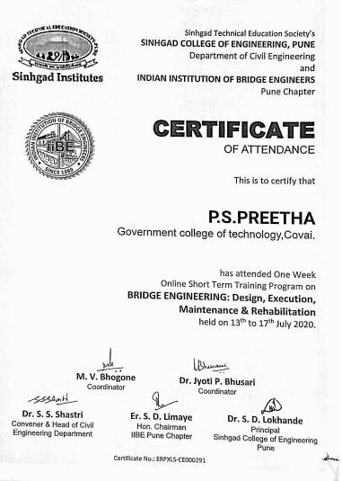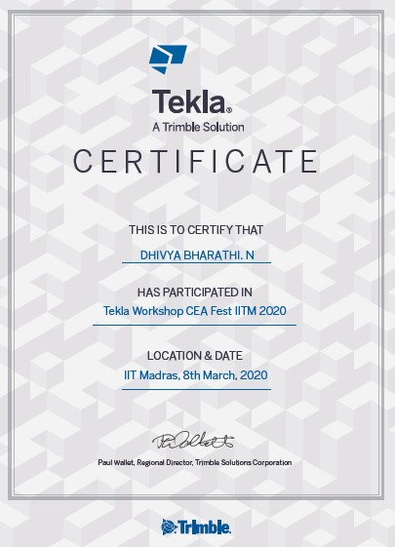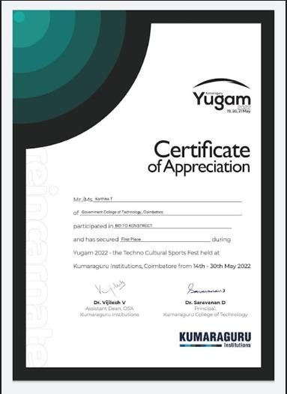
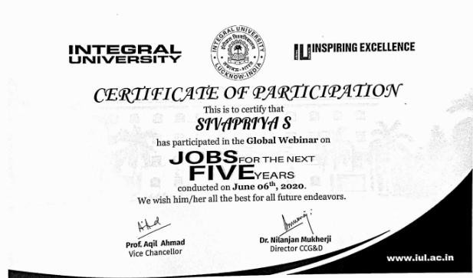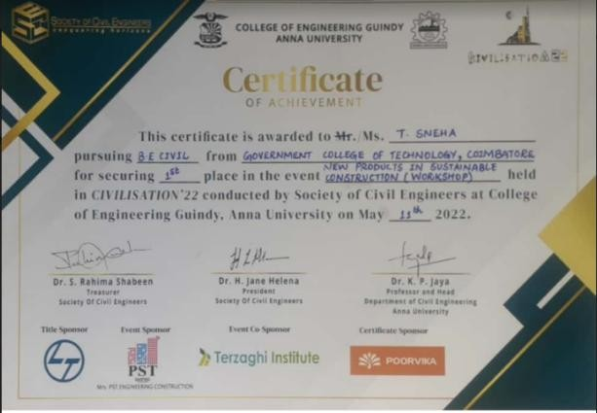

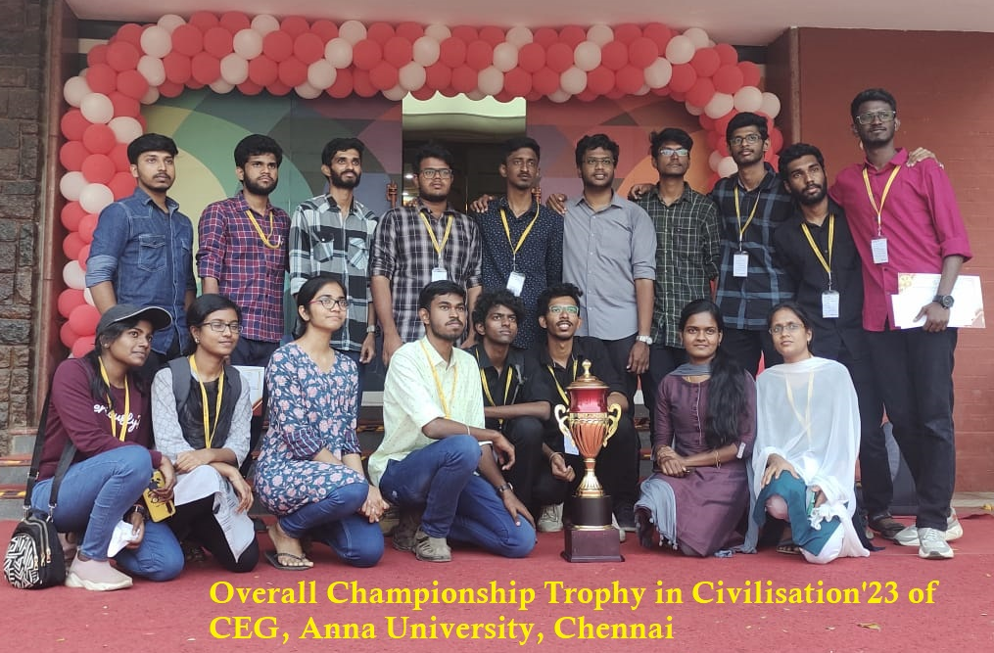

Participation in Inter-Institute Events

Participation in National Competitive Events

S.No. | Name | Institute | Event | Prize /Participation | Level
 | 1711199  Vaishali P S | PSG I Tech | CODIFY , NL Tech Symposium | 1st Place | National
 | 1711204  Vinitha R | PSG I Tech | CODIFY , NL Tech Symposium | 1st Place | National
 | 1711185  Selvi.S | PSG I Tech | CODIFY , NL Tech Symposium | 1st Place | National
 | 2011307  S Shalini | AATAM - An Atheletics Meet | Relay | 1st Place | National
 | 2011195  B Sowmiya | KCT Coimbatore | Bid to Konstruct, YUGAM 2022 | 1st Place | National
 | 1711312  Sanjana M | PSG I Tech | Bridge IT , NL Tech Symposium | 2nd Place | National
 | 1711164  Parameswaran J S | PSG I Tech | Brahmos Fully Loaded , NL Tech Symposium | 2nd Place | National
 | 1711198  Vadivel Prasanna R | PSG I Tech | Inquiztive , NL Tech Symposium | 2nd Place | National
 | 1711199  Vaishali P S | PSG I Tech | INQUIZTIVE , NL Tech Symposium | 2nd Place | National
 | 1711206  Yoga Arasazagan P | PSG I Tech | Brahmos Fully Loaded , NL Tech Symposium | 2nd Place | National
 | 1711L06  Dharanivel S | PSG I Tech | BRIDGE IT , NL Tech Symposium | 2nd Place | National
 | 1911186  Sabeera Jenisha S | Smart India Hackathon | SIH 2022 | Selected for 2nd Round | National
 | 1911102  Ahalya S | Smart India Hackathon | SIH 2022 | Selected for 2nd Round | National
 | 1911L08  Kathir Praveen T | Smart India Hackathon | SIH 2022 | Selected for 2nd Round | National
 | 1911180  Rathina Boopathi S | Smart India Hackathon | SIH 2022 | Selected for 2nd Round | National
 | 1911181  Rathina S | Smart India Hackathon | SIH 2022 | Selected for 2nd Round | National
 | 2011307  S Shalini | AATAM - An Atheletics Meet | 100 m Athlete | 2nd Place | National
 | 2011205  Vigneswaran G | KCT Coimbatore | Blend Art, YUGAM 2022 | 2nd Place | National
 | 1711189  Sivanandham M | AICTE | AICTE Chhatra Viswakarma Awards -2019 | Shortlisted for Regional convention | National
 | 1711177  Rajkrishnan B | AICTE | AICTE Chhatra Viswakarma Awards -2019 | Shortlisted for Regional convention | National
 | 1711172  Pravin S | AICTE | AICTE Chhatra Viswakarma Awards -2019 | Shortlisted for Regional convention | National
 | 1711L06  Dharanivel S | AICTE | AICTE Chhatra Viswakarma Awards -2019 | Shortlisted for Regional convention | National
 | 1711187  Sindhu.M | INSDAG | National Award Competition | Participation | National
 | 1711190  Sivapriya.S | INSDAG | National Award Competition | Participation | National
 | 1711312  Sanjana M | INSDAG | National Award Competition | Participation | National
 | 1711204  Vinitha R | INSDAG | National Award Competition | Participation | National
 | 1711312  Sanjana M | PSG I Tech | Webinar, NL Tech Symposium | Participation | National
 | 1711200  Vaishnavi B | PSG I Tech | EMFLIDS PRESNTATTION , NL Tech Symposium | Participation | National
 | 1711204  Vinitha R | PSG I Tech | Project Management Using MS Project | Participation | National
 | 1711192  Sujithra M | PSG I Tech | STAAD PRO Workshop, NL Tech Symposium | Participation | National
 | 1711173  Preetha P S | PSG I Tech | STAAD PRO Workshop, NL Tech Symposium | Participation | National
 | 1711191  Sowmiya P | PSG I Tech | STAAD PRO Workshop, NL Tech Symposium | Participation | National
 | 1711203  Vennilla M | PSG I Tech | STAAD PRO Workshop, NL Tech Symposium | Participation | National
 | 1711187  Sindhu M | PSG I Tech | PROJECT MANAGEMENT USNG MS PROJECT | Participation | National
 | 1711183  Segi S | PSG I Tech | STAAD PRO Workshop, NL Tech Symposium | Participation | National
 | 1711L20  Snowlin Winslet G | PSG I Tech | STAAD PRO Workshop, NL Tech Symposium | Participation | National
 | 1711190  Sivapriya.S | PSG I Tech | STAAD PRO Workshop, NL Tech Symposium | Participation | National
 | 1711185  Selvi.S | PSG I Tech | STAAD PRO Workshop, NL Tech Symposium | Participation | National

Participation in International Competitive Events
S.No. | Name | Institute | Event | Prize /Participation | Date/Period | Level
1 | 1411191  SowndaryaV | Universiti Tecknologi Petronas, Perak,  Malaysia | Foreign Technical Training Programme | Participation | 06.09.2017  to 22.09.2017 | Inter National
2 | 1511106  Anita Sherlin S | Leibniz University,Hanover, Germany | Foreign Technical Training Programme | Participation | 18.06.2018  to 02.07.2018 | Inter National
3 | 1911116  Dhivya S R | ASCE – India Section Southern Region | International Webinar on Architecture, Civil and  Earthquake Engineering | Participation | 24.09.2021 &  25.09.2021 | Inter National
4 | 1911105  Anupiraba L K | ASCE – India Section Southern Region | International Webinar on Architecture, Civil and Earthquake  Engineering | Participation | 24.09.2021  25.09.2021 | Inter National
5 | 1911168  Pavithran P | Concordia University  Montreal Canada | Research Internship on  Circular Economy in construction | Selected based on competition | 25.07.2022  to 30.09.2022 | Inter National

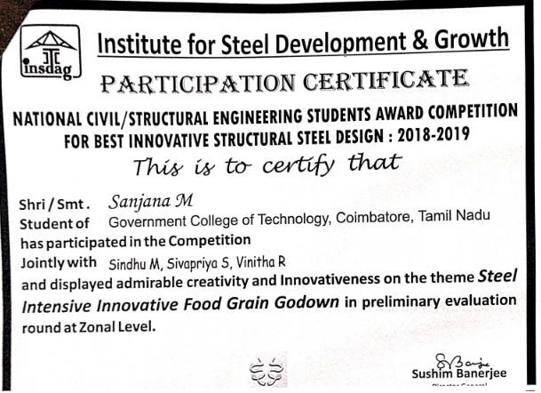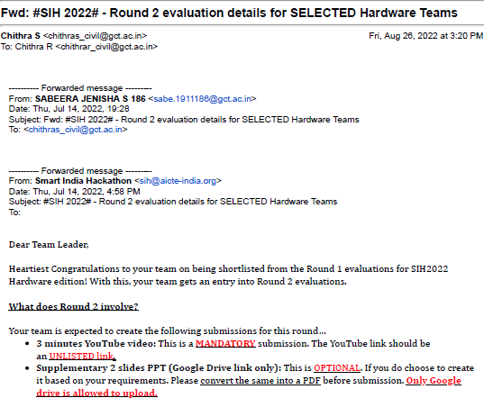
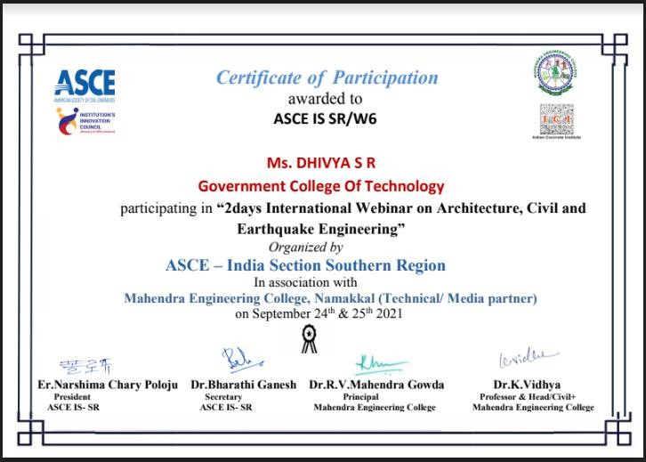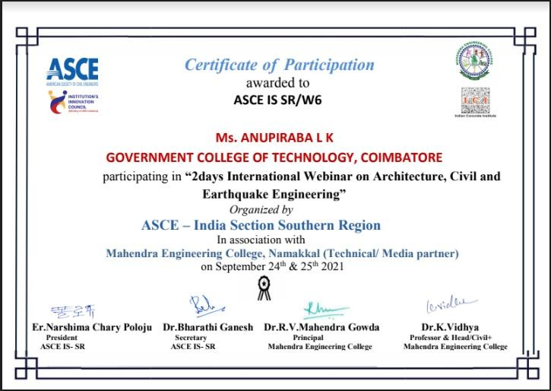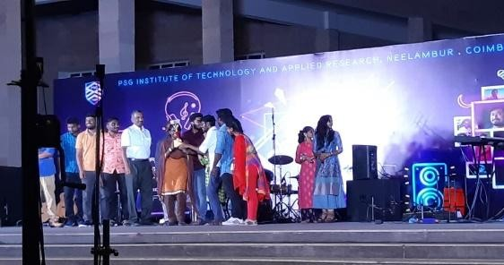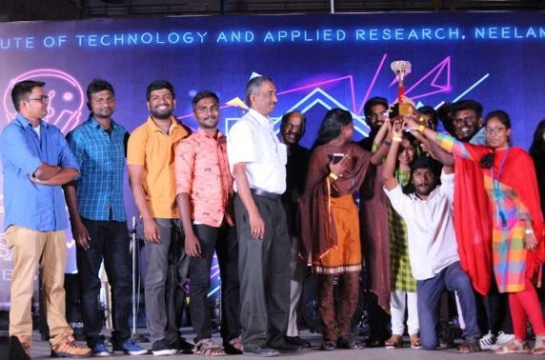

Participation in National/International Competitive Event

