DEPARTMENT OF TECHNICAL EDUCATION : TAMILNADU

From, To,
The Principal
Government College of Technology,
Coimbatore -641 013.
Tamil Nadu.

Enquiry No. TEQIP/BT2/Fur-Staff table/07/ 2007-08. Dated: 18-05-2007

Sir,
Sub: Govt.College of Technology, Coimbatore-13.
Quotations for Equipment and Stores- Called for –reg.

Please furnish your quotations for the stores mentioned in the sealed cover super scribed with the reference number of this enquiry and with the enquiry quotation due on 04-06-2007. Please note that the quotations should be received at this office before 5.00 p.m. on 04-06-2007.

The rates should be quoted in rupee and should be inclusive of sales tax packing and forwarding and insurance charges for delivery at this college. In case of materials wherein Central Tax is chargeable. This institution will pay at 4% since this institution belongs to the Government of Tamil Nadu and necessary ‘D’ form will be issued.

Delivery period required by you to supply the stores after receipt of the firm supply order `should be clearly mentioned in the quotations.

Quotations received after the due date will not be considered. If no quotation is received by the due date it will be presumed that you have nothing suitable to offer.

If the equipment and materials are available under DGS & D rate contract terms of state trading corporation prices, the relevant particulars and the rates applicable should be specified.

ADVANCE PAYMENT CANNOT BE MADE. PAYMENT WILL BE EFFECTED ONLY AFTER THE RECEIPT OF MATERIAL IN GOOD CONDITION AND NO NEGOTIATION BE MADE THROUGH BANKS.

Fragile and costly equipment will be accepted only on open delivery basis if open delivery system is not possible for any reason these are to be necessarily insured. The charges for insurance however should be included in the rates quoted, the cost of the articles and the insurance charges indicated therein separately. Damage during transit should be made good by you.
Incase of equipment instrument and accessories printed illustrated leaflets furnishing full technical particulars, besides makers name. model no Etc are to be furnished along with the quotations.

If materials and equipment are not available meeting the exact specifications prescribed here, quotations can be sent for materials and equipment, which satisfy the specifications approximately.
In the event of placing an order with you should execute an agreement with the principal of this college on a Non –Judicial stamp paper of value of Rs.2.50 and income tax clearance certificate.

The Railway Station nearest to the College is Coimbatore North /Coimbatore Junction (Southern Railway)

PLEASE NOTE: The quotation should be addressed to

THE PRINCIPAL
GOVT.COLLEGE OF TECHNOLOGY
COIMBATORE -641 013.
TAMIL NADU.

On the top of the envelope containing quotation, the enquiry date and the due date of the receipt of quotation should be written in bold capital letters.
Please also furnish registration number (TNGST in case of Tamil Nadu) and central sales tax number (CST) along with the quotation.

PRINCIPAL

DEPARTMENT OF BIOTECHNOLOGY
GOVERNMENT COLLEGE OF TECHNOLOGY
COIMBATORE – 13.

List of furniture

Annexure-II

BT 2/ Fur-Staff table/ 07/

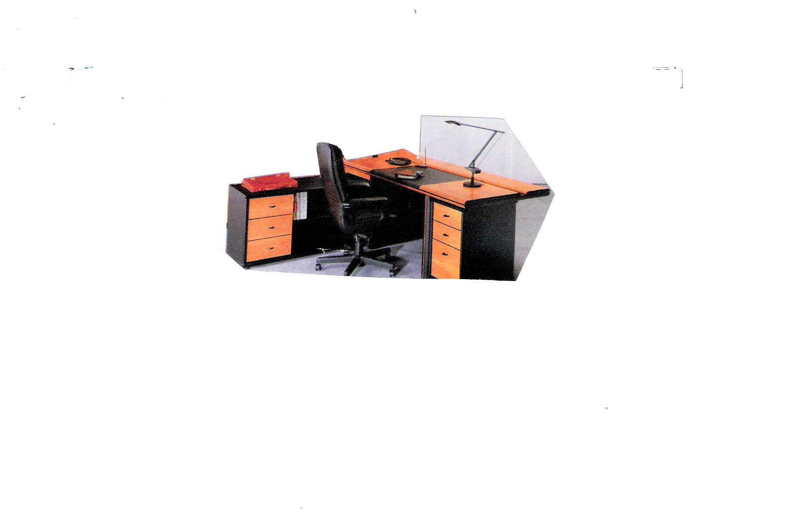
1. Ex. Table ( office table with side table) - 3 nos
Table Size 6’ L x 3’W x 2 ½’ H
Side table size 3’ L x 1 ½’ W x 2 ½’ H
Made of pre laminated particle board,
Three drawers and provision for keeping
computer key board and CPU

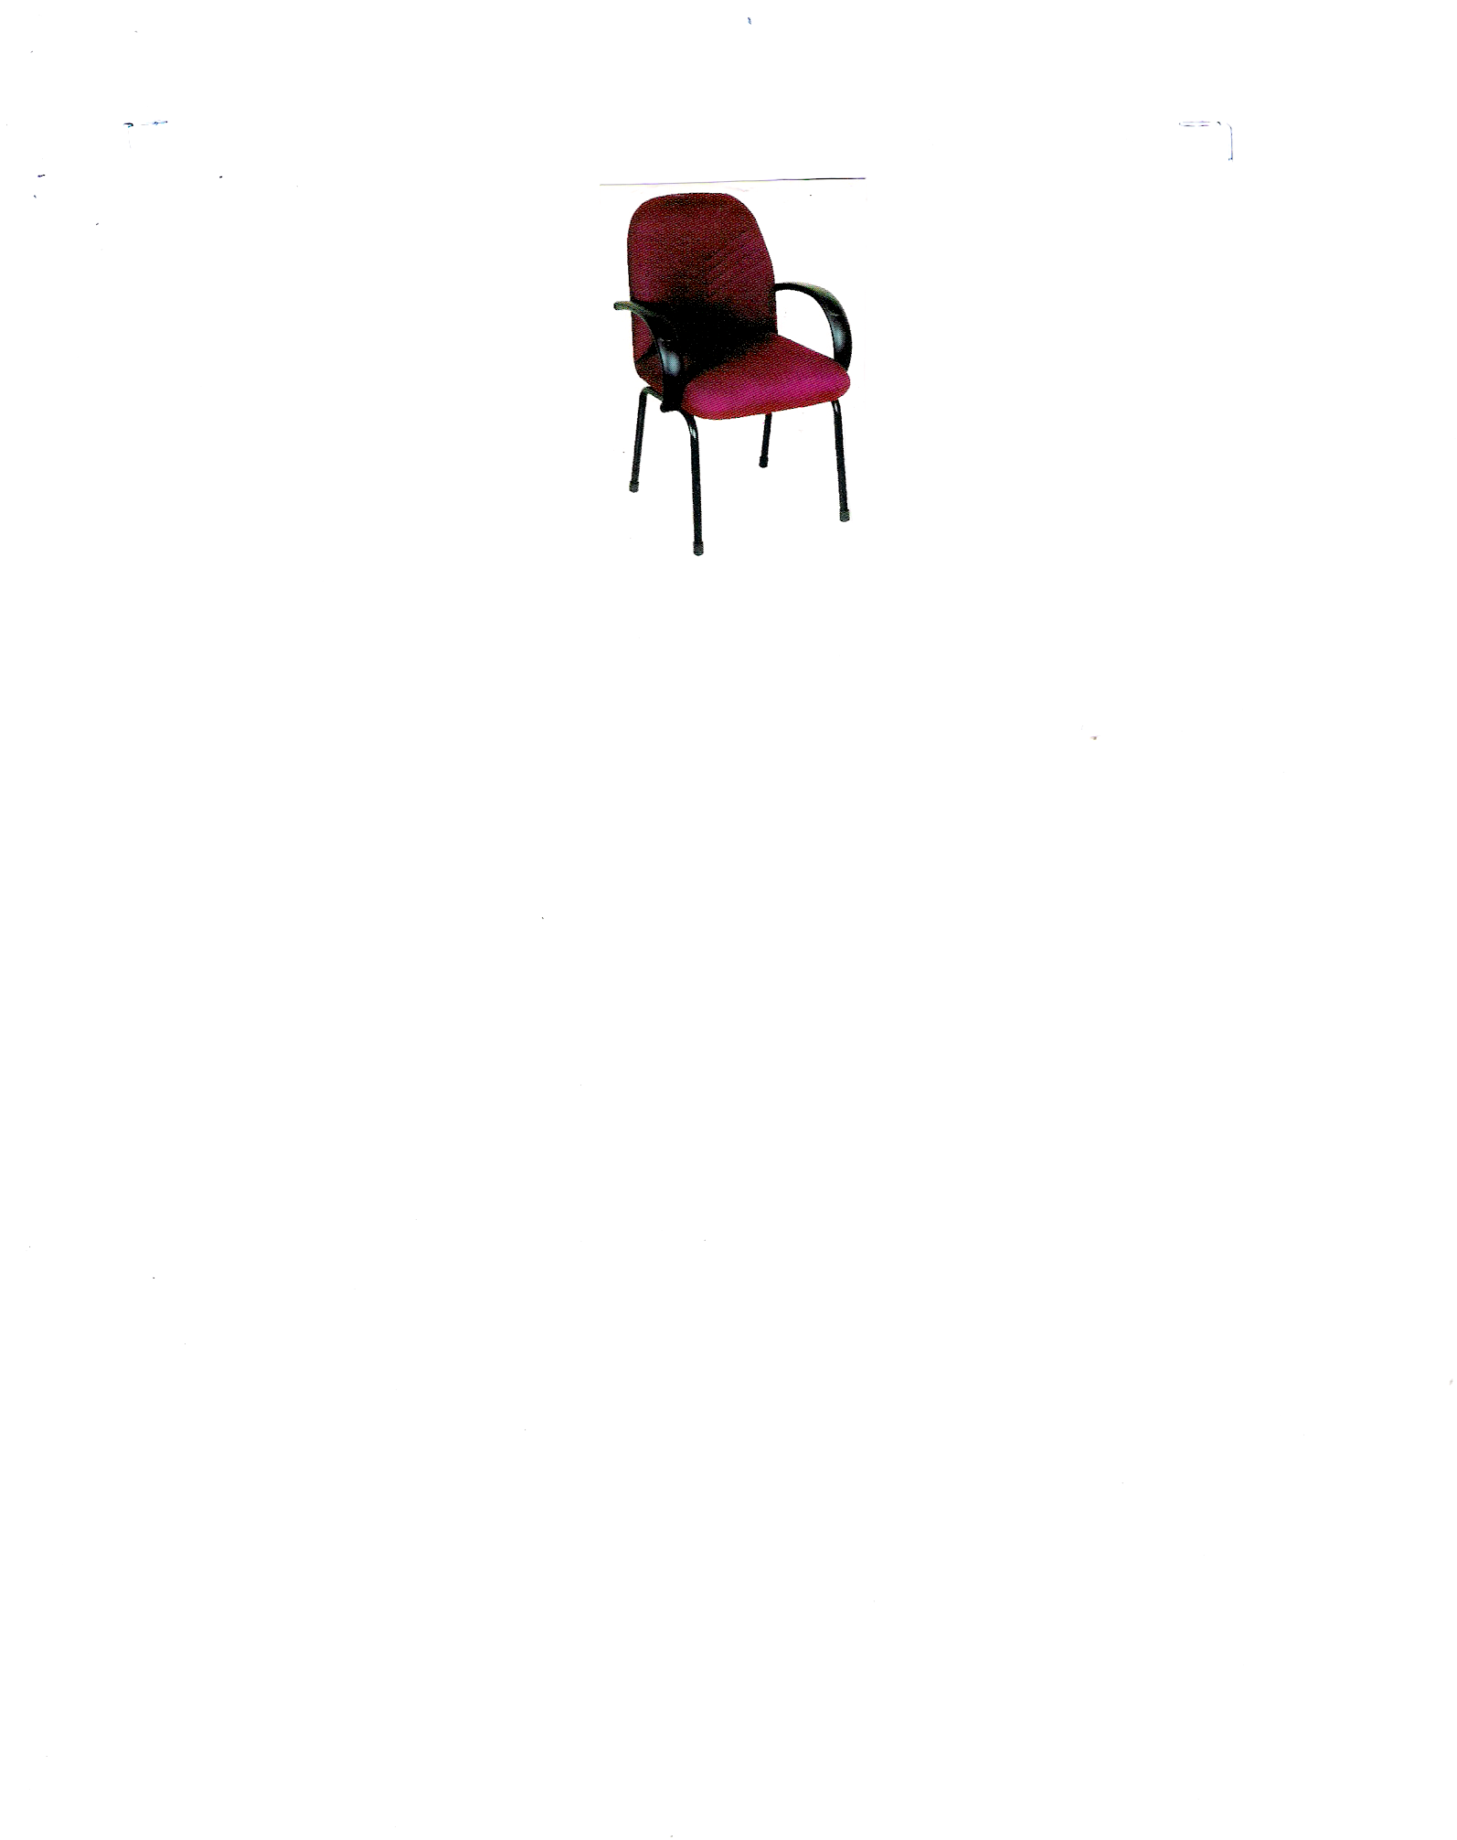

2. Visitors chair - 30 nos.
Executive with arm seat and back cushion with
High density PU foam
Seat size 20’’ x 20’’ back rest 20’’ x 19’’

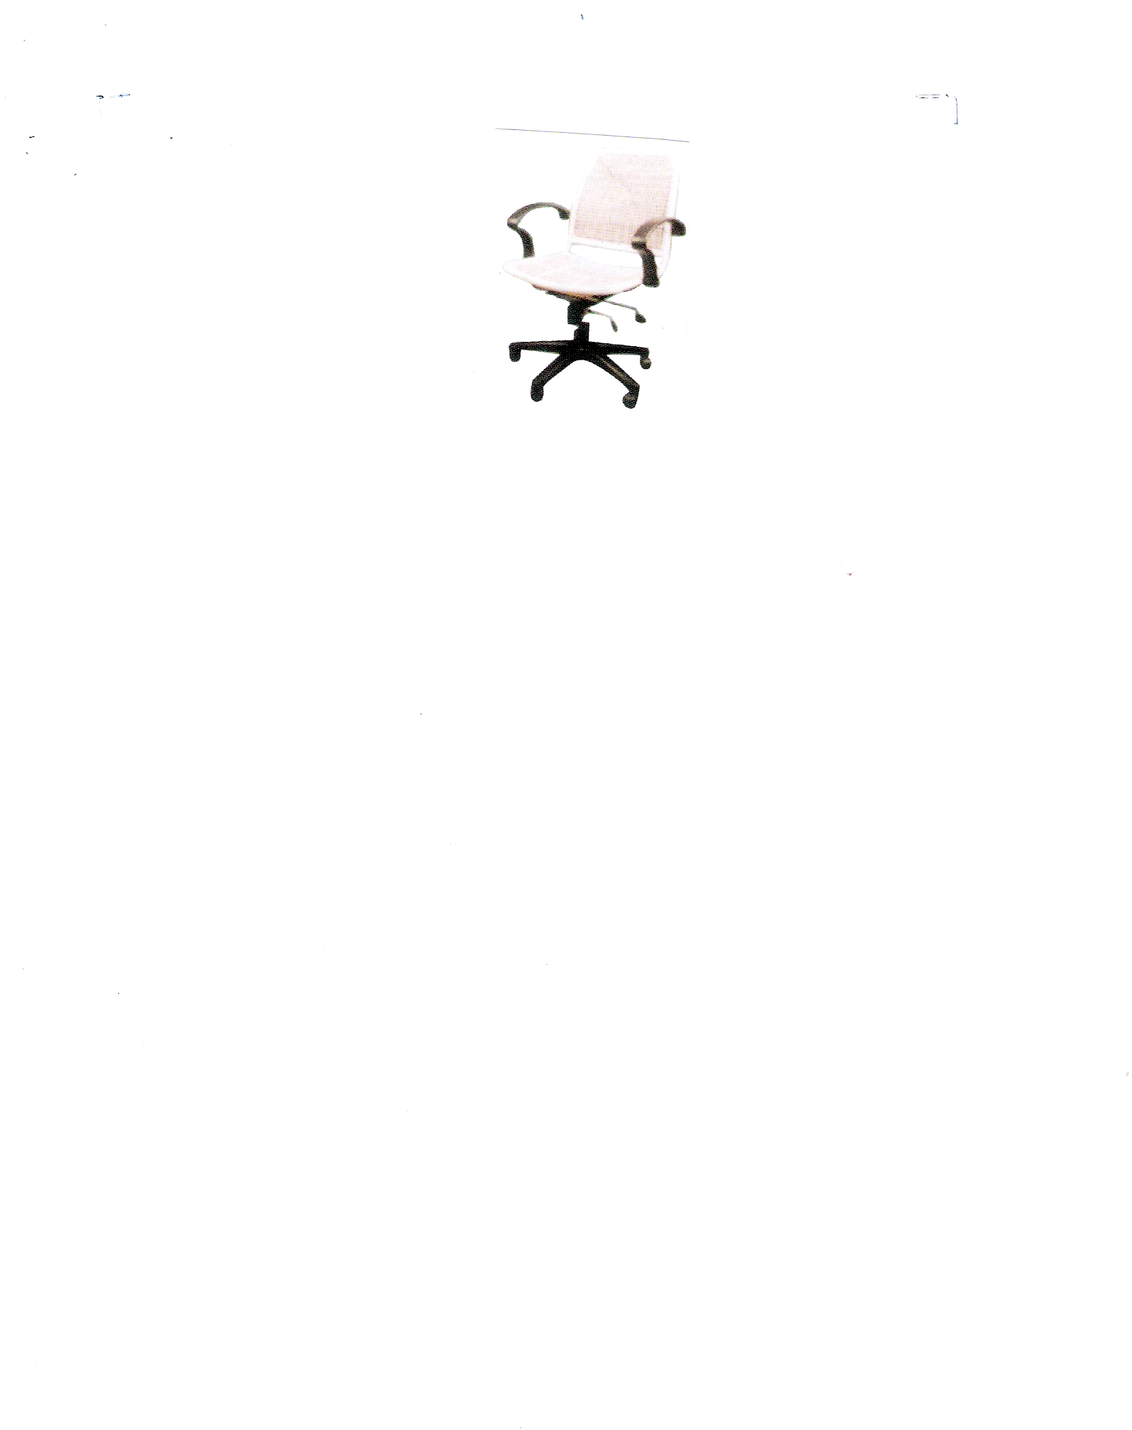

3. Revolving chair cane nested high back model chair
with arms height adjustment with wheels – seat
with rotten bottom - 4 nos.

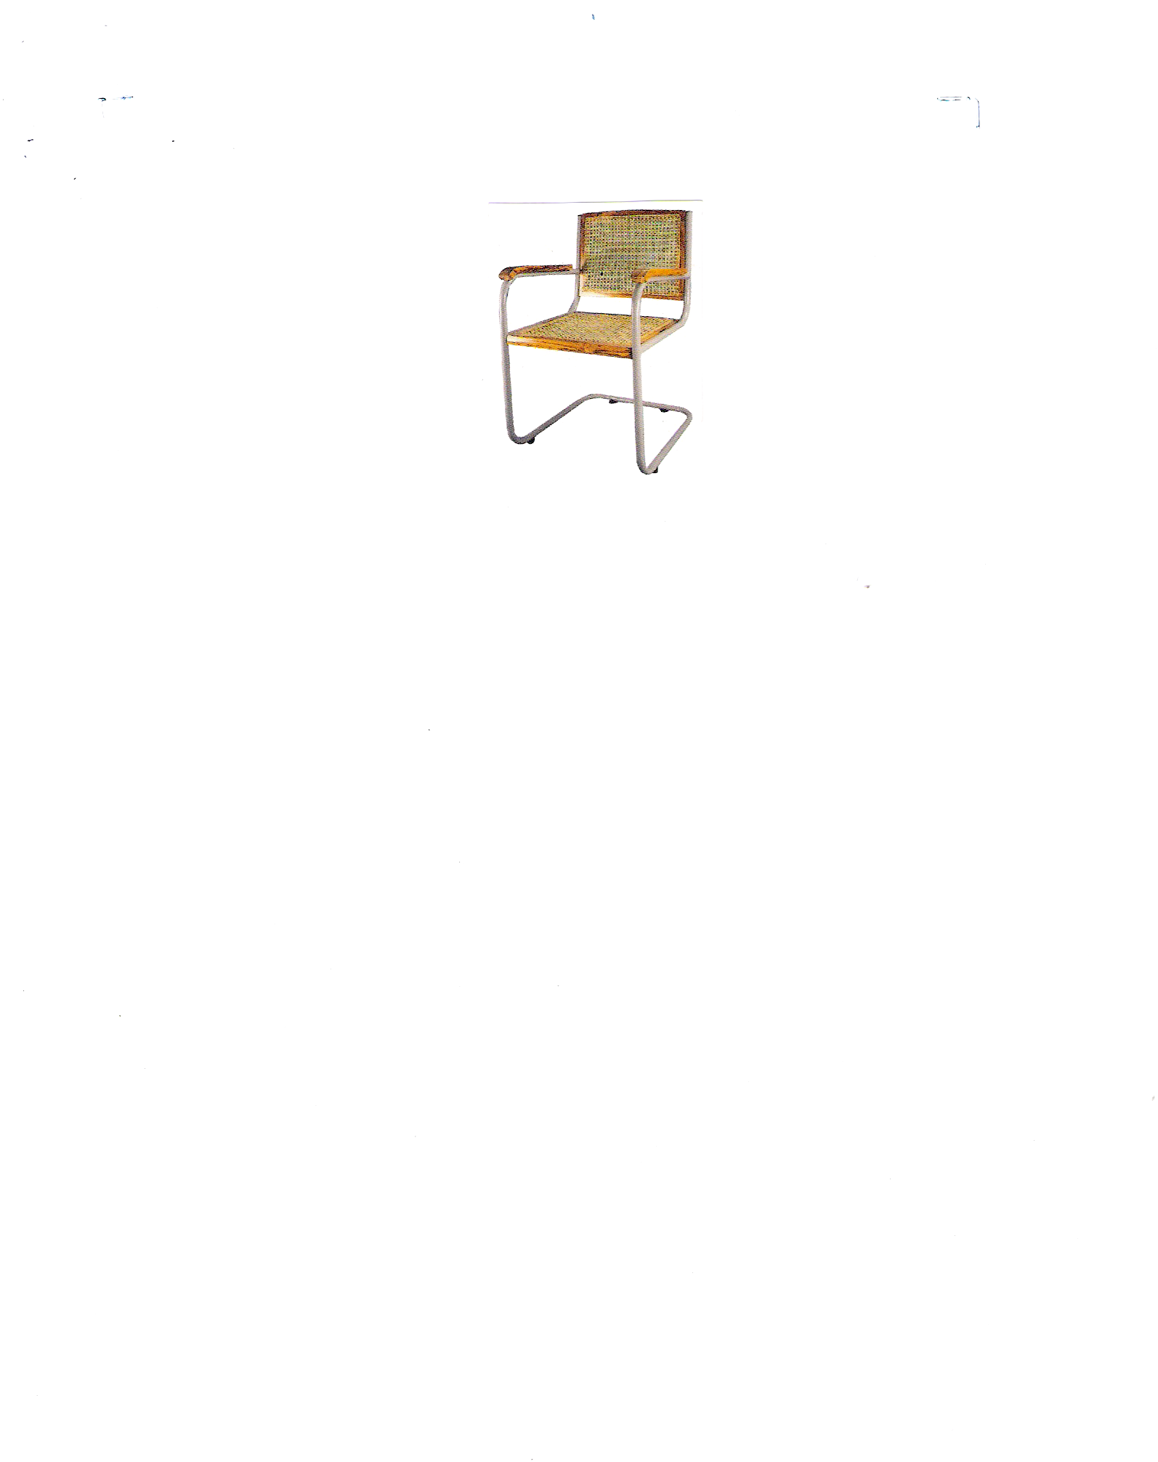

4. S – type chair - 20 nos.
Net seat and back made of round pipe

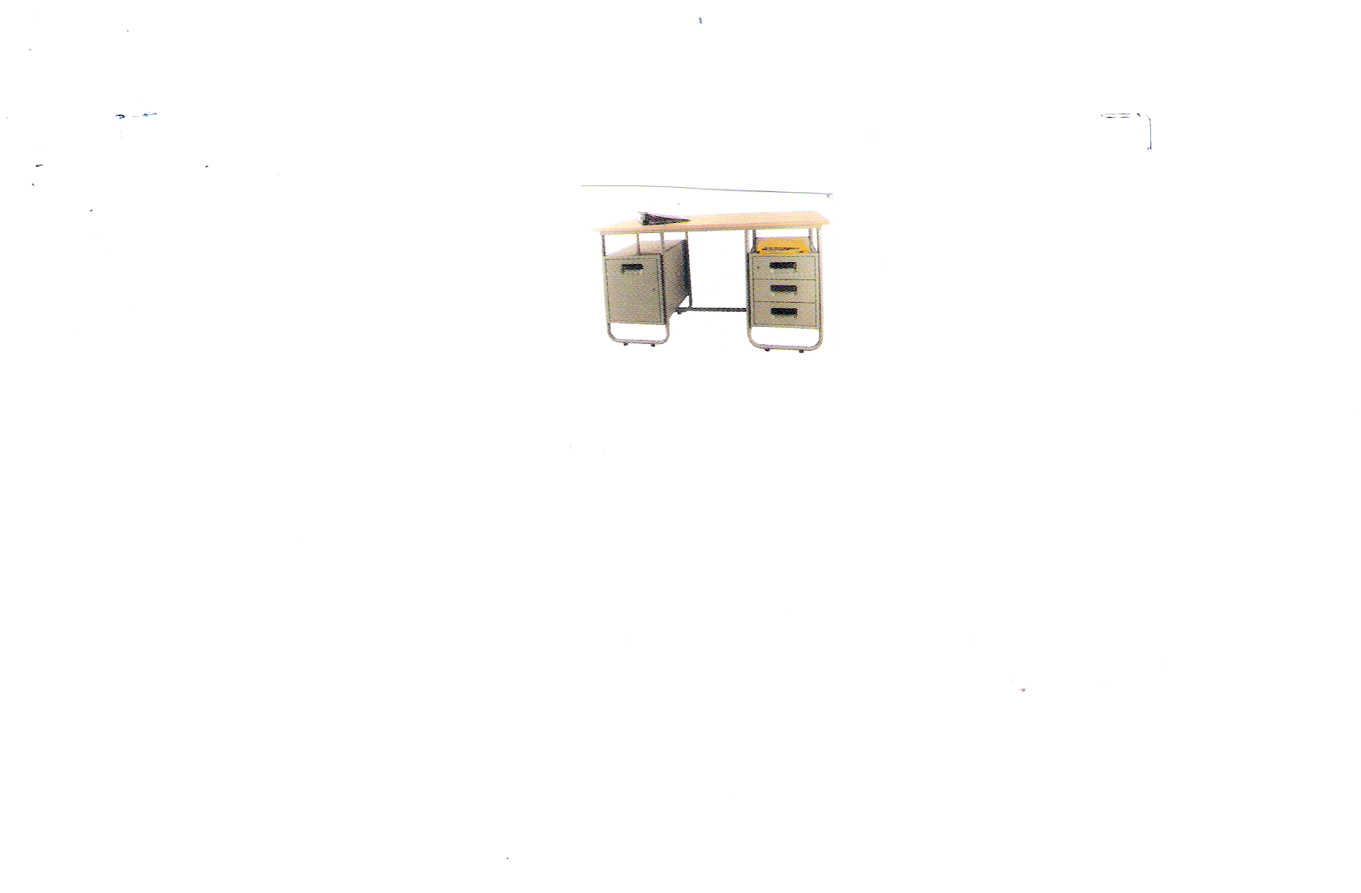
5. Steel junior Ex. Table - 15 nos.
Right side three drawers’ left side one cupboard
With pre laminated tap
Size – 54’’ Lx 34’’W x 30’’H

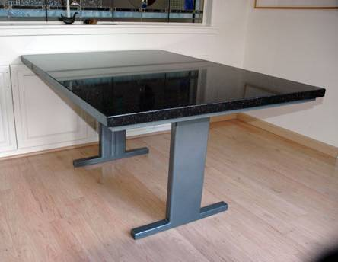

6. Dining table - 3 nos.
Size 5 L x 3 W x 2 ½ D
Granite top, steel frames

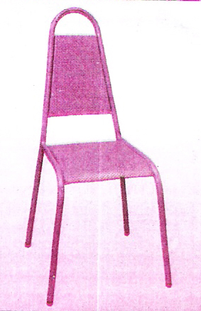

7 Perforated steel seat and back chair for dining - 20 nos.

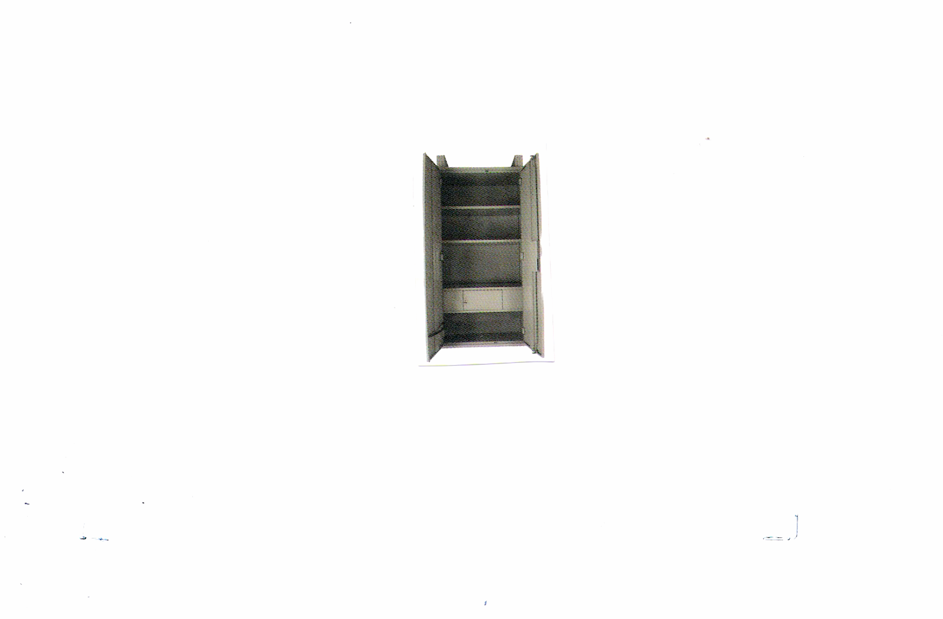

8. Bureau - 15 nos.
Size 78’’H x 36’’W x 19’’ D
With lockers with door
1 mm back covered and 0.8mm steel CR sheet
with lock

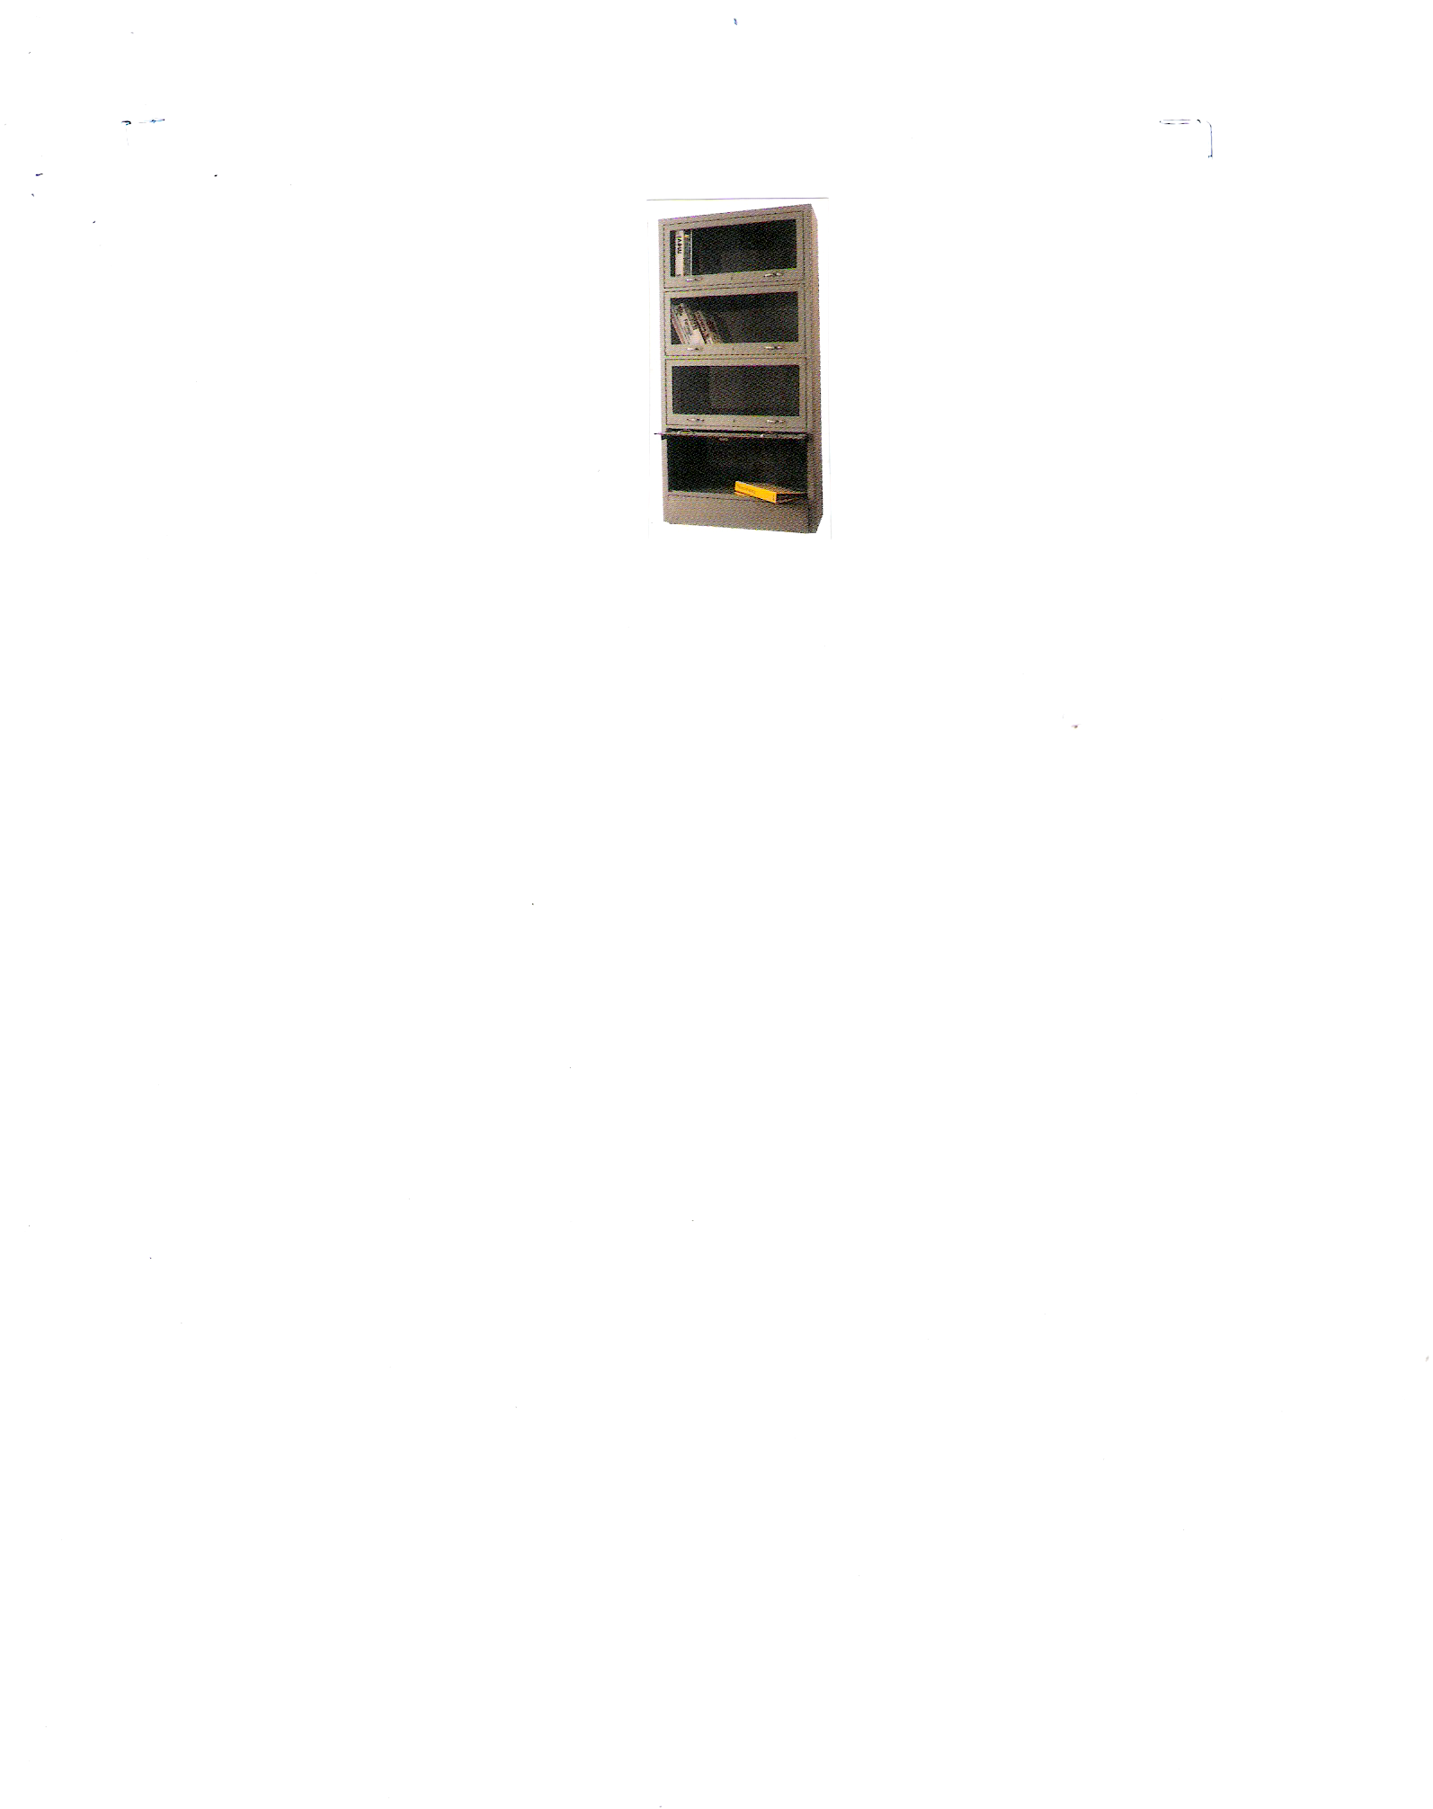

9 . Book shelves - 10 nos.
1mm CR steel sheet with glass sliding doors with
four partitions

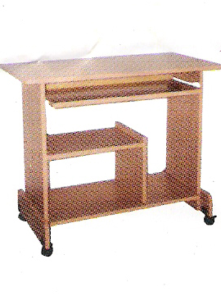

10. Computer table - 30 nos.
Table size – 48”L x 18” D x 30”H

