TEQIP III sponsored webinar on “Women Empowerment through Legal Protection” for Women Teaching, Non-Teaching and Ministerial staff of GCT on 22.02.2021
Guest speaker: Dr. S.N Venkatesan, Management and Legal Consultant, Advocate.
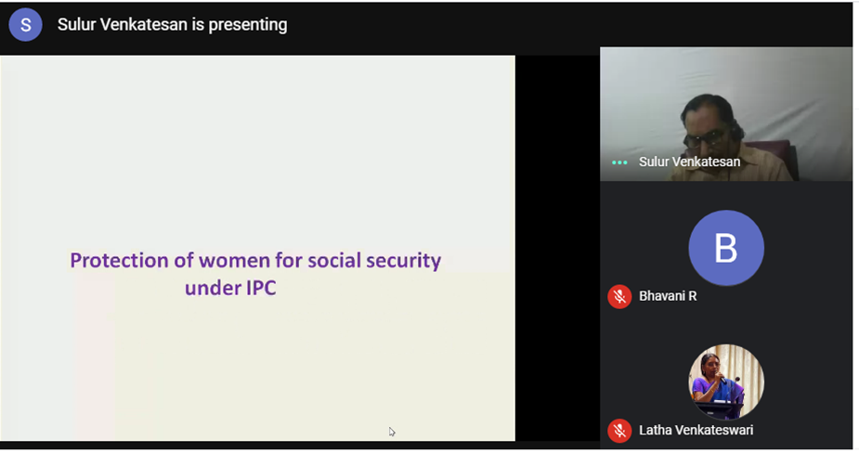

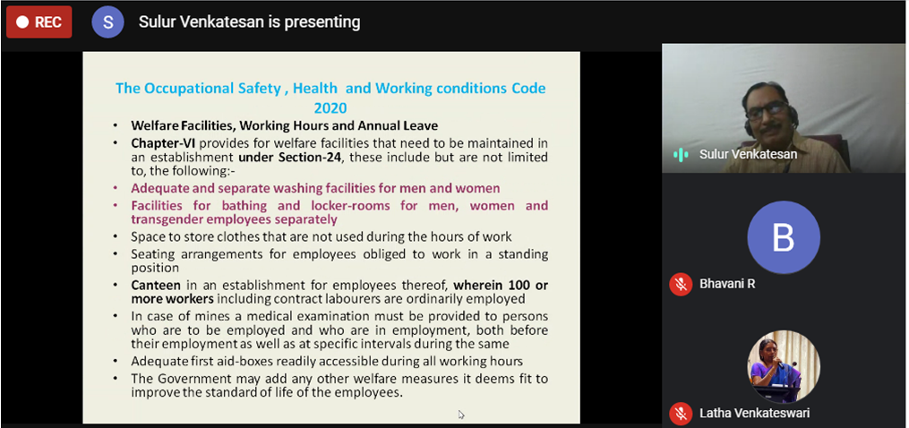

Video making contest on “Social Impact of Women’s Financial Independence” for students of GCT on October’ 2021

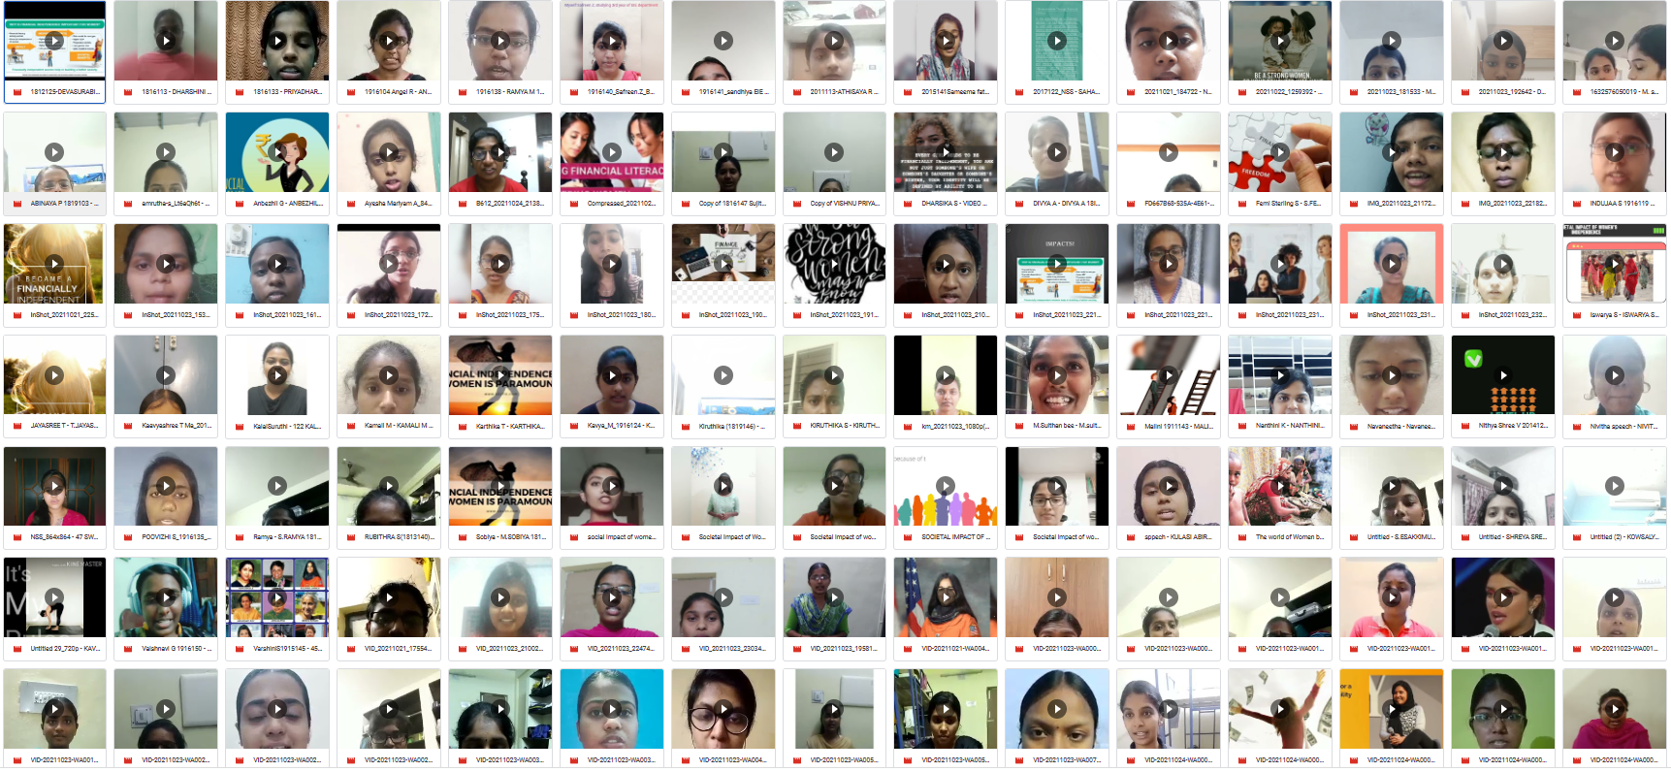
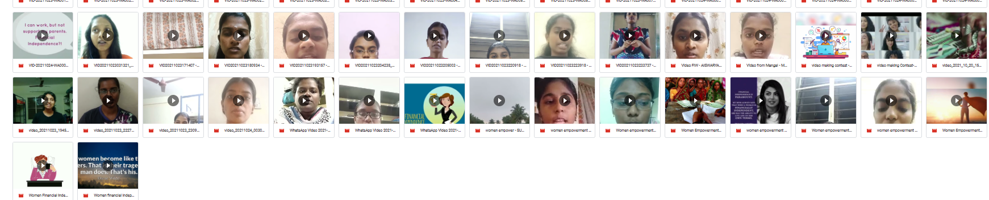

Logo Design Contests conducted on November’ 2021

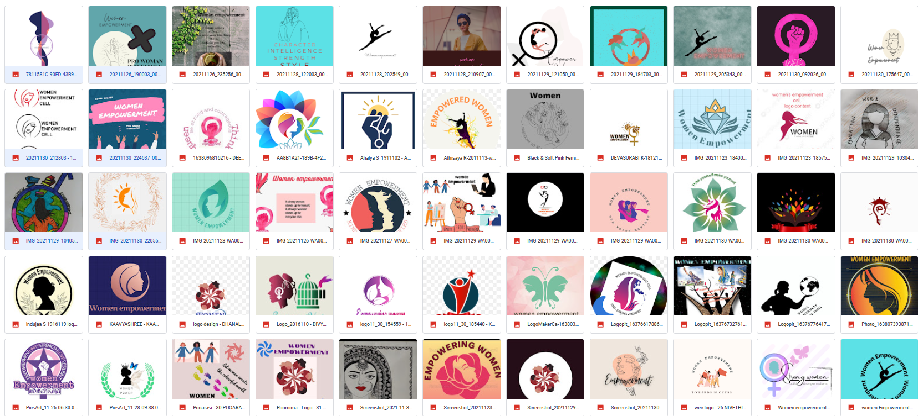
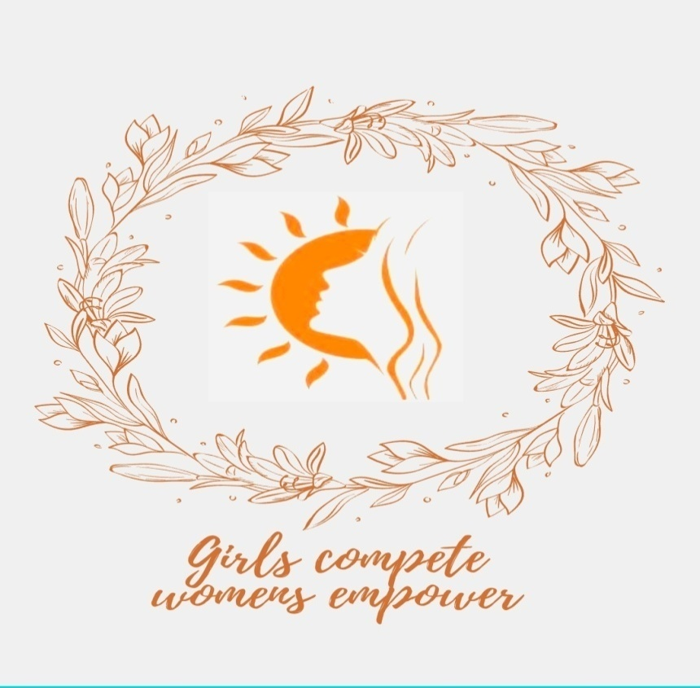 SOWBARNIGA K- II Year EIE

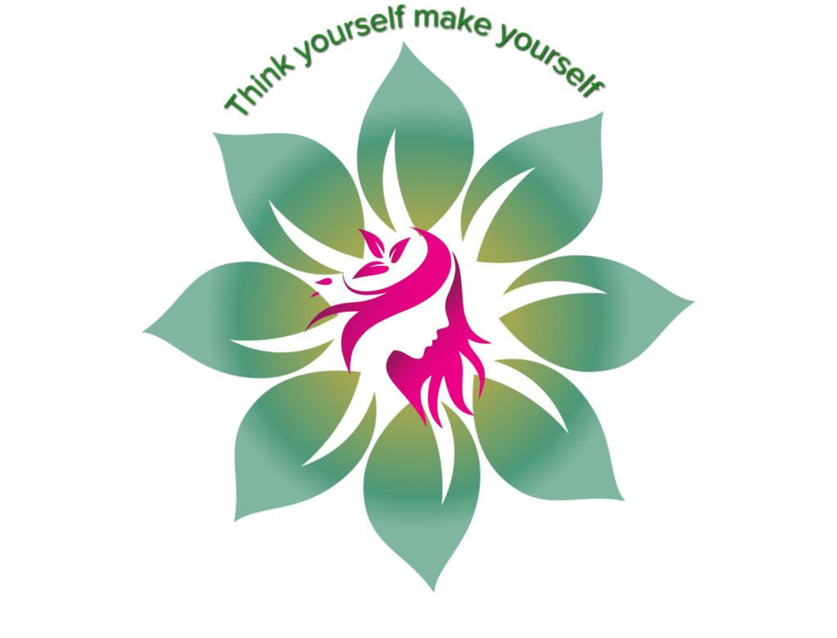V.SANTHIYA

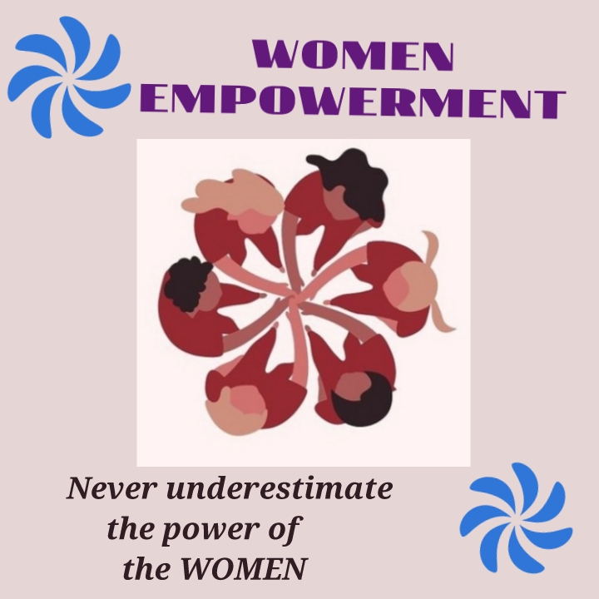

POORNIMA P –II Year Production Engg

Elocution-Conducted Onsite on 03.03.2022
Title: “Media News on Sexual Harassment – Observe, Explain and Solution”

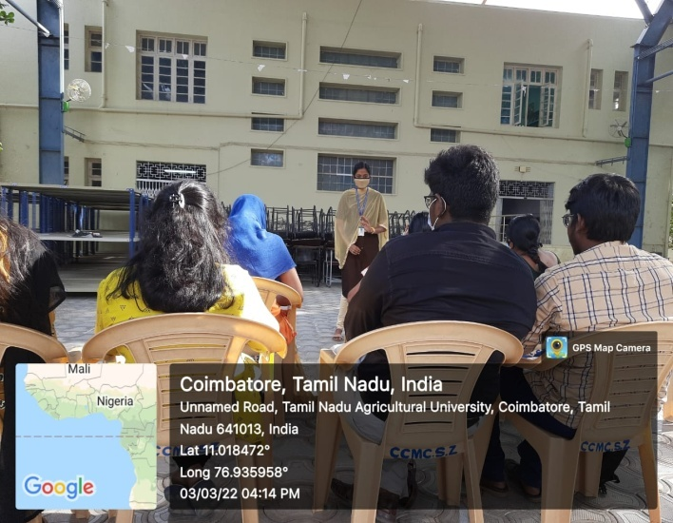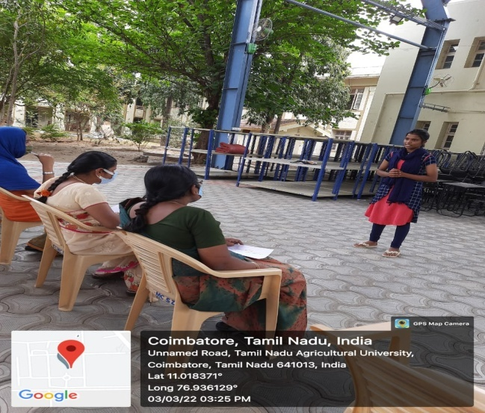
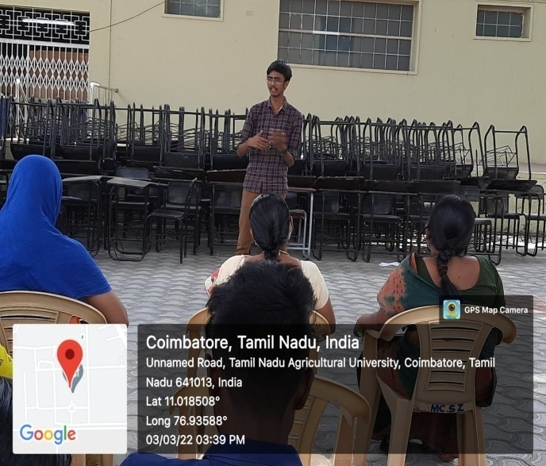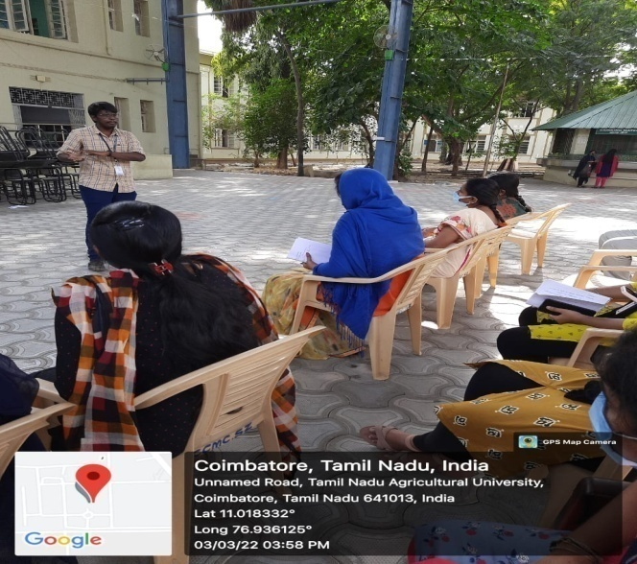

Rangoli- Conducted Onsite on 04.03.2022
Title: “Media News on Sexual Harassment – Observe, Explain and Solution”
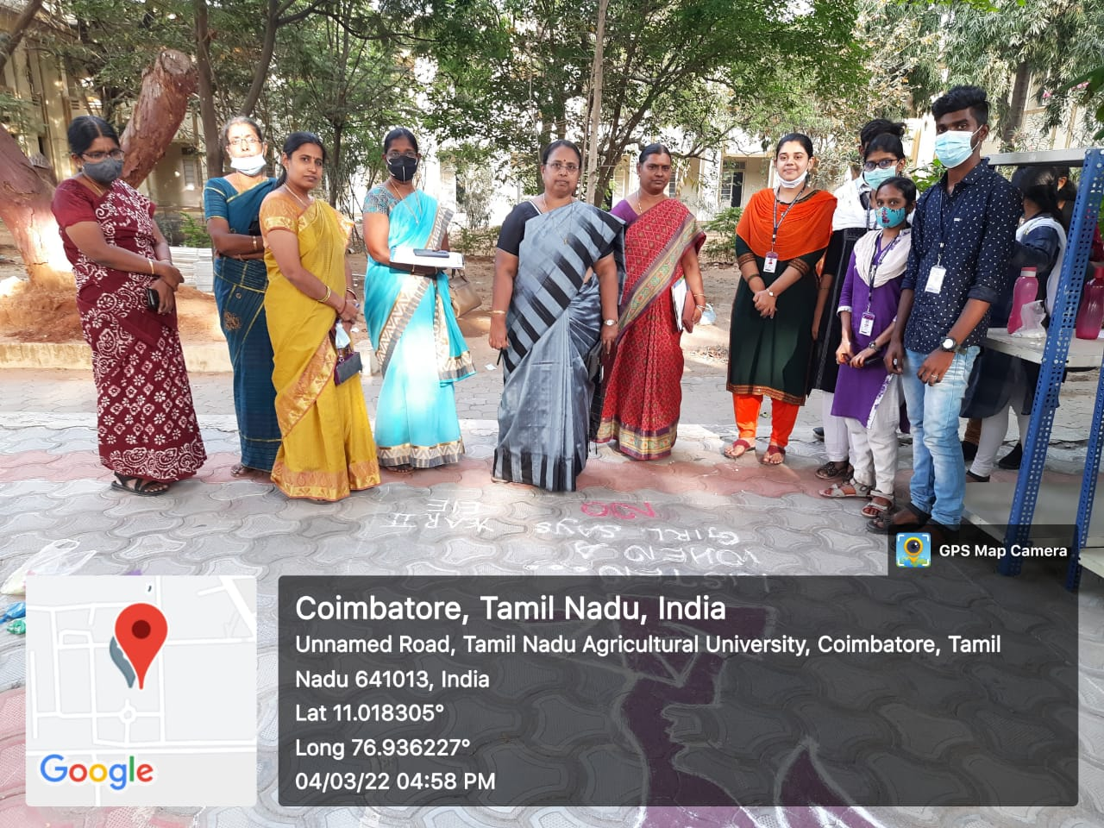
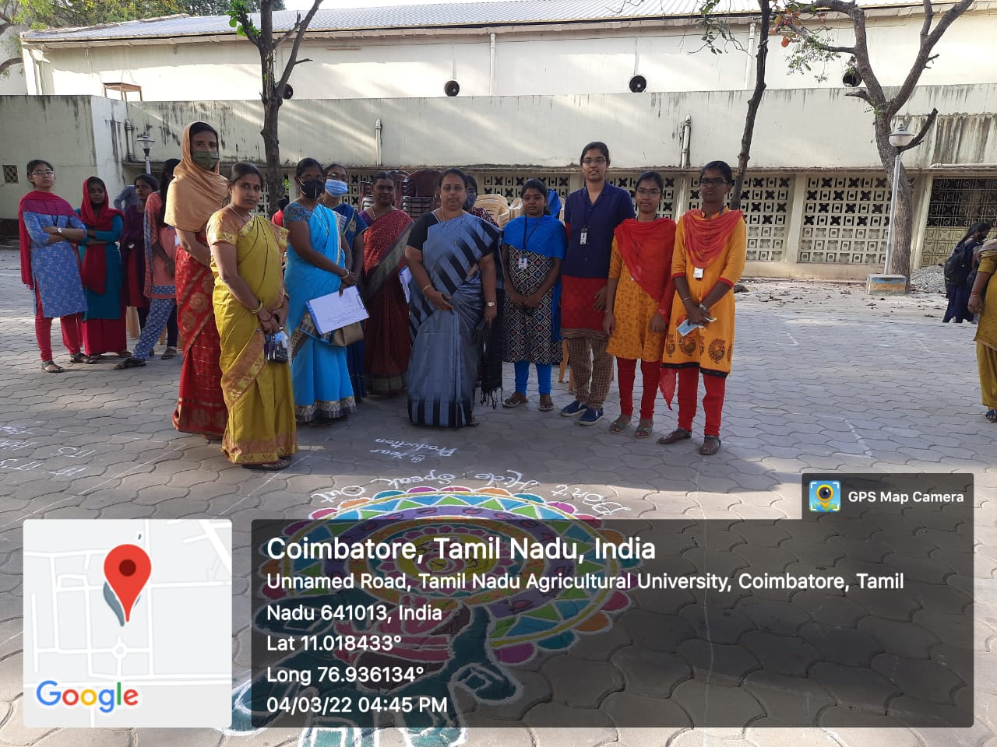
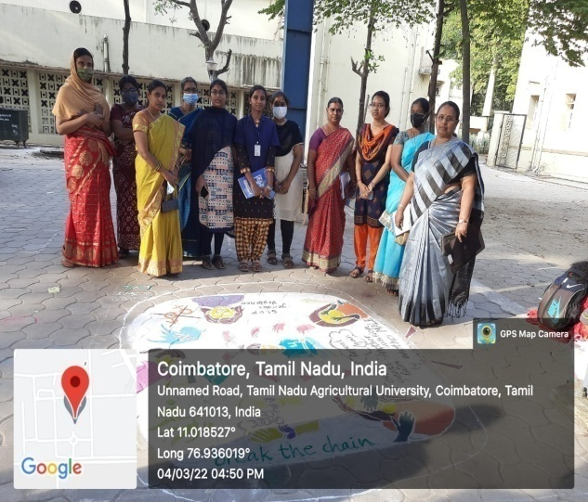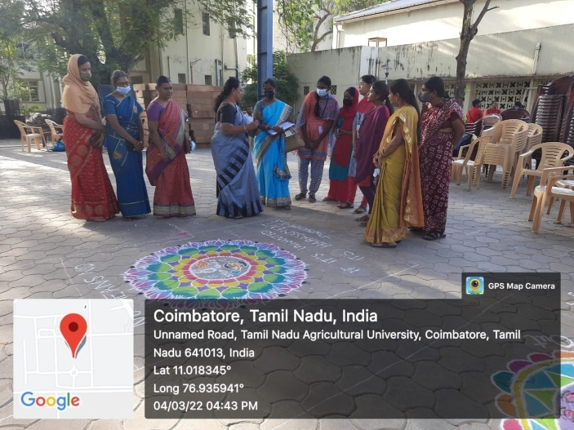
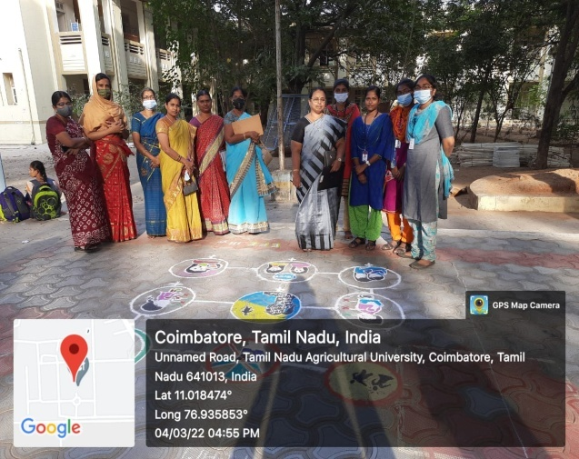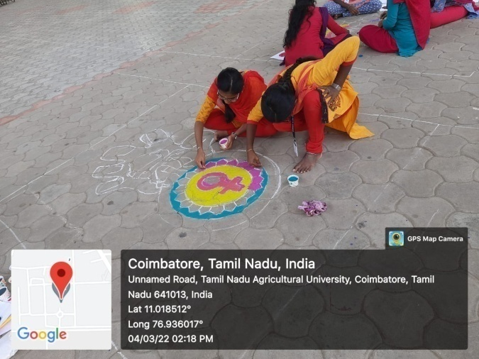

International Women’s Day Celebration on 07.03.2022
Venue: EEE Seminar Hall
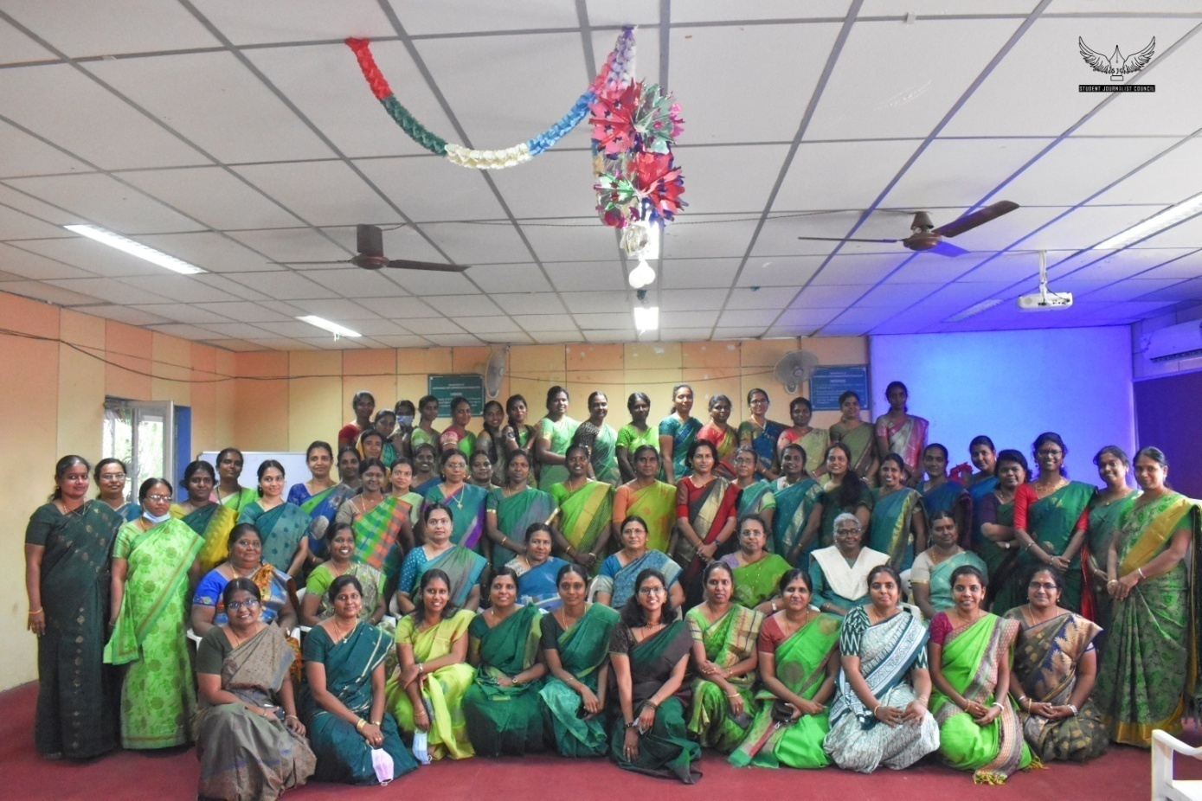
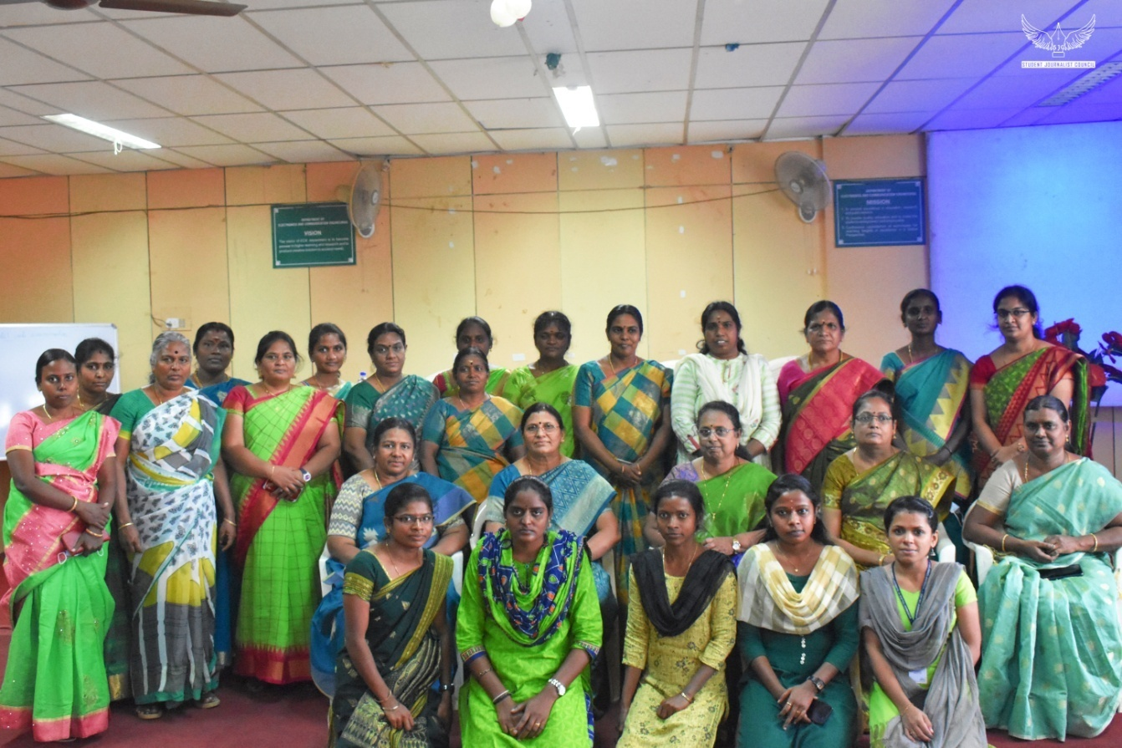
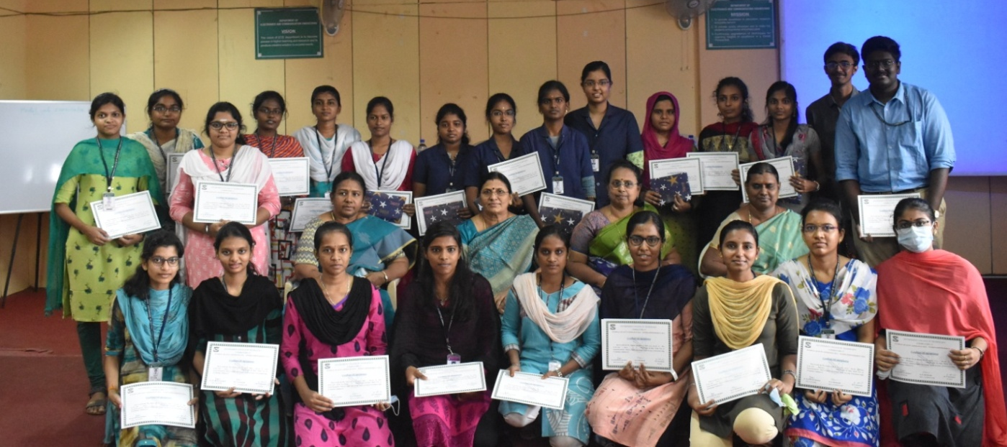

International Women’s Day Celebration on 07.03.2022-Fun Activities

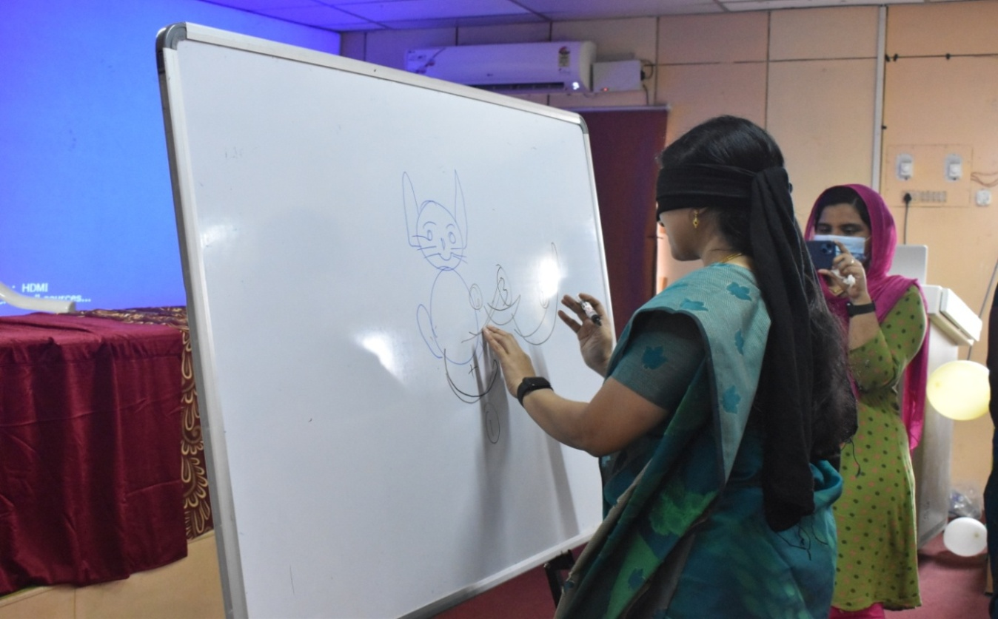
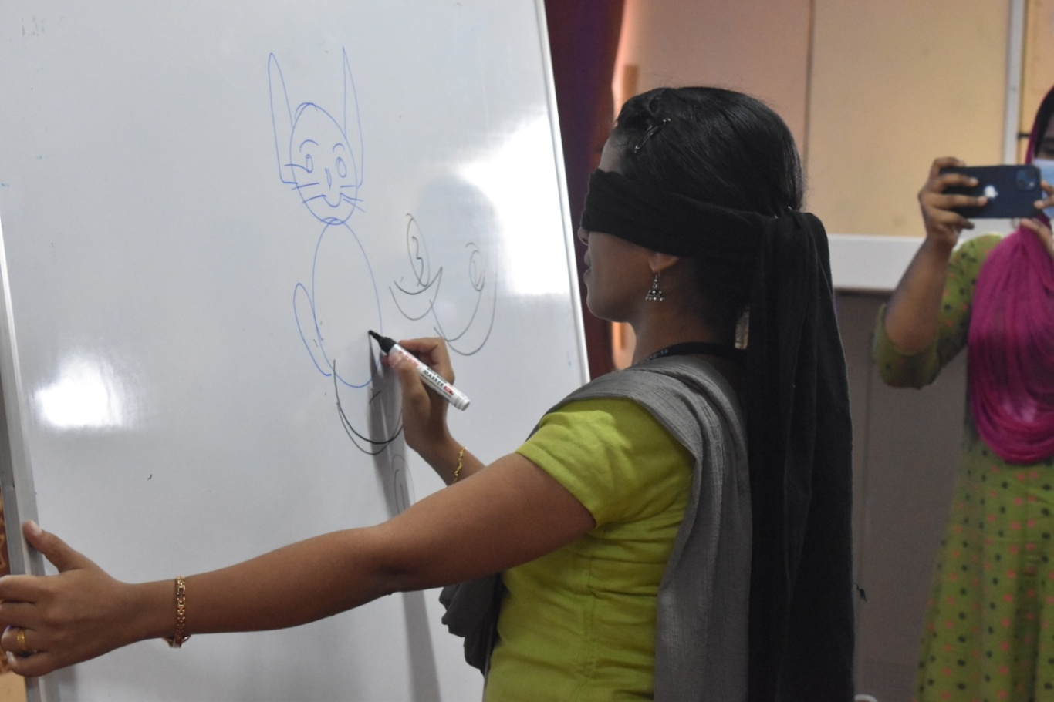
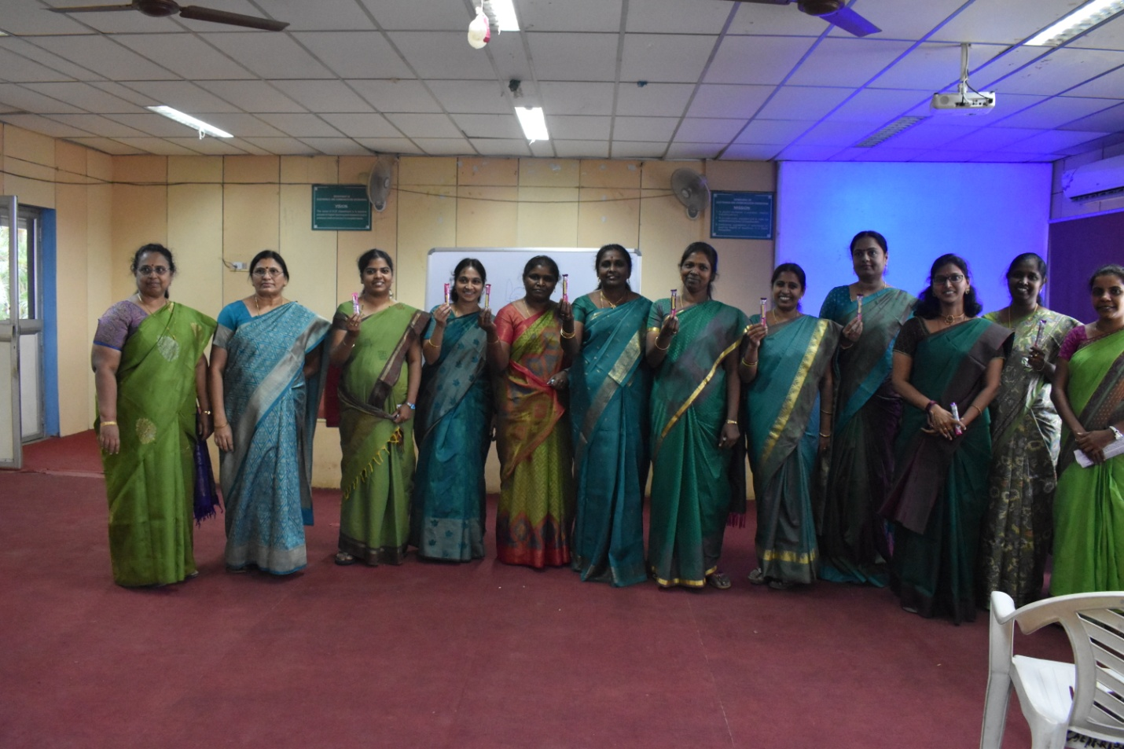
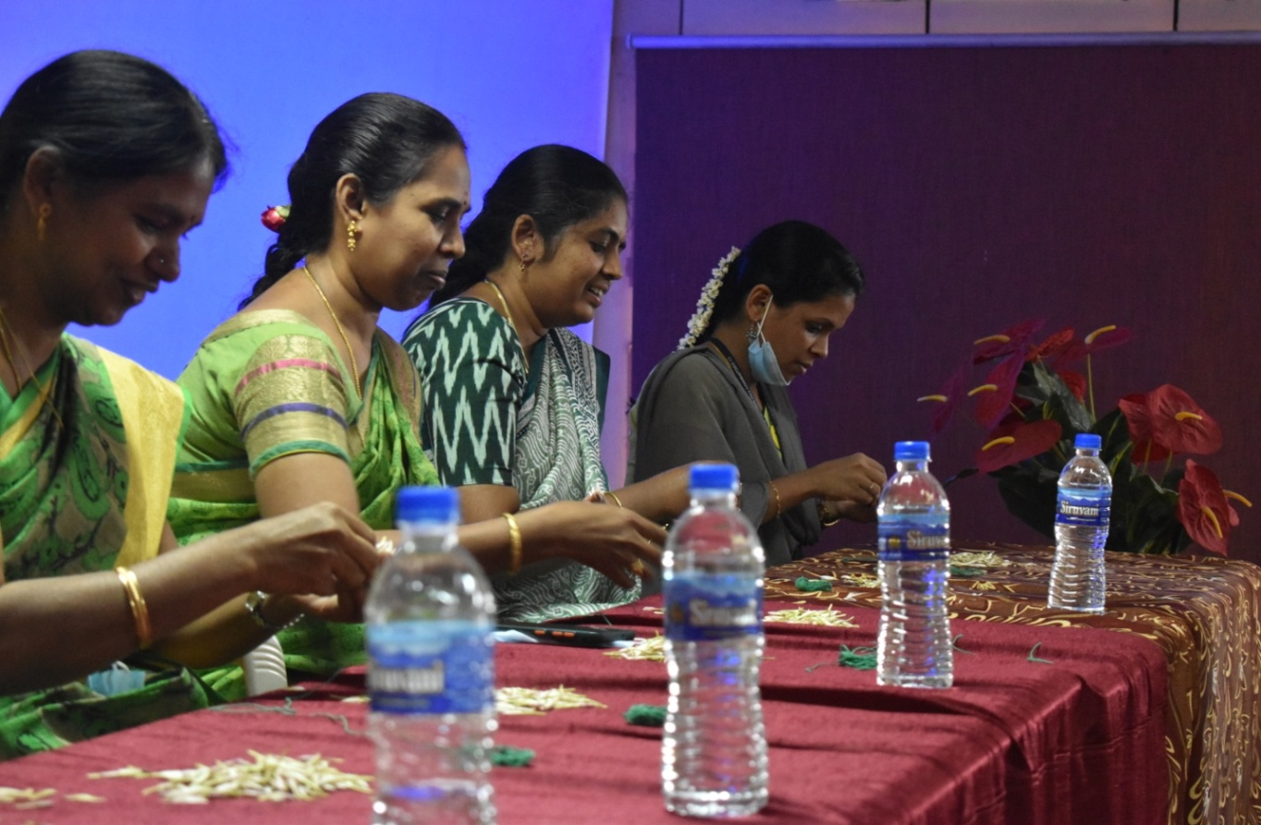
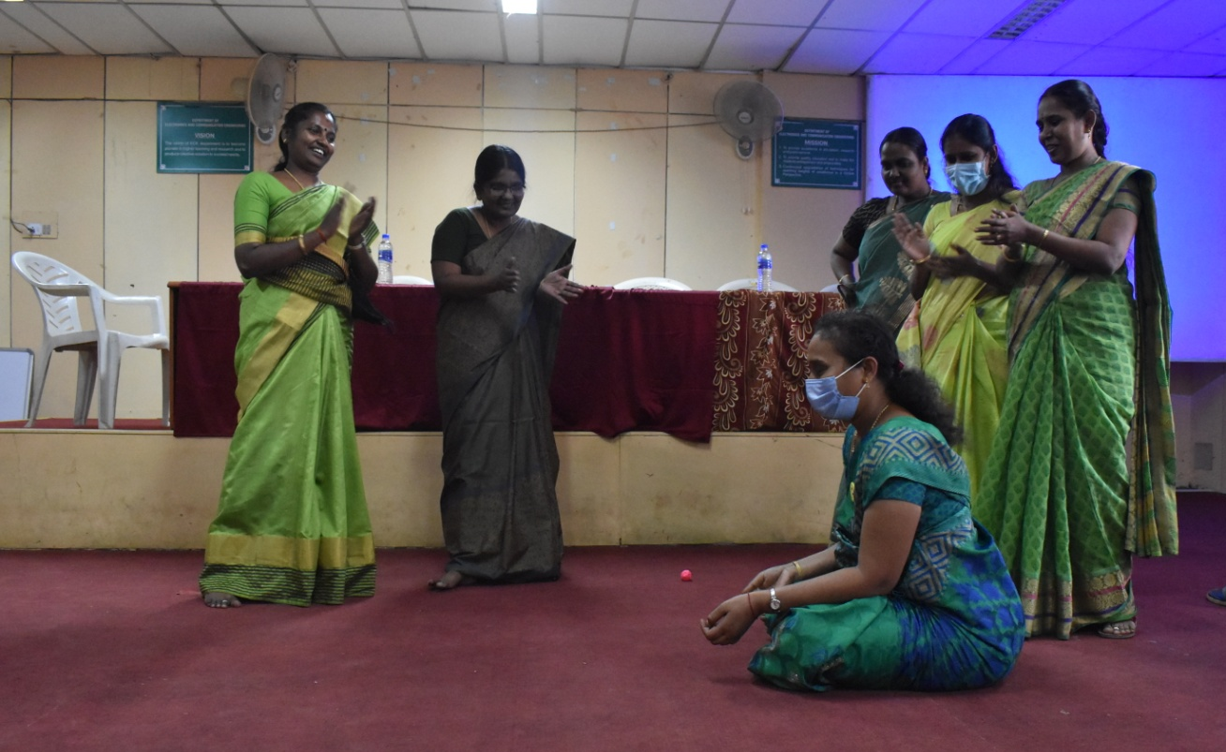

Webinar on “ஊக்கமது கைவிடேல்” for Women Teaching, Non-teaching and Ministerial Staff on 08.03.2022
Guest Speaker: GyanaAsiriyar G.A. Malarkodi B.E, M.Sc.
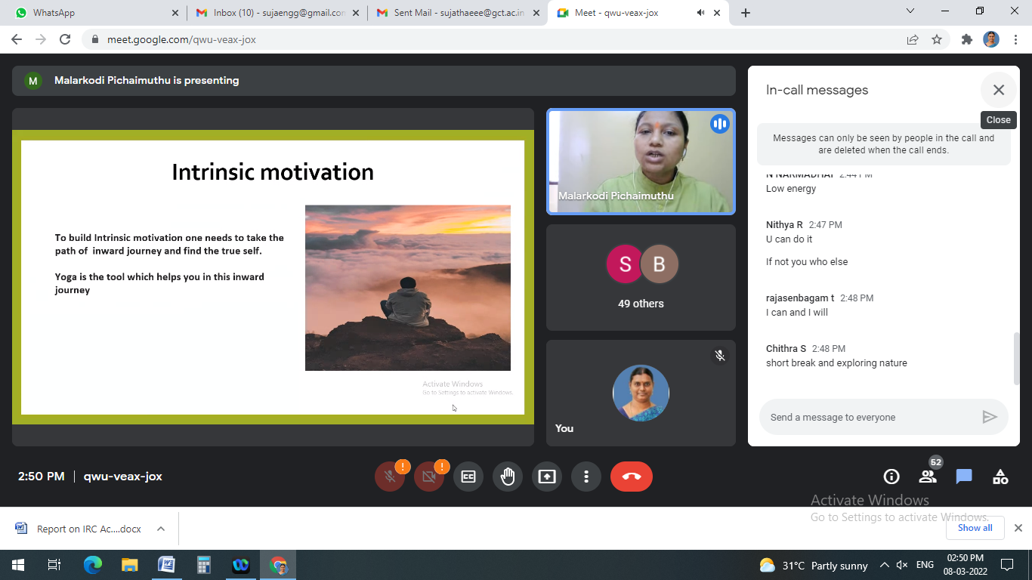

Debate
Topic “சுய பாதுகாப்பில் சிறந்தவர்கள் - சங்க காலப் பெண்களா நவீன காலப் பெண்களா”
Date: 22-03-2022
for students of GCT

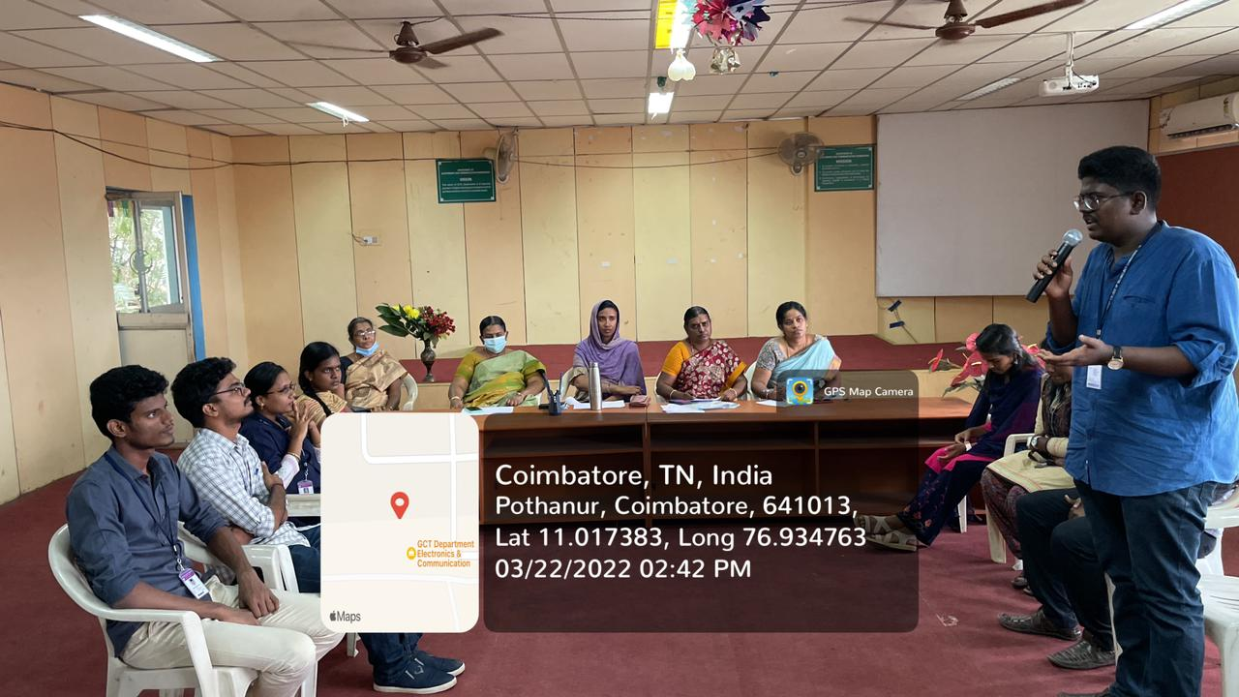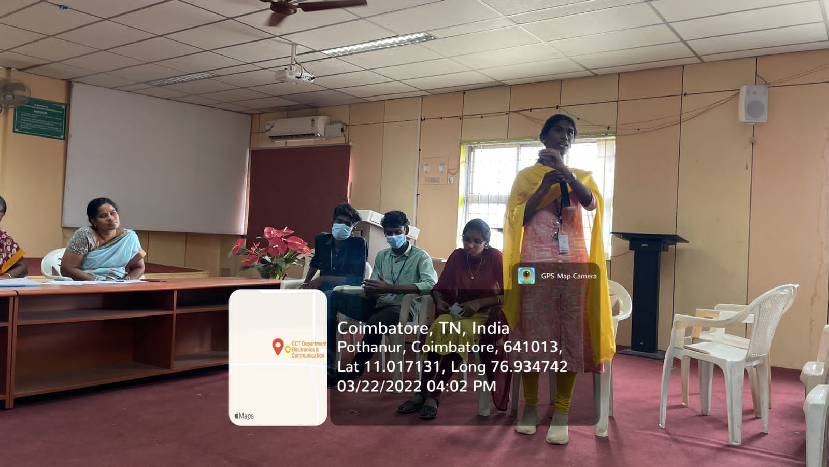
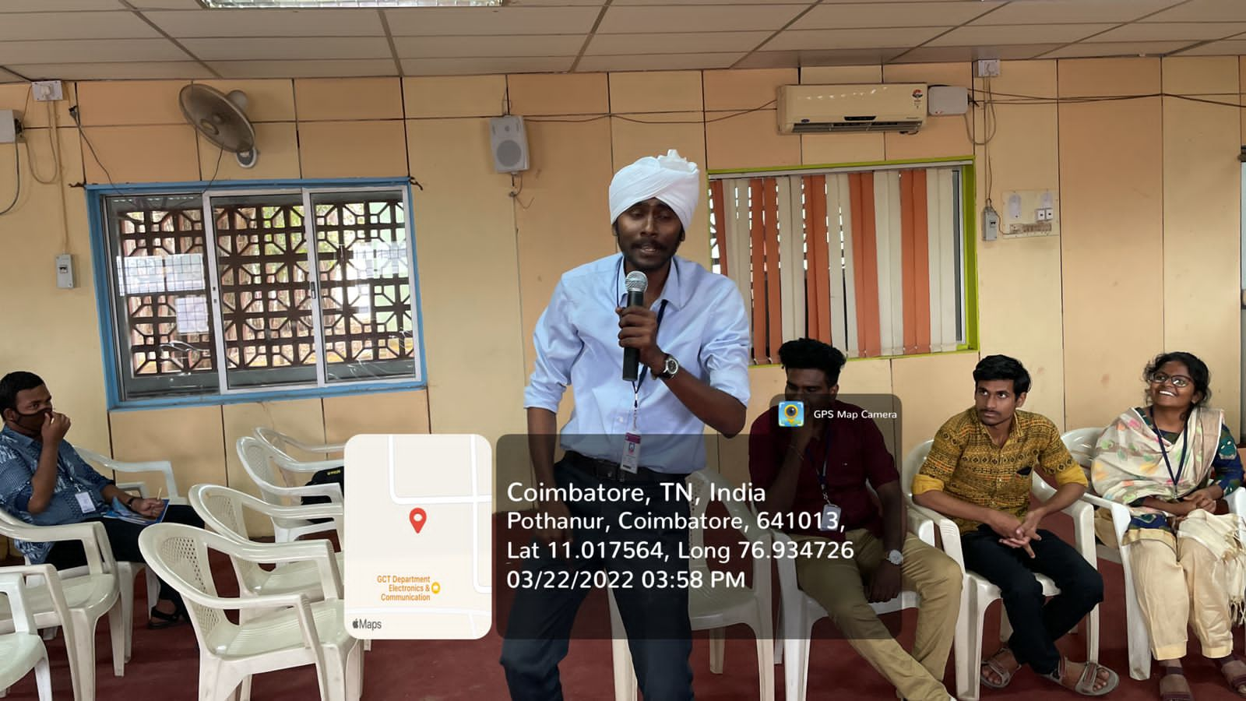

Mime on the topic “Child Trafficking” on 18.05.2022

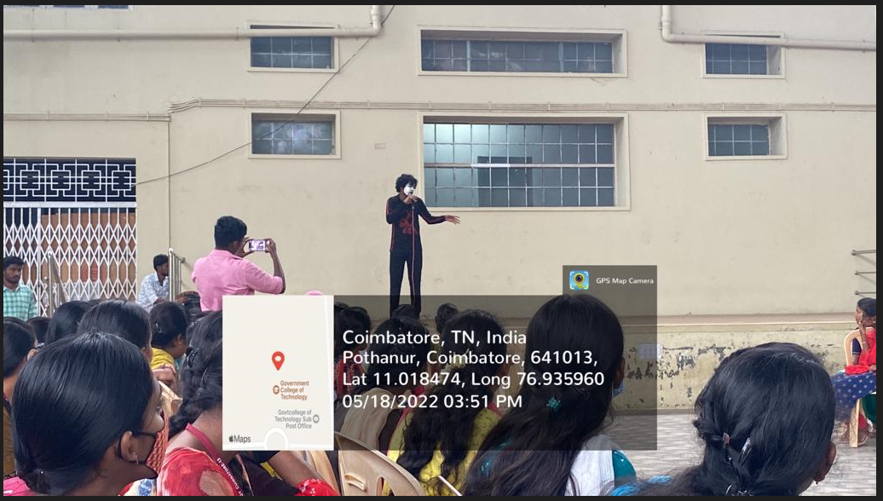
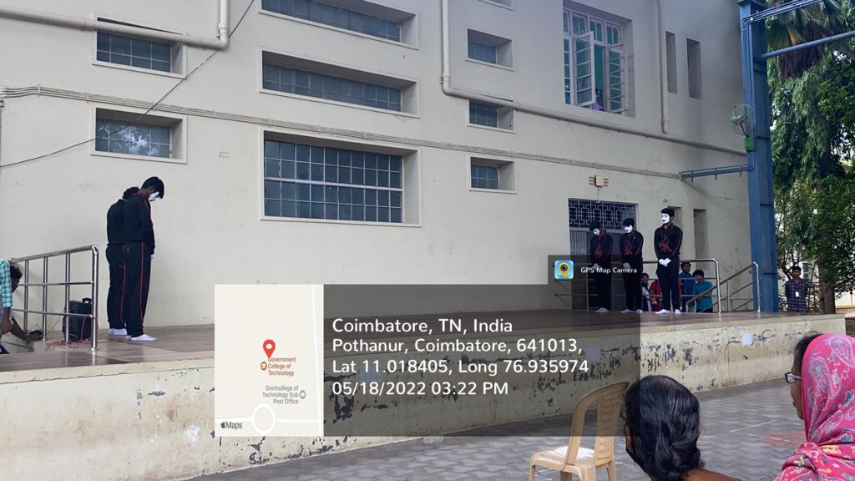

Skit on the topic “Women Harassment” on 18.05.2022

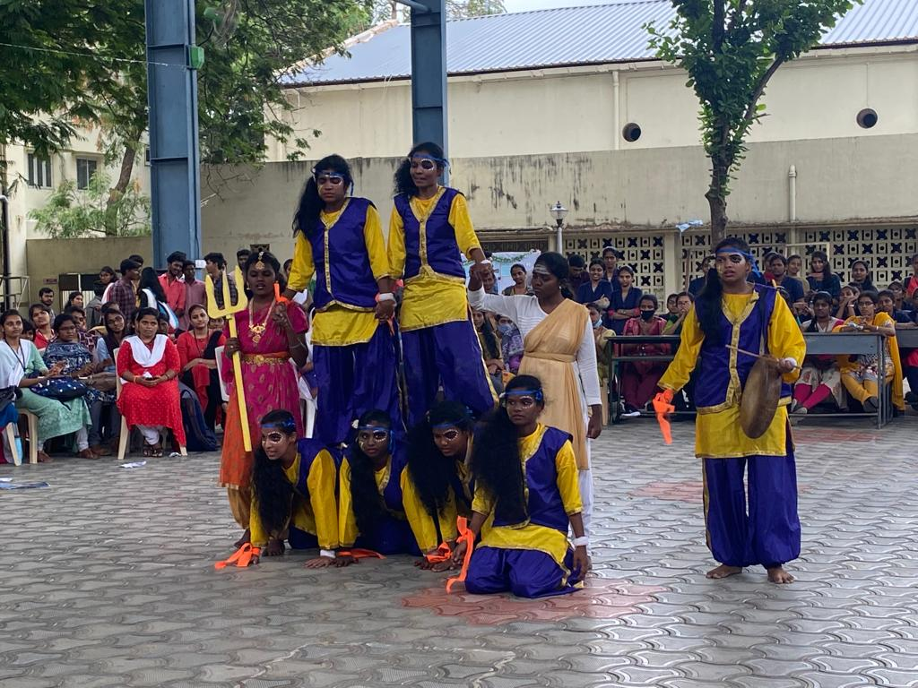
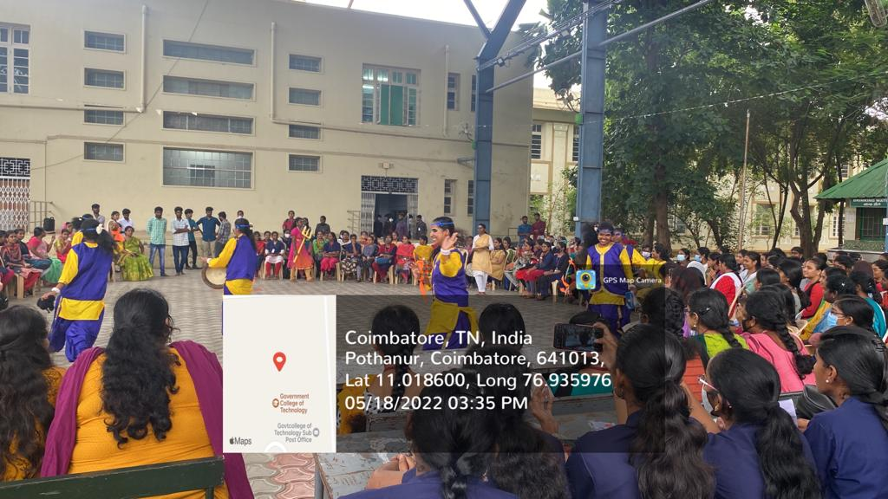

Awareness Programme on “ Lactation” for Teaching, Non-Teaching and Ministerial staff members on 04.08.2022
Speaker: Ms.Harshini C D
Certified Lactation Care Counselor and Lamaze Certified Childbirth Educator

