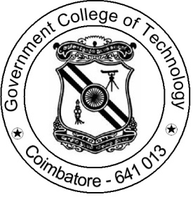

SOCIETY OF AUTOMOTIVE ENGINEERS

OFFICE BEARERS:
Faculty Advisor
Dr. S. PERIYASAMY
Associate Professor in Mechanical Engineering
Phone: 8754030606

Addnl. Faculty Advisor
Dr.A. SASIKUMAR
Assistant Professor in Production Engineering
Phone: 9486575333

Student’s Chair-Person
Mr. MATHEW ROJAR A
Final Year Mechanical Engineering
Phone: 9342280208

Student’sVice Chair-Person
Mr. PRAKASH K
Final Year Production Engineering
Phone: 9952077961

Student’s Treasurer
Mr. SAKTHI SARAVANAN V
Final Year Computer Science
Phone: 9655775678

Membership Count
Total Count | Male (30) | Female (07) | Total (37)
Mechanical Engineering | 16 | 01 | 17
Production Engineering | 07 | 03 | 10
Electrical and Electronics Engineering | 03 | Nil | 03
Electronics and Instrumentaion Engineering | 03 | 01 | 04
Electronics and Communication Engineering | Nil | 01 | 01
Computer Science Engineering | 01 | Nil | 01
Industrial Bio Technology | Nil | 01 | 01

