Government College of Technology, Coimbatore – 13
Society of Automotive Engineers – GCT
Screwtenizers Baja SAE Arizona Competition Results

Baja SAE® consists of competitions that simulate real-world engineering design projects and their related challenges. Each team's goal is to design and build a single-seat, all-terrain, sporting vehicle whose structure contains the driver. The vehicle is to be a prototype for a reliable, maintainable, ergonomic, and economic production vehicle which serves a recreational user market. The competition consists of both static and dynamic events, teams will be scored based on their performance in each and overall results will be published.

Due to concerns around the rapidly evolving coronavirus (COVID-19) pandemic, SAE International shifted the 2020 Baja SAE events onto a virtual platform. The competition happened online with static events alone during May- June 2020 and the results were published on 19th June, 2020
GCT’s Team Screwtenizers competed in the International Baja SAE Arizona event and secured overall 17th Rank among 98 teams all over the globe. The competition was organized online between May 26, 2020 and June 16, 2020 and had three static events: Cost Event, Design and Sales Presentation.

Results: https://www.bajasae.net/res/EventResults.aspx?competitionid=58bac15a-15d9-4896-8916-9c62fc6beee2&eventkey=DESN

Brief Summary of Results:
Overall World Rank – 17th (4th among Indian teams)
Cost Event Rank – 8th (1st among Indian teams)
Design Rank – 21st (6th among Indian teams)
Sales Presentation Rank – 27th (7th among Indian teams)

List of participated teams: https://www.sae.org/attend/student-events/baja-sae-arizona/teams

The competition had university participants majorly from United States, Canada and Mexico along with India, China, Egypt and South Africa. In total, 11 teams represented India, where Government College of Technology, Coimbatore was the only team from Tamil Nadu. This is was GCT’s first time participation in the International Baja SAE event.

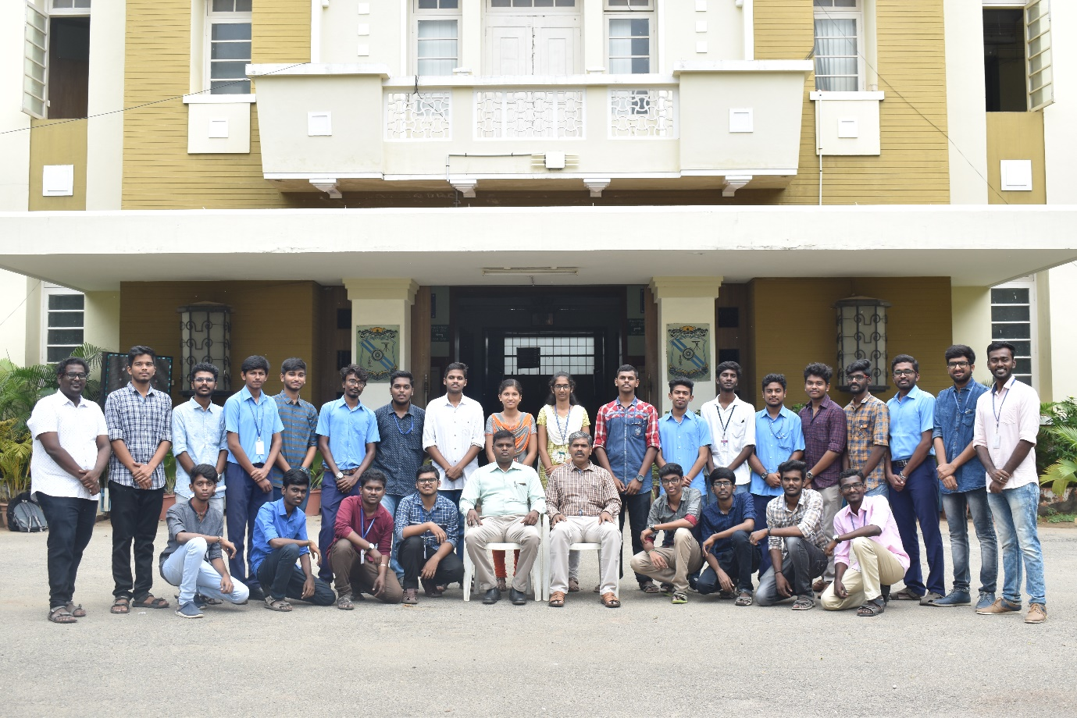
Screwtenizers 2020 Team

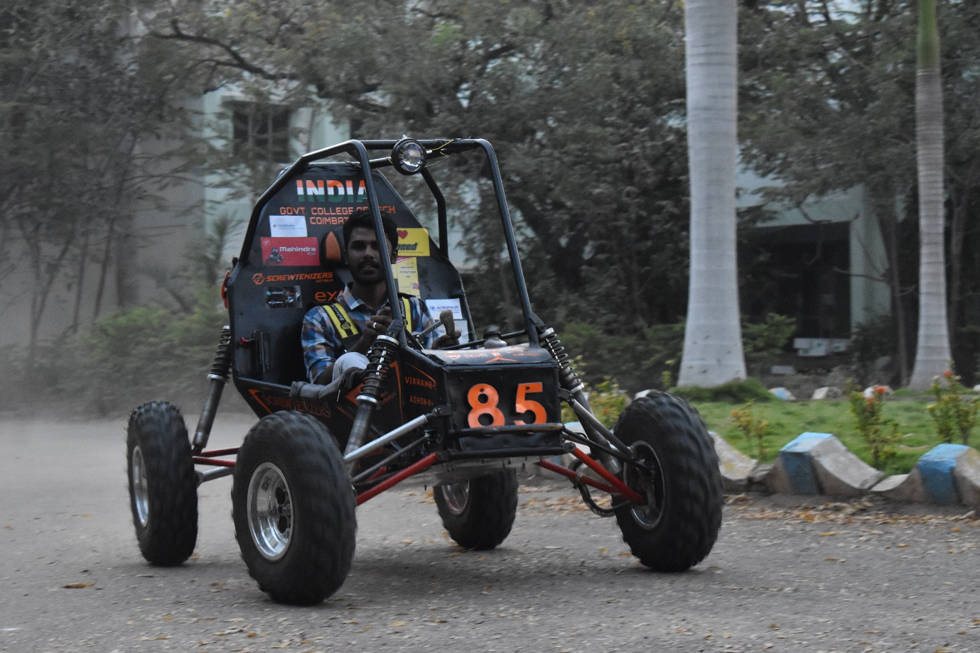
GCT Screwtenizers 2020 Car
Cost Event – 8th Position out of 98 teams (1st Position among India teams)
https://www.bajasae.net/res/EventResults.aspx?competitionid=58bac15a-15d9-4896-8916-9c62fc6beee2&eventkey=COST
The purpose of the Cost Event is to provide teams an opportunity to show the cost/benefit design decisions used in the prototype vehicle. The teams are evaluated based on the Cost BOM submitted and scored with respect to details, accuracy and engineering.
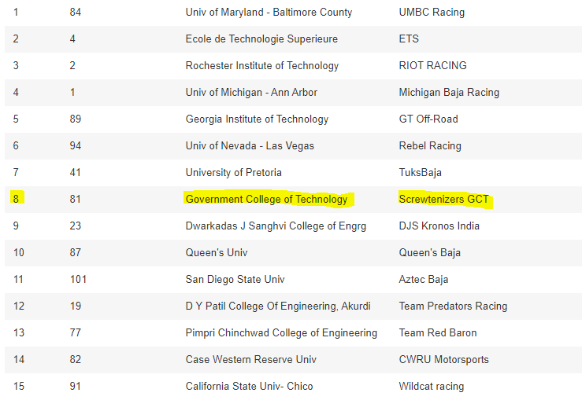

Design Award – 21st Position out of 98 teams (6th Position among India teams)
https://www.bajasae.net/res/EventResults.aspx?competitionid=58bac15a-15d9-4896-8916-9c62fc6beee2&eventkey=DESN
The objective of the engineering design evaluation event is to evaluate the engineering effort that went into the design of the vehicle and how the engineering meets the intent of the market Students will be judged on the creation of design specifications and the ability to meet those specifications, computer aided drafting, analysis, testing and development, manufacturability, serviceability, system integration and how the vehicle works together as a whole. Each of these parts of the engineering product development cycle will be judged within the following subsystems: Suspension, Steering, Brakes, Drivetrain/Powertrain, Chassis and ergonomics.
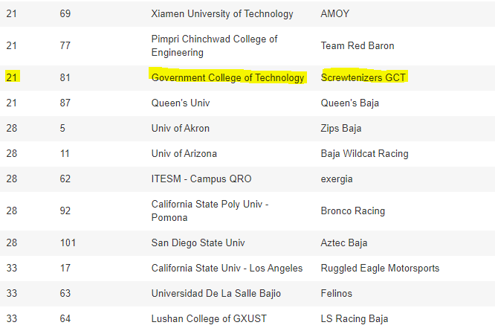

Sales Event - 27th Position out of 98 Teams (7th Position among India teams)
https://www.bajasae.net/res/EventResults.aspx?competitionid=58bac15a-15d9-4896-8916-9c62fc6beee2&eventkey=PRES
The objective of the Sales Presentation is for the team to persuade the “executives” of a hypothetical manufacturing company to invest in the team’s Baja SAE vehicle design, manufacturing, sales, and distribution. The teams will be evaluated based on the Business, Operation and Execution plan as well as the pitching skills.
