HYBRID VEHICLE CHALLENGE
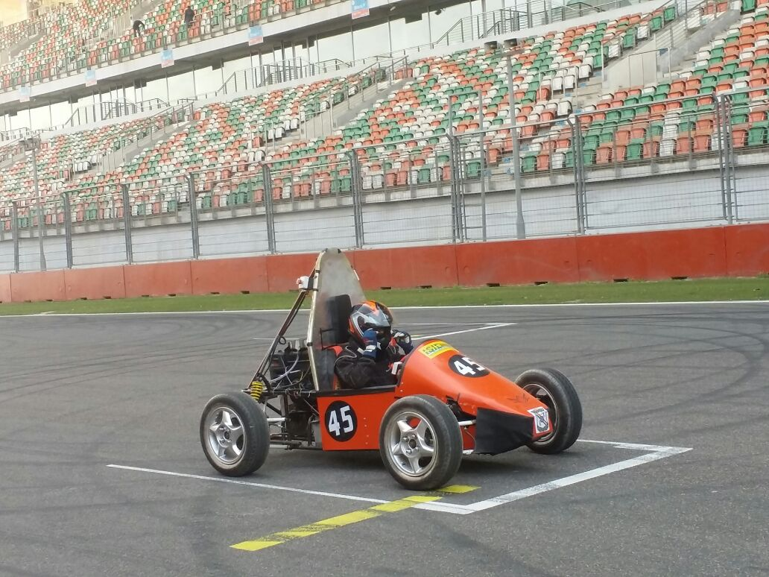
HVC – Hybrid Vehicle Challenge is an all powered vehicle where students are given a task to design and fabricate the most advanced current trend vehicle. The team “AATROX”representing the club participated in the event held at ‘BUDDH INTERNATIONAL CIRCUIT, NOIDA’. The team secured 2nd place in the virtuals among the Tamilnadu teams.

