GCT MOTORSPORTS
- EFFICYCLE:
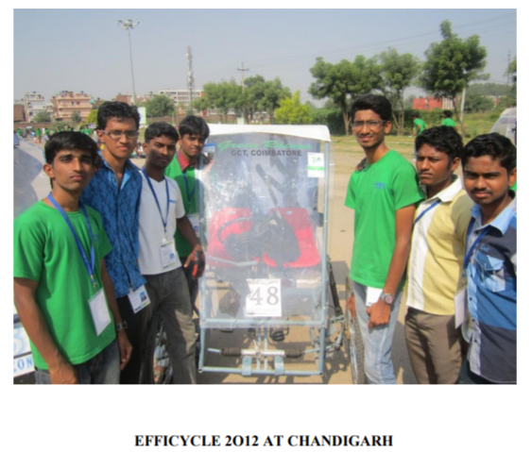
In October 2012 our SAEGCT efficycle team GREEN RHINOS participated in the final round of EFFICYCLE 2012. They had cleared all the endurance test successfully and also they secured a good position among the top 30 teams in India.
YEAR: 2016
Moving on this year, it has been a benchmark where our team “ESPERANZA”has secured the overall 3rd place in EFFICYCLE held at Lovely Professional University, Punjab.This team consist of 10 enthusiastic engineers whose constant efforts for 8 months made them to achieve this victory after 2 years.
And proud to state that this team also bagged the season award
“BUILD QUALITY AWARD”.
