Events during the academic year 2019-2020

- One day seminar on “Petroleum Conservation” for third year studentson 23-07-2019 conducted by Petroleum Conservation Research Association (PCRA) Coimbatore for third year EEE students. Co-ordinator : Dr.P.Maruthupandi

- Industrial Automation using IoT Conducted by Lema Labs, IIT MADRAS Research Park and Department of EIE. From 31.07.2019 to 02.08.2019. Total number of EEE students participated: 6 students from 2018-2022 batch and 6 students from 2017-2021 batch

- Industrial Visit to Padmavahini Transformers Pvt.Limited on 22.8.2019 for 2018-2022 Batch of 61 students accompanied by Dr.P.Maruthupandi and Prof.S.Sowkarthika

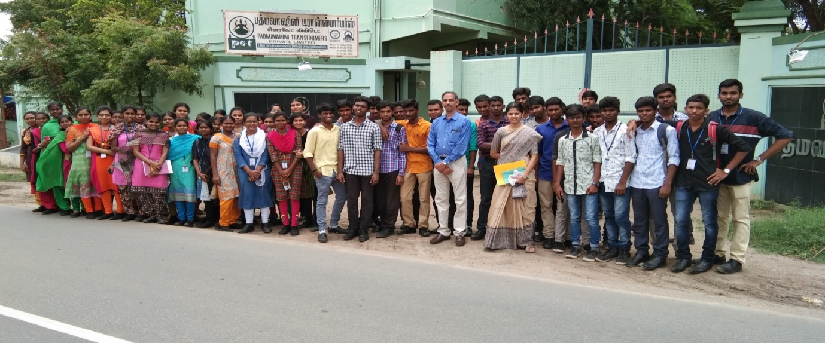

- Two week AICTE sponsored FDP on “Renewable energy grid integration : Challenges and solutions”, organized by Dept. of Electrical Engg. GCT,Coimbatore, from 20-11-2019 to 03-12-2019 for Faculty No.54, Co-ordinator : Dr.P.Maruthupandi

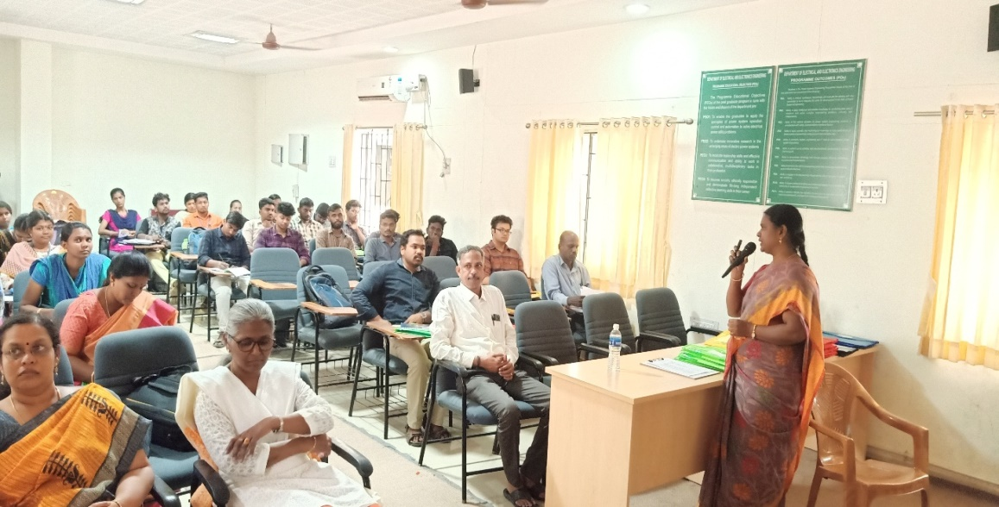

- Training for the students in soft skills, aptitude and logical reasoning
conducted by Business Development Manager, 2013 Alumnus Metaflex Doors India Pvt. Ltd. Bengaluru, on 13.01.2020.

Photographs - Training for the students in soft skills, aptitude and logical reasoning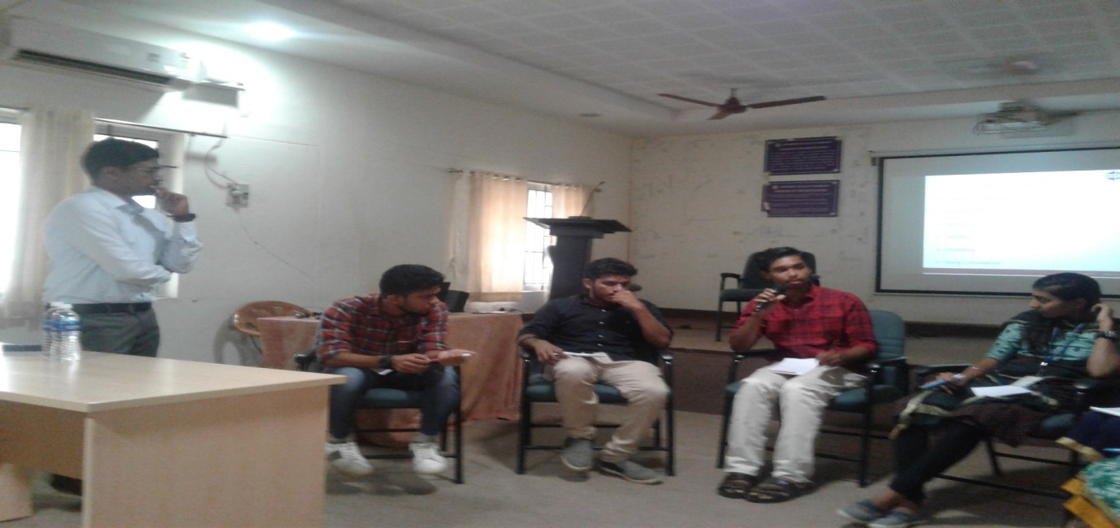

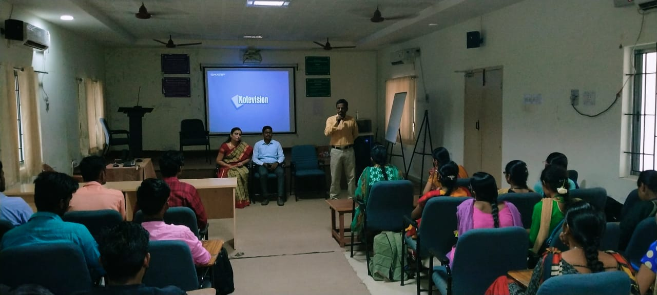

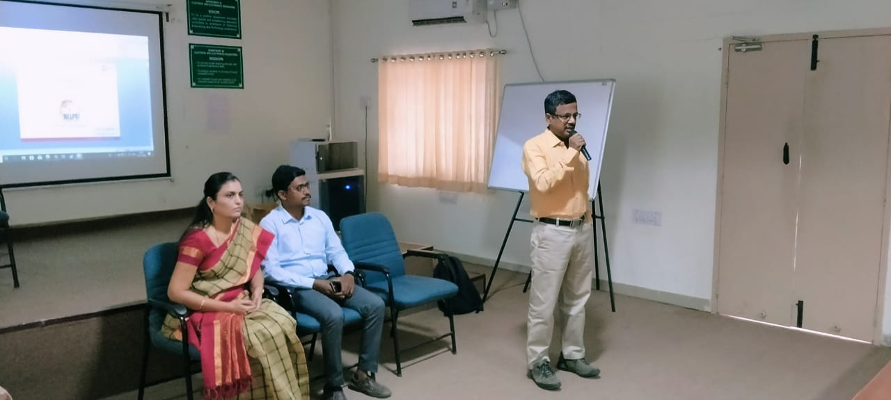

- TEQIP III sponsored 4-Days National Level Workshop on "Mobile & WiFi Controlled Robot & Humanoid Walking Robot" for EEE (III year- 66 and II year- 53 ), E & I, ECE, CSE and IT students. Technically conducted by EduxLabs (Esoir Business Solution LLP Gurugram) in association with IIT, Roorkee.
Co-ordinators:Dr.Sujatha Balaraman/EEE, Mrs. Wincy Pon Annal/EIE, Mrs. Raja Shenbagam/CSE and Mr. Gladson Oliver/IT
Date: 7-10, Jan 2020 Beneficiaries: Male - 105 ; Female - 92 ;
Total – 197

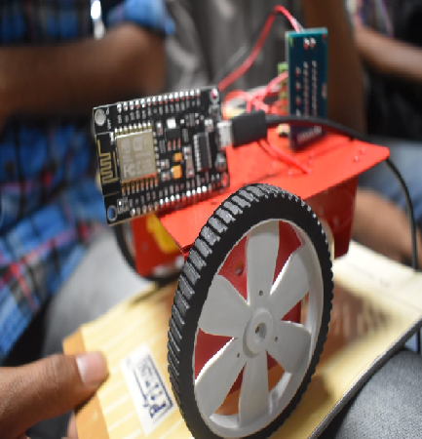

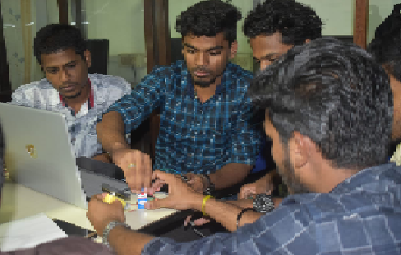

- TEQIP-III sponsored one day workshop on “Hands on Training on Numerical Relay Development Board” Feb 2020, Co-ordinator: Dr.R.Rajeswari

- Industrial Visit to Kerala Electrical and Allied Engineering Co.Ltd, Cochin on 6.3.2020 & 7.3.2020 with 60 students.(2017 to 2021 Batch)

- TEQIP III sponsored two day workshop on computational intelligence techniques for distributed generation systems-Hands on training with MATLAB, 09-3-2020 and 10-3-2020 for I and II year PG students and research scholars Co-ordinator : Dr.P.Maruthupandi

- TEQIP III Sponsored two day workshop on “Computational Intelligence techniques for Distributed generation systems-Hands on training with MATLAB”, 09th and 10th March 2020 for I and II year PG-Power Systems Engg. and Power Electronics & Drives students and Research Scholars.
Co-ordinators: Dr. Sujatha Balaraman and Dr. P.MaruthuPandi

- TNSG Sponsored 3 day online FDP on "Research Avenues in Smart Power Grid Technologies" 28.5.2020 to 30.5.2020 (online mode), Co-ordinator: Dr.R.Rajeswari

SITARC VISIT BY FACULTY MEMBERS:
Under the leadership of Dr.E.Latha Mercy HOD/EEE along with Dr.R.Rajeswari, Dr.K.Yasoda ,Dr.P.Maruthupandi, Dr.S.Chitra and Prof.S.Sowkarthika from EEE department visited SITARC - Scientific and Industrial Testing and Research Centre, Coimbatore on July 30.2019 to setup Electrical Motor Testing at EEE laboratory, GCT. Visit to SITARC, gave them an opportunity and it was insightful to setup Electrical Motor Testing Unit at GCT.

