7.2. Two Best Practices Implemented by the Institution

BEST PRACTICE

- Title of Practices:

Experiential Learning and Practical Approach in Teaching Learning Process

- Objectives of the Practice:
- To promote direct industry links with the departments and improve in-plant training, industry visits, field/site visits, industry projects, and internship opportunities for students.
- To train and meet out the students the industry readiness requirements.
- To design industry-oriented curricula to meet the requirements and incorporate the most recent technologies into the syllabus.

- The Context:
- Industrial experts are involved in the Board of Studies, Programme Advisory Committee, Board of Governance, Smart Hackathon Selection Committee Members, Programme Evaluation committee.
- Expert Members are invited for special lectures and Chief Guest for various technical programmes for the benefit of students.

- The Practice:
- 13 MoUs have been signed with industries in the recent 5 years.
- Students are regularly visiting construction and structural industries to get field exposure. Students are undergoing 4 weeks industrial training with government funding assistance.
- The department takes up consultancy projects for various government, semi government departments and private organizations. These include material property testing, Stability of buildings, monitoring of various construction works, building design and vetting, Soil investigation, GPS Surveying and water quality testing etc.
- These practices bring out collaborative research as mentioned in NEP 2020 policies.
- The students after their internship /industrial training are informed to submit report to the departments.

- Evidence of Success
- Students are also involved in Non-destructive testing techniques of Retaining wall for strength and stability analysis, Soil Nailing and Underpinning project works under the guidance of industrial experts in addition to the internal guide.
- Faculty Members and Students are involved in Real Time Analysis and Design of structures like Residential, Hostel, Commercial, Institutional and Pre Engineered Buildings.
- The total number of students undergone internship / industrial training as shown below are one of the evidence of success.
Sl. No. | Type of Industrial Activity | Academic Year | No of Students Undergone Training \ Project
1 | Internship (BE Civil) | 2018-19 | 116
2 | Internship (BE Civil) | 2019-20 | 96
3 | Internship (BE Civil) | 2020-21 | 121
4 | Internship (ME Environmental) | 2022 | 2
5 | Internship (ME Geotechnical) | 2022-23 | 6
6 | Internship (ME Geotechnical) | 2022-2023 | 15

- As Teaching-Learning resources, real scale models of all structural, Geotechnical, Hydraulic models are available in the Campus which were constructed in the year 1971. All the students of Civil Engineering branch were taken to the model yard by faculty members for the respective courses.

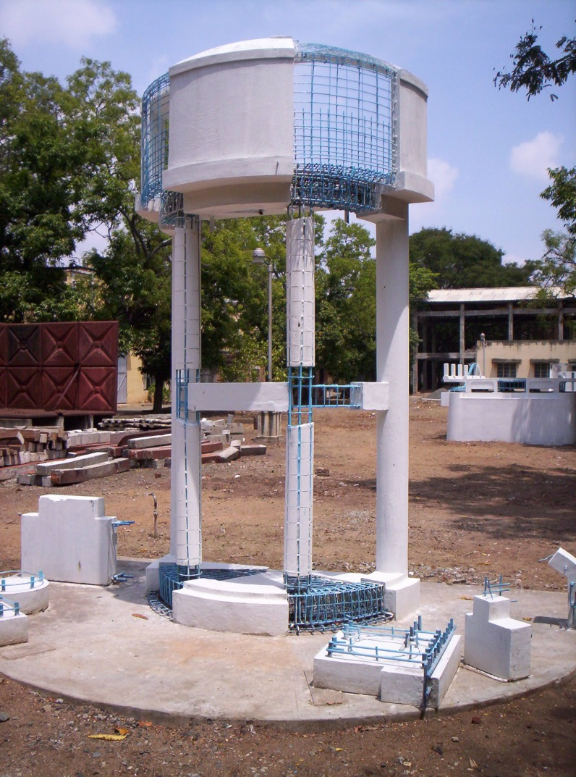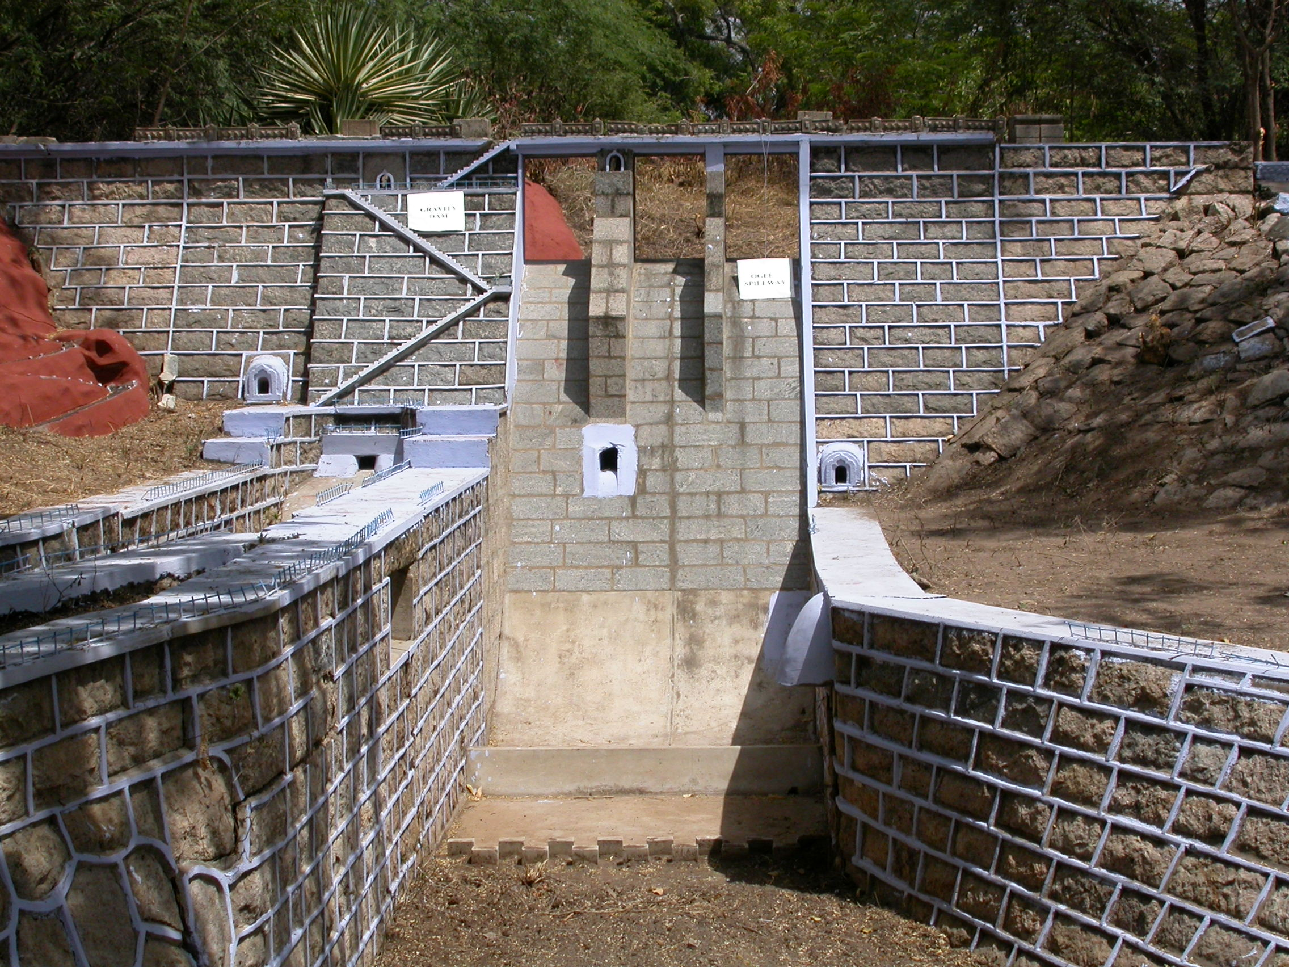

Intze tank model Gravity dam model
- Problems Encountered and Resources Required

More training programmes along with industries may be arranged for faculty members. This helps in bringing the issues faced by the industry into the curriculum.

