7.2.1. Describe two best practices successfully implemented by the Institution as per NAAC format provided in the Manual.

Best Practice I
1. Title of Practices
Earn While Learn
2. Objectives of the Practice
• To impart field exposure and practical knowledge through testing and consultancy works.
• The goal is to employ research students and PG Students to work in the Testing and Consultancy services along with faculty members.
• To get familiarity in the Analysis and Design of various structures, Stability Analysis, Inspection and Rehabilitation, Borehole Soil Investigation, Third Party Inspection, GPS Survey, Sewage Treatment Plant design, Water Quality testing, Air Quality Monitoring, Testing of plant material extraction, design of conventional and machine foundations, Design of pavements, Stability analysis of retaining structures, Ground Improvement Techniques, Water treatment plant, Segregation machinery and refinement machinery supply and erection work of dry solid waste management.
3. The Context
• This paves way for earning and makes the student community to solve complex field problems.
• It helps to face societal challenges and to solve current issues by giving solutions to recent industrial problems.
• The institute helps in finding solutions to the various problems with the help of recent technologies and modern equipment.
• This leads to contribution towards sustainable development goals by way of involvement in practical issues.
• It improves Industry Institute Interaction as mentioned in NEP-2020 policy.
• This helps technology transfer from theoretical knowledge/practical skills to the field.
• This connects academics and industry, which is the need of the day.

4. The Practice
• Faculty members and students are involving in the analysis and design of various structural work and consultancies related to wastewater sample analysis.
• Testing procedures as per IS standards, analytical skills as per permissible limits are followed, that will improve the report writing capability.
• Consultancy projects help to understand the challenges real-world problems/complex field problems.
• Honorarium is given to students, faculty and staff members from the revenue generated through Internal Revenue Generation (IRG).
• It develops partnership between industry and institute.
• Also, this kind of activities helps them to shine well in on - campus and off – campus interviews.
• The experts from different industries regularly visit our institute and interact with students about the engineering challenges encountered in the field. This exercise helps the students to understand the application of theoretical concepts in practical problem solving.

5. Evidence of Success
• In the last 5 years, on an average amount of Rs. 5,00,00,000/- (rupees five crore) has been generated as IRG through consultancy services from various organizations like government, quasi government. The details of the consultancy amount per year is shown in the below graph.
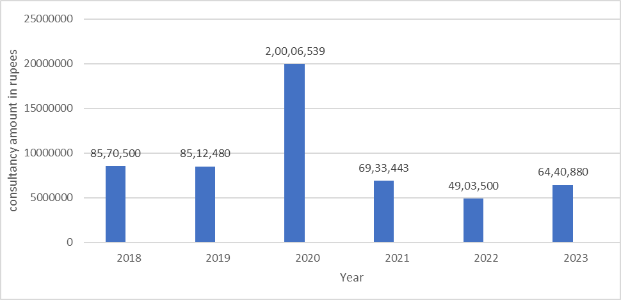
• Students gained field exposure, instrument handling exposure and practical knowledge also. The success of the best practice of earning while learning is the honorarium for students by involving them in the consultancy and testing works.
6. Problems Encountered and Resources Required

• Equipment’s/ Machinery needs to be maintained regularly for testing of materials; specimen testing of project works.
• Purchase of different kind of Software used in practice become essential.
• Additional fund should be maintained to service the equipment.
• Trained person related to consultancy work should be available to finish the assigned work in stipulated time.
• Validation of reliability of the analysed data should be done by experts in the relevant field.

BEST PRACTICE II

1. Title of Practices:
Experiential Learning and Practical Approach in Teaching Learning Process
2. Objectives of the Practice:
· To promote direct industry links with the departments and improve in-plant training, industry visits, field/site visits, industry projects, and internship opportunities for students.
· To train and meet out the students towards the industry readiness requirements.
· To design industry-oriented curricula to meet the requirements and incorporate the most recent technologies into the syllabus.
3. The Context:
· Industrial experts are involved in the Board of Studies, Programme Advisory Committee, Board of Governance, Smart Hackathon Selection Committee Members, Programme Evaluation committee.
· Expert Members from different industries are invited for special lectures and Chief Guest for various technical programmes for the benefit of students.
· These processes will be helpful for the students to get sponsorship for their SAE project.
4. The Practice:
· Society for Automotive Engineers (SAE) is an International organization with its motto “The engineering society for advancing mobility Land Sea Air and Space” is serving as a platform for students to explore globally and to cope up with the advancements in the techno- world.
· It is a professional engineering society which guides its members to imbibe the fundamentals and applications of the engineering field.
· The students from different engineering disciplines such as Mechanical, Production, Electronics & Communication and Electronics & Instrumentation Engineering actively participated in SAE events.
· The following are the different events conducted through SAE club:
1. SAE-Efficycle
2. SAE-Baja
3. SAE-Tractor Design Challenge
4. Effi-car
5. ISIE-HVC (Hybrid Vehicle Challenge)
6. ISIE - GOKART
5. Evidence of Success:
· The SAE team won the first price in 2018 & 2019 and second price in 2020 for the Tractor Design Challenge.
· The total numbers of students from different engineering disciplines were involved in the SAE activities shown below are one of the evidence of success.

S. No. | Type of Activity | Academic Year | No of Students involved in Project
1 | SAE | 2017-18 | 109
2 | SAE | 2018-19 | 49
3 | SAE | 2019-20 | 77
4 | SAE | 2020-21 | 30
5 | SAE | 2021-22 | 19
6 | SAE | 2022-23 | 30

6. Problems Encountered and Resources Required

· More training programmes along with industries may be arranged for faculty members and students. This helps in bringing the issues faced by the industry into the curriculum aspects.
· Getting sponsorship for making prototype models is difficult.
· Hands-on training should be conducted periodically to enlighten the knowledge of the students. This requires separate funds and staff members.

