7.1.4 - Water conservation facilities available in the Institution:

- 1. Rain water harvesting

- 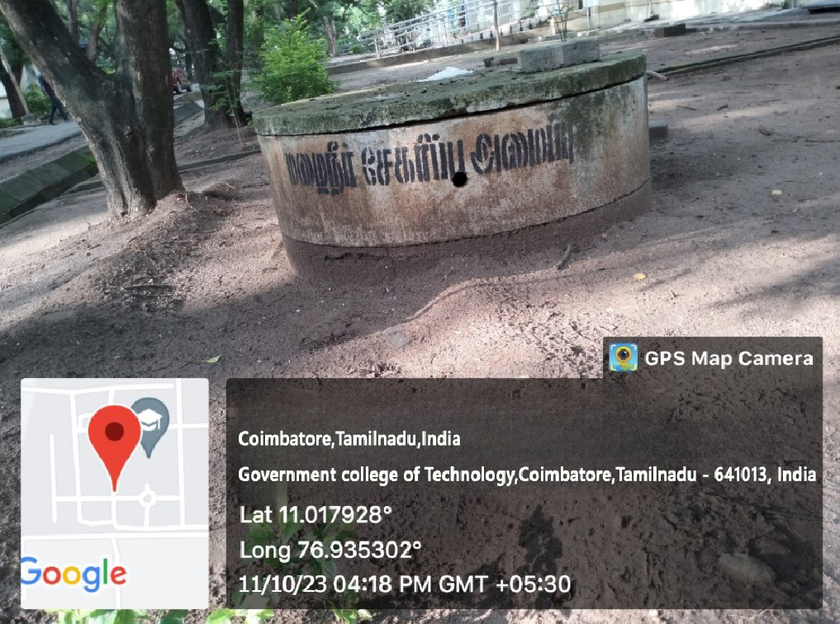

- 2. Bore well /Open well recharge
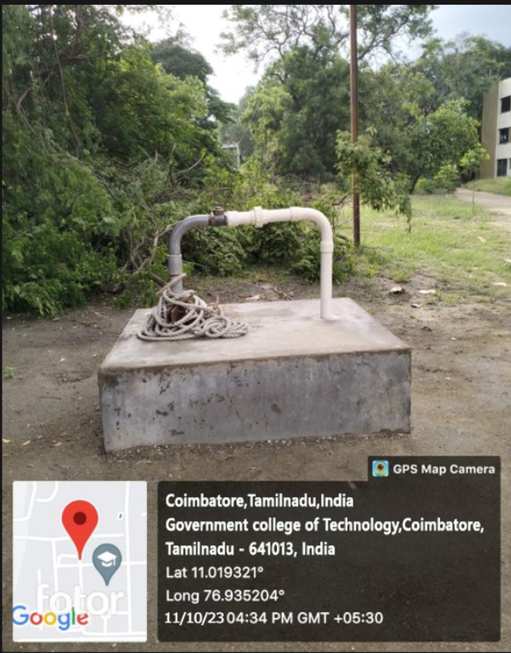

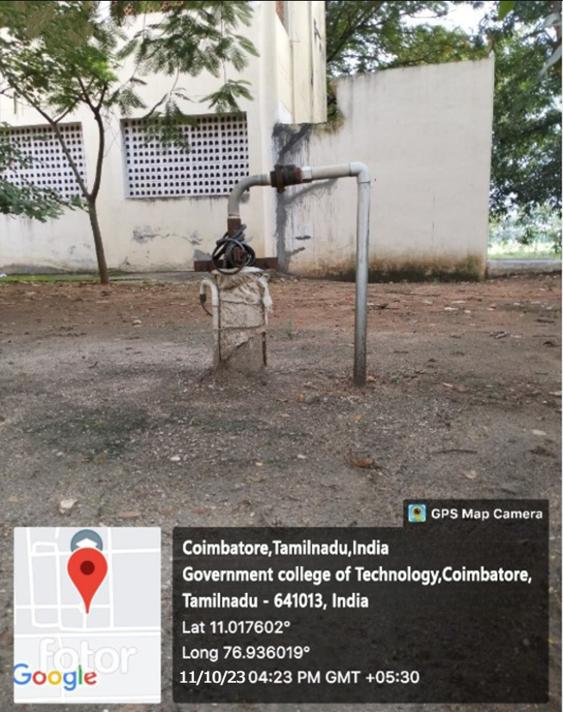

3.Construction of tanks and bunds
