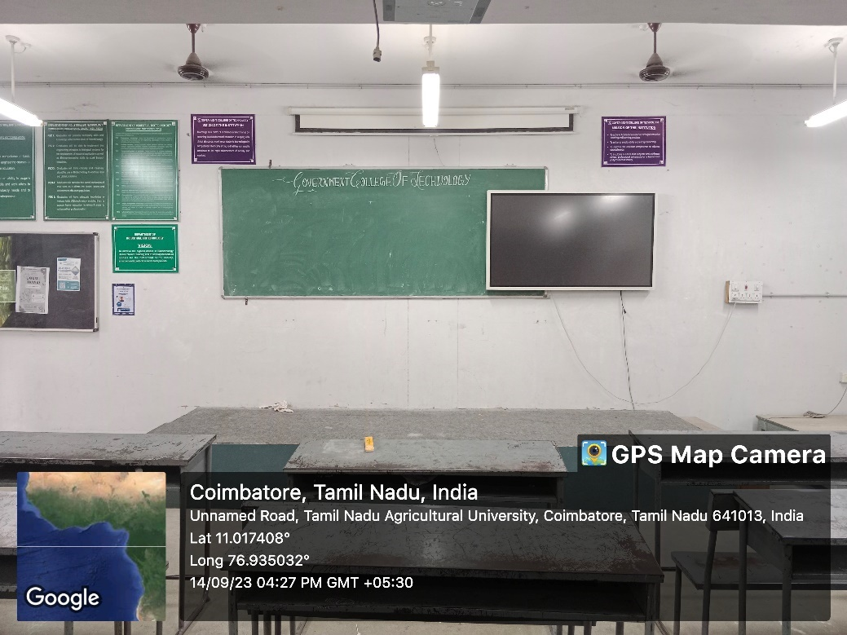
IBT CLASS ROOM

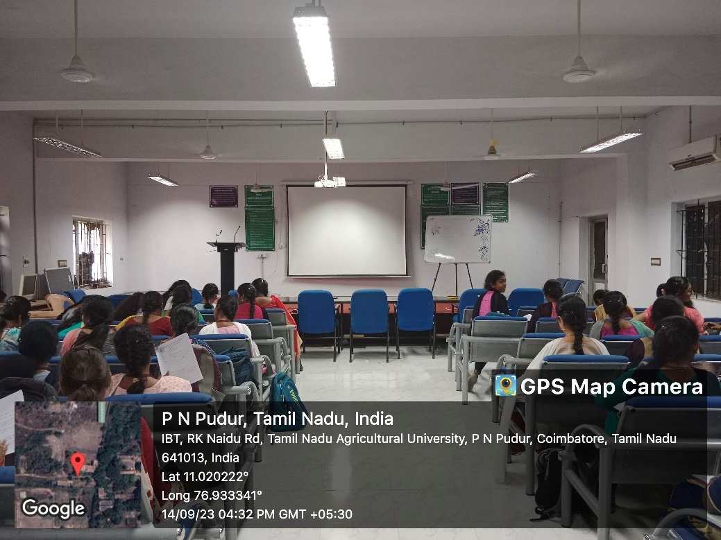
IBT SEMINAR HALL

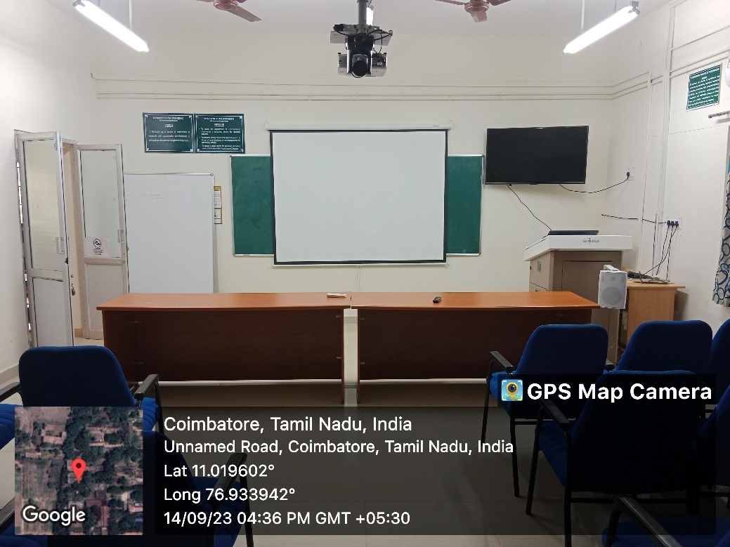
PG ENVIRONMENTAL CLASS ROOM
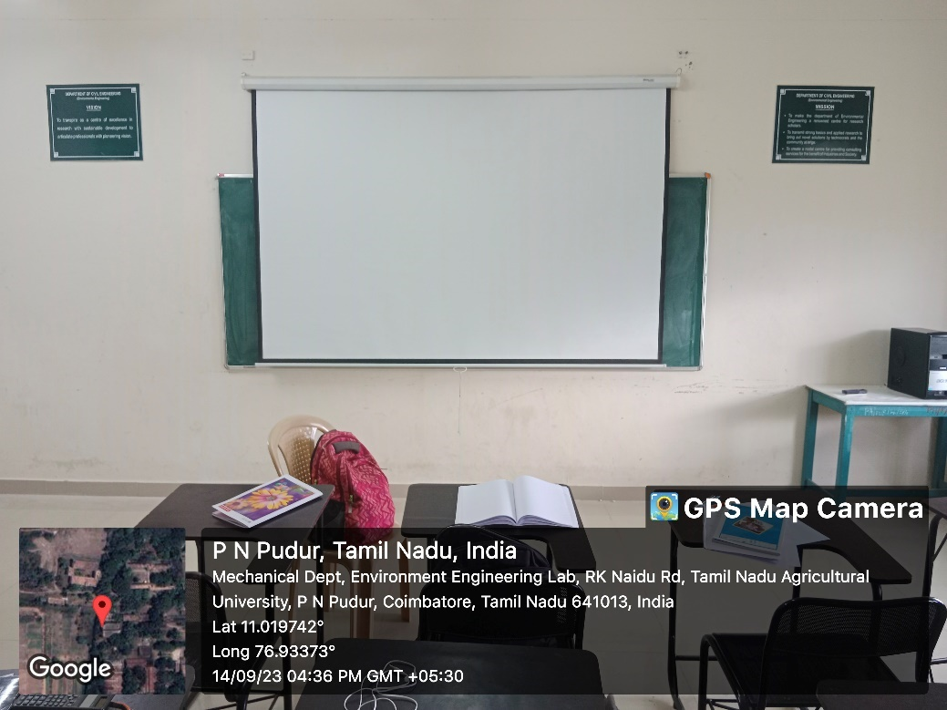
PG ENVIRONMENTAL SEMINAR HALL
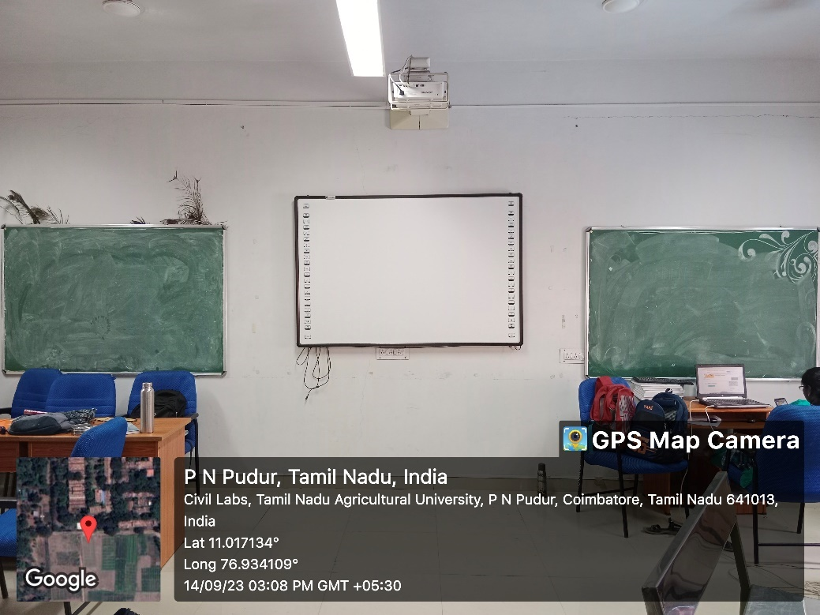

PG GEOTECH SEMINAR HALL
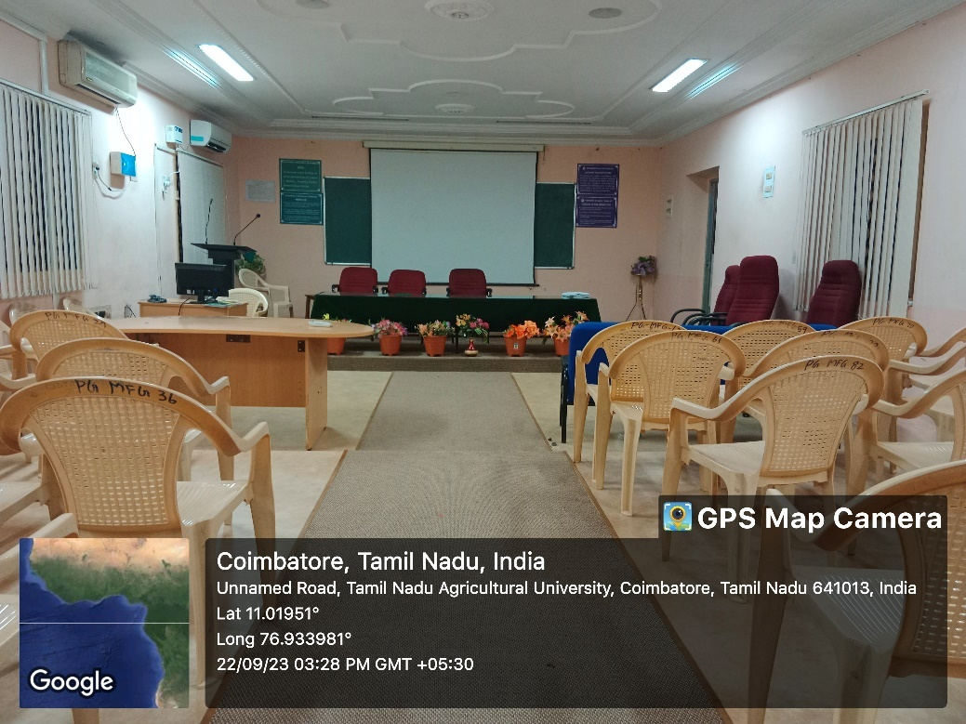
PG MANUFACTURING SEMINAR HALL
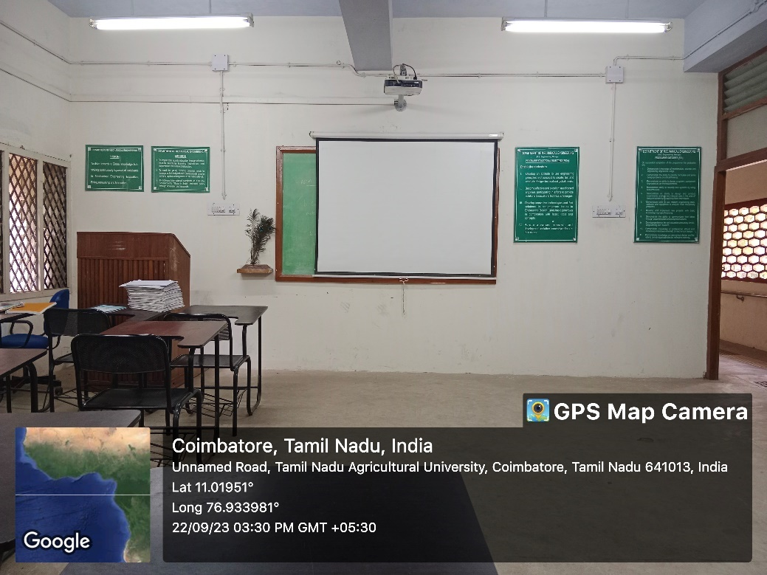
PG MANUFACTURING SMART CLASS ROOM

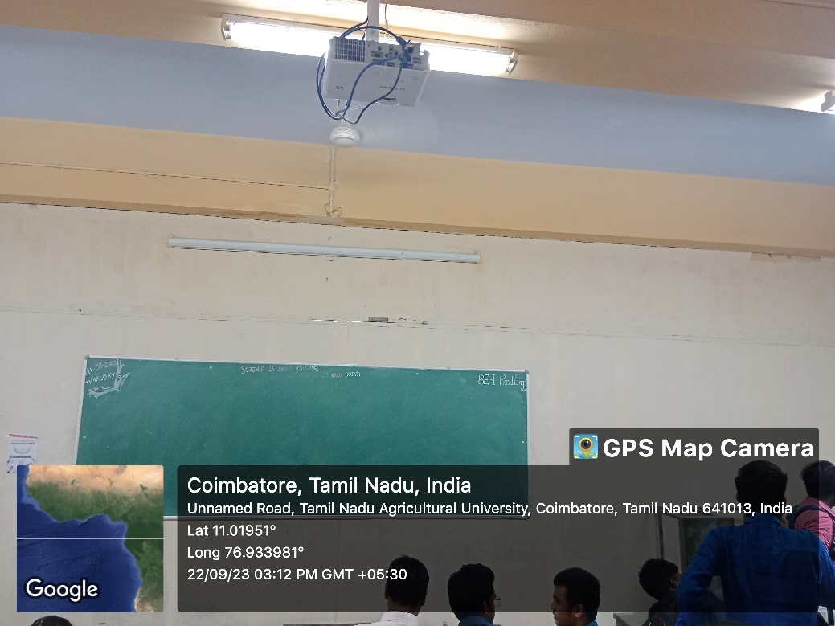
SCIENCE & HUMANITIES SMART CLASS ROOM

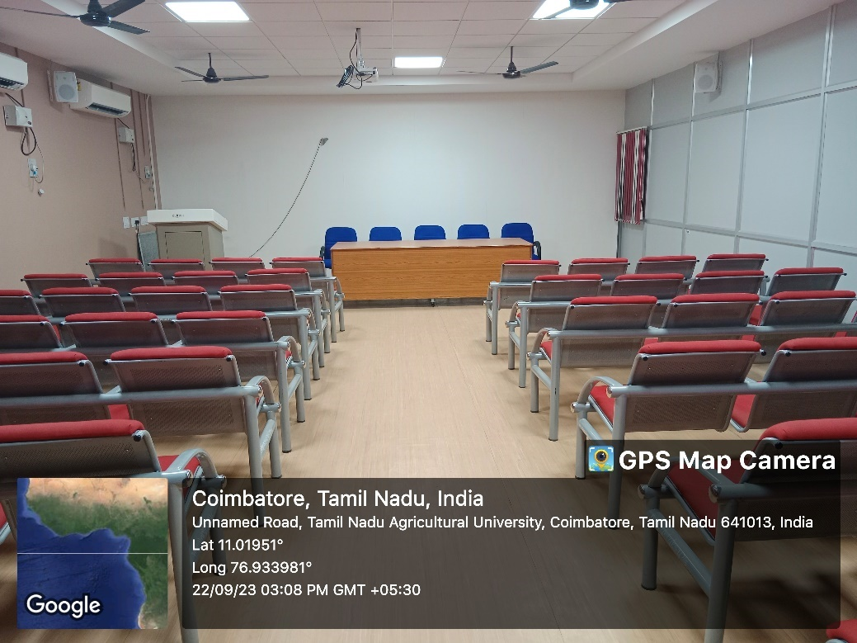
SCIENCE & HUMANITIES SEMINAR HALL

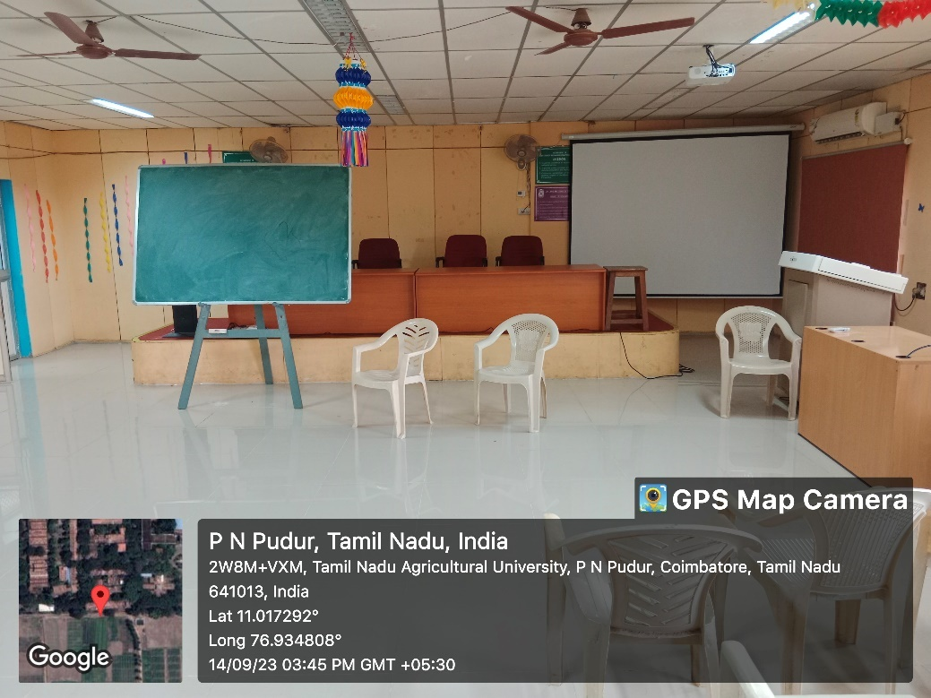
ECE SEMINAR HALL

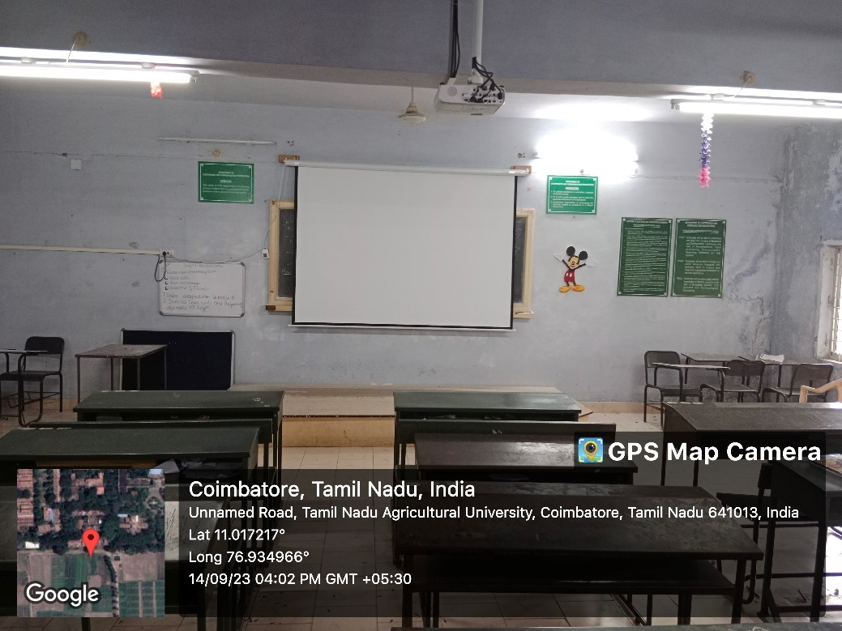
ECE SMART CLASS ROOM
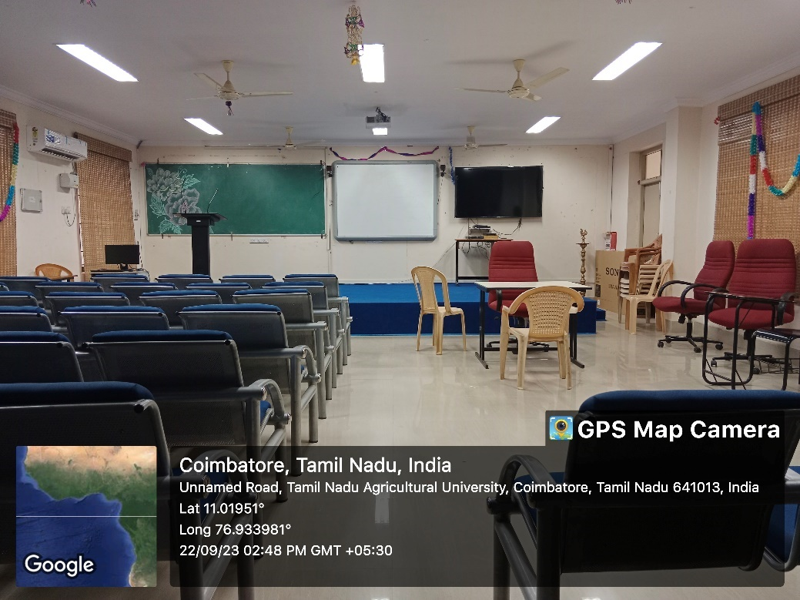
IT SEMINAR HALL

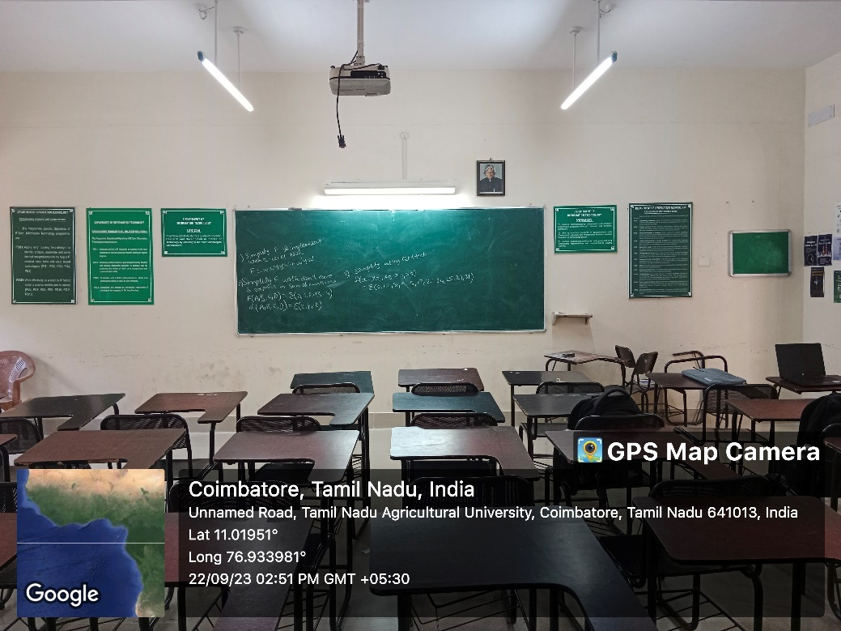
IT SMART CLASS ROOM
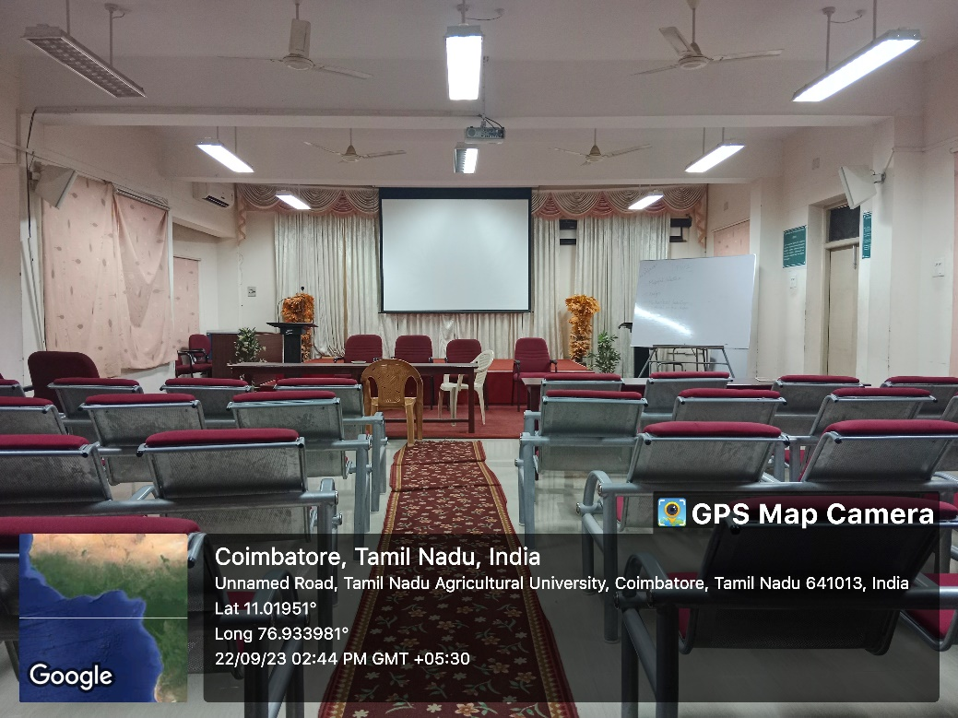
PRODUCTION SEMINAR HALL
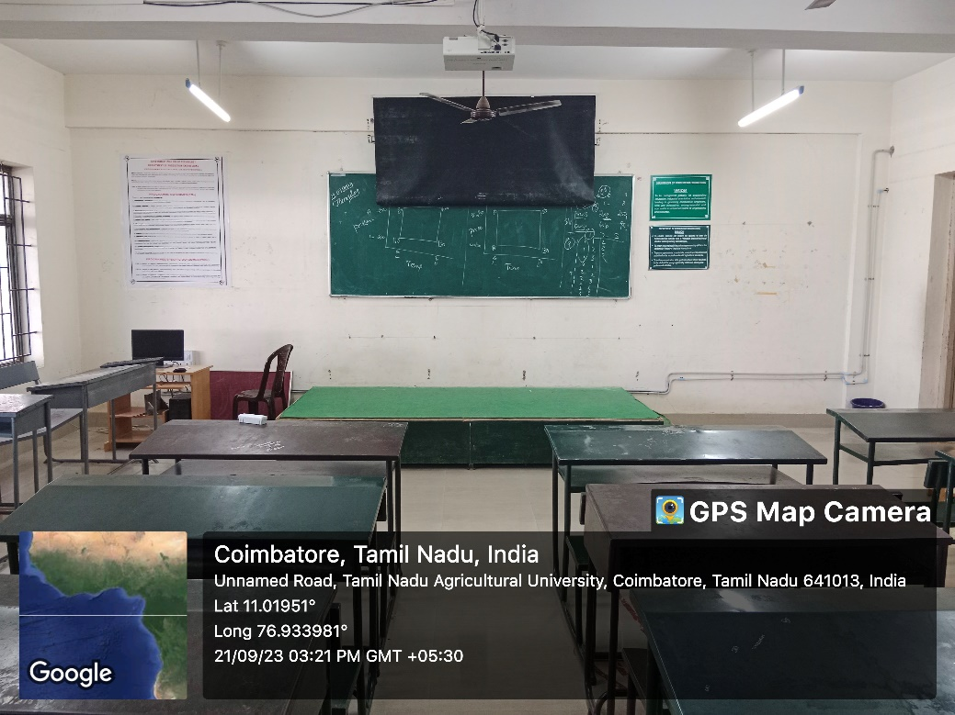
PRODUCTION SMART CLASS ROOM
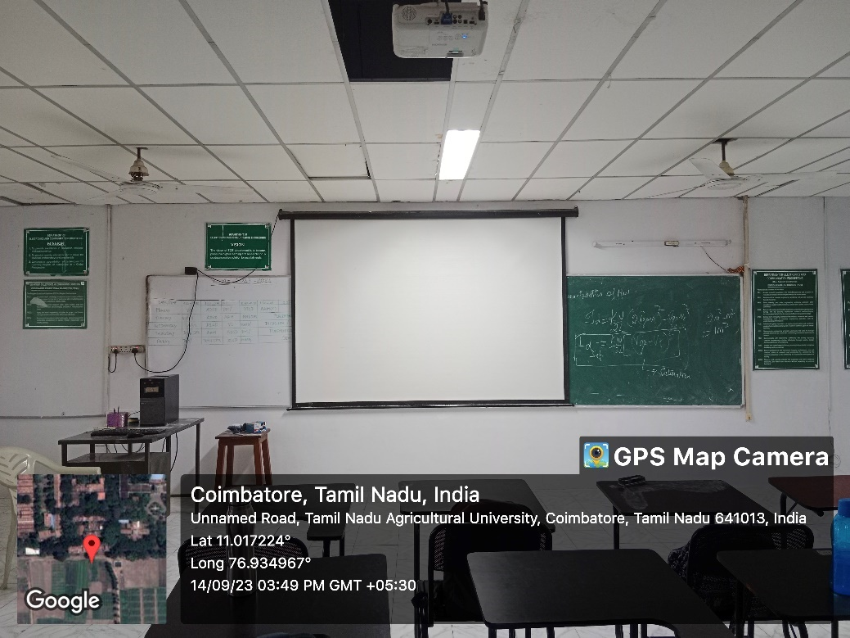
PG APPLIED ELECTRONICS SMART CLASS ROOM
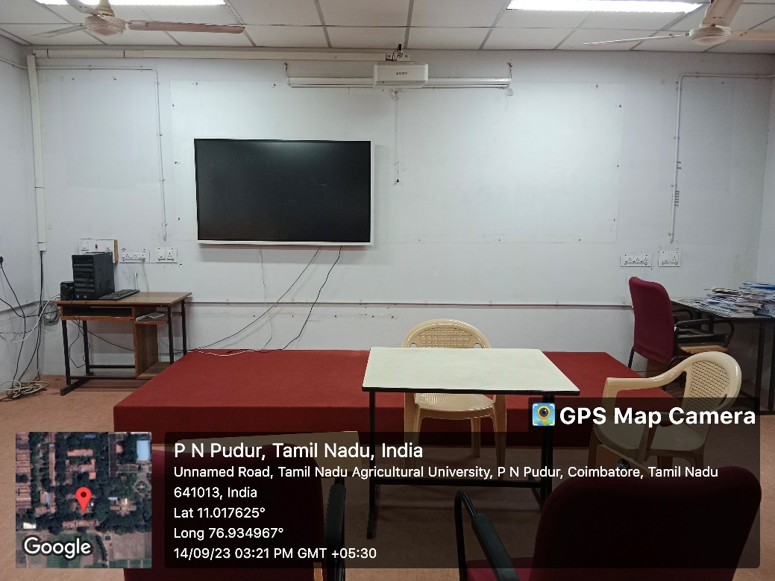
PG CSE SMART CLASS ROOM
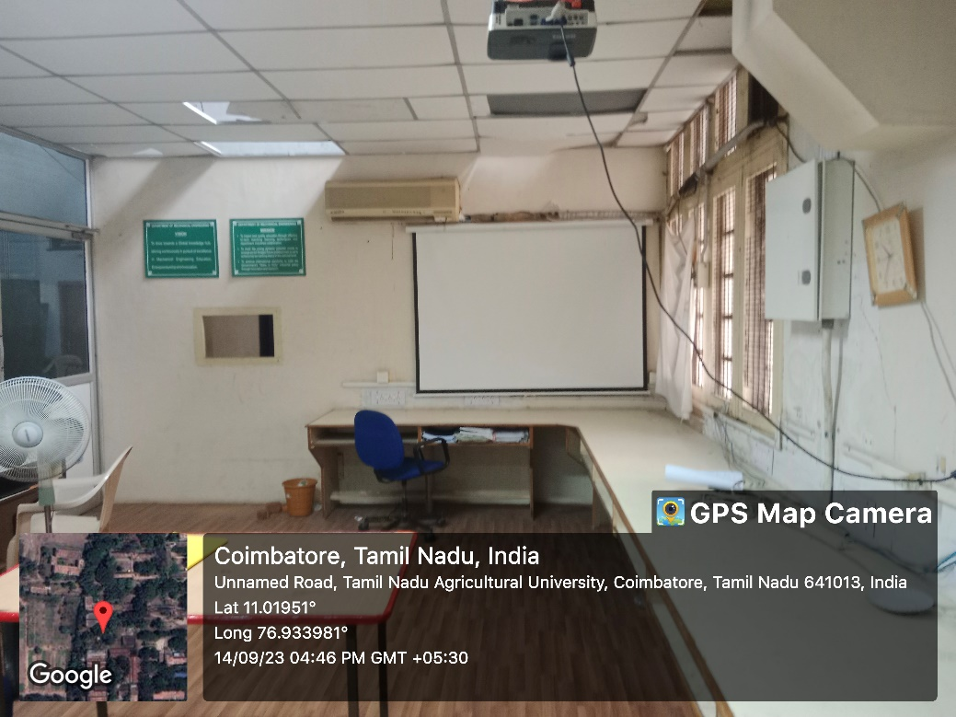
PG DESIGN SMART CLASS ROOM

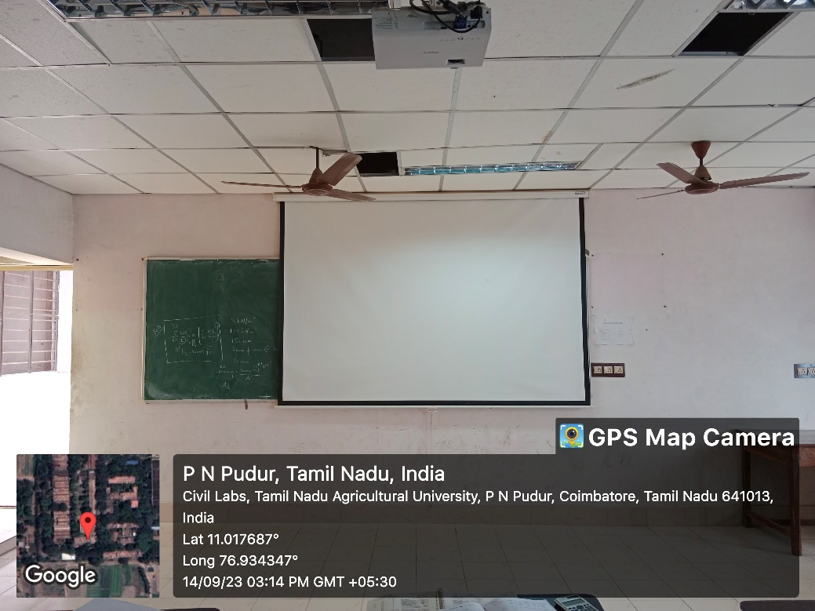
PG STRUCTURAL SEMINAR HALL
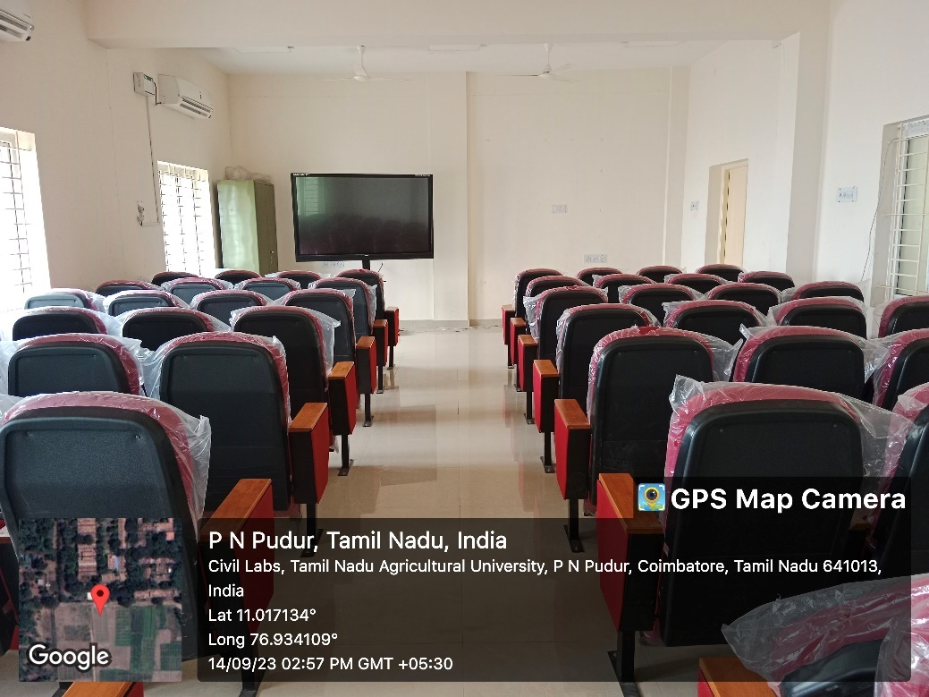
PG THERMAL SEMINAR HALL

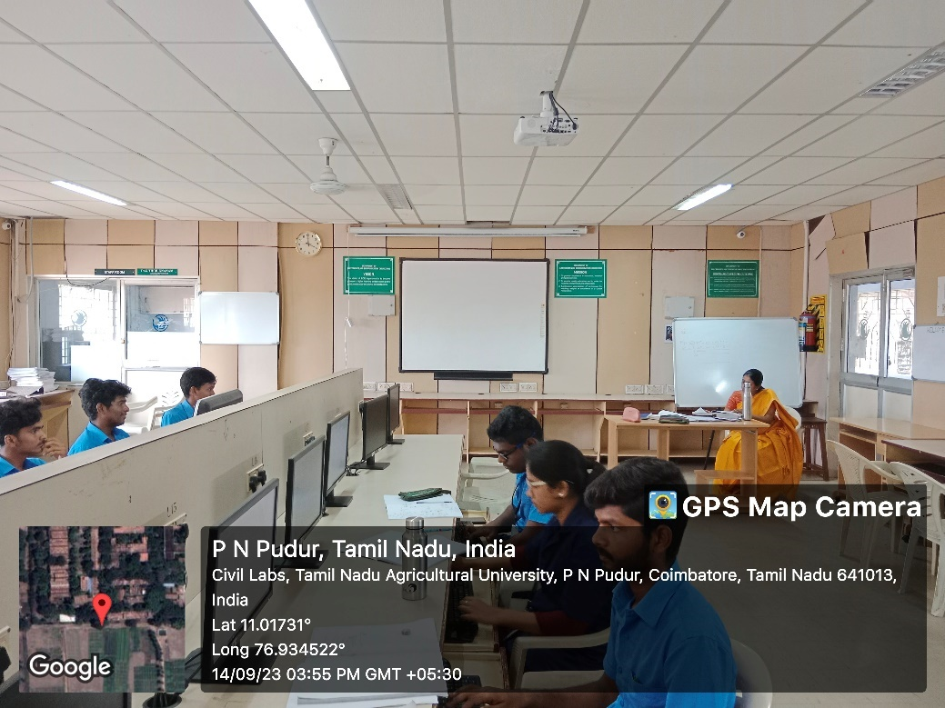
PG VLSI SMART CLASS ROOM
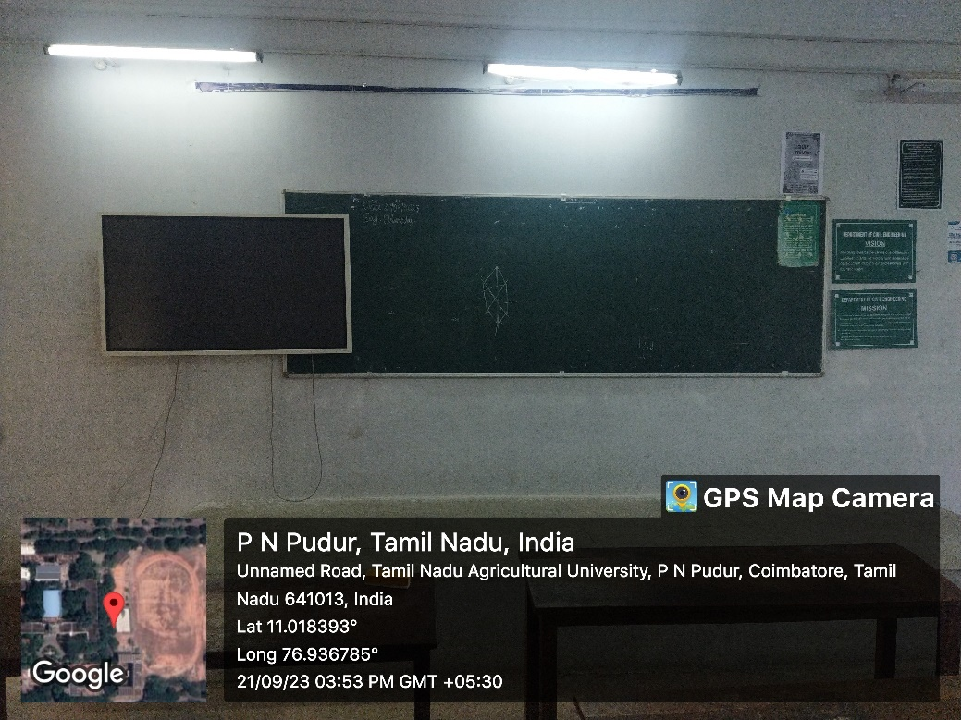
UG CIVIL SMART CLASS ROOM

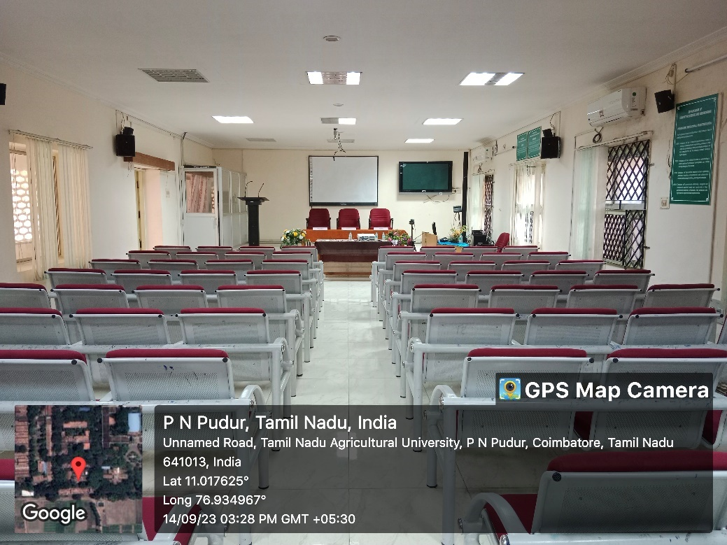
UG CSE SMART CLASS ROOM

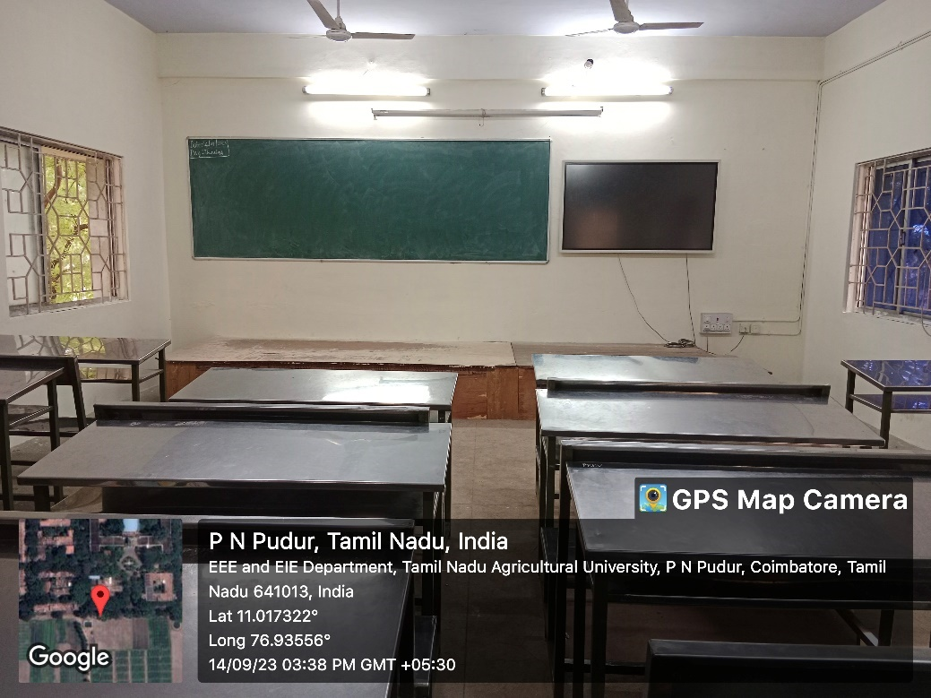
UG EIE SMART CLASS ROOM

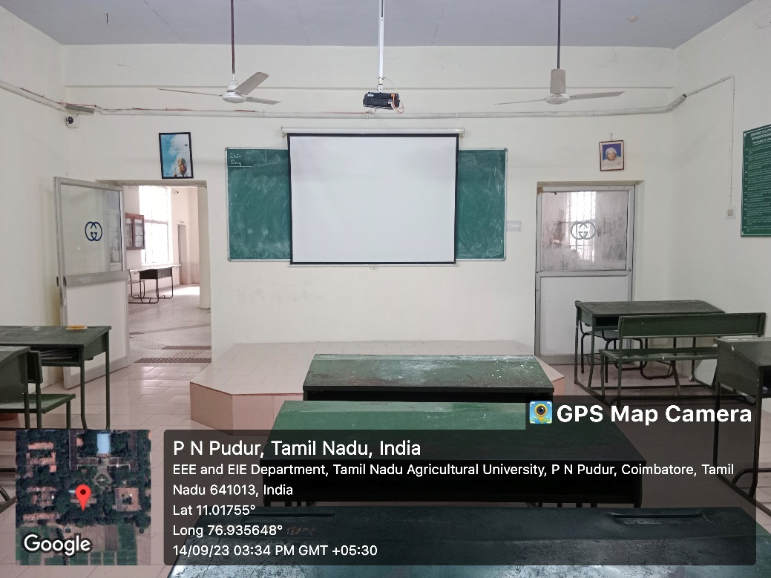
UG EEE SMART CLASS
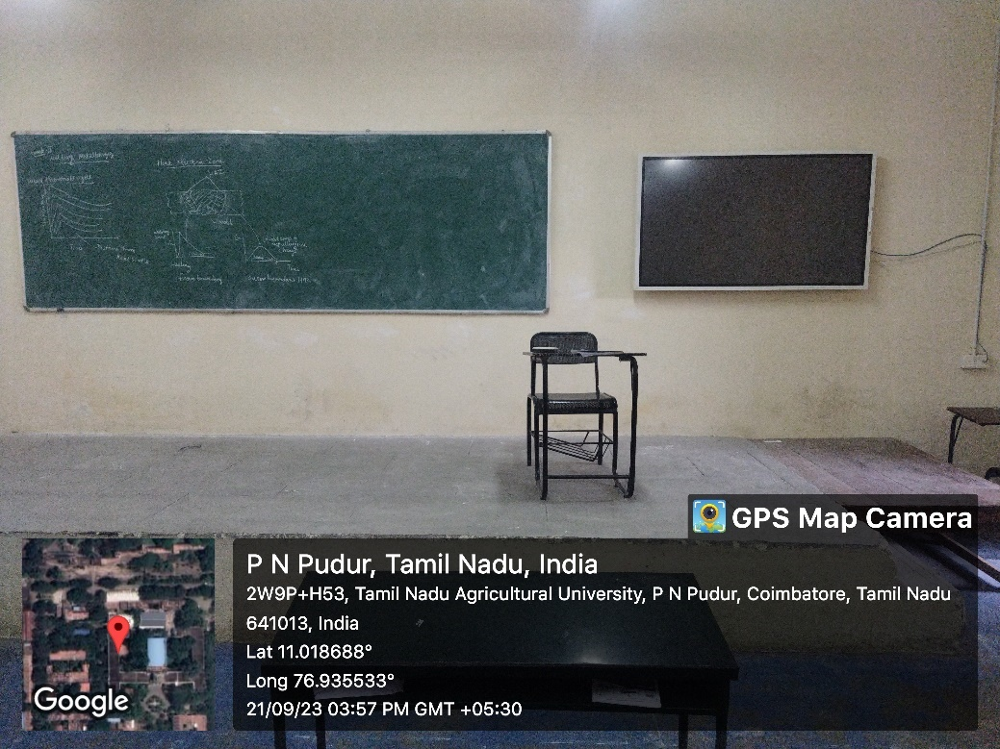
UG MECH SMART CLASS

