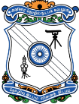
GOVERNMENT COLLEGE OF TECHNOLOGY, COIMBATORE
(An Autonomous Institution & Affiliated to Anna University)
Established in 1945, Thadagam Road, Coimbatore – 641013.

7.1.9 Sensitization of students and employees of the institution to constitutional obligations: Values, rights, duties and responsibilities of citizens:
At GCT, we believe in providing holistic all round education to the students and sensitizing students on our constitutional rights, values, duties and responsibilities is one of the primary educations given at the institute through various means.
Sensitization of students and employees of the Institution to the constitutional obligations is done through curriculum as well as through extra-curricular activities. The students of GCT of all branches study constitution of India as a compulsory paper which sensitizes the students about constitutional obligations. As a part of strengthening the democratic values, all students take a course on Environmental science in their curriculum which gives them insight into environment acts, wildlife protection act, forest act, global environmental concerns etc. In addition to this many regular programs are conducted by Women empowerment cell of the institute to educate women about their rights. Also seminars and workshops are conducted on days of national importance on various rights, duties and responsibilities of citizen. Seminars on topics like Right to Information, Sexual Harassment are conducted periodically. Every year Republic Day is celebrated on 26th Jan by organizing activities highlighting the importance of Indian Constitution. Independence Day is also celebrated every year to highlight struggle of freedom and importance of Indian constitution.
Constitution of India - Syllabus R2018 Curriculum:
Environmental Sciences and Engineering - Syllabus R2018 Curriculum:

Republic Day 2022:
Due to Covid, the Republic day for the year 2022 was not held. But the occasion was celebrated by planting the Saplings by the cadets and other students at home by following the COVID procedures.

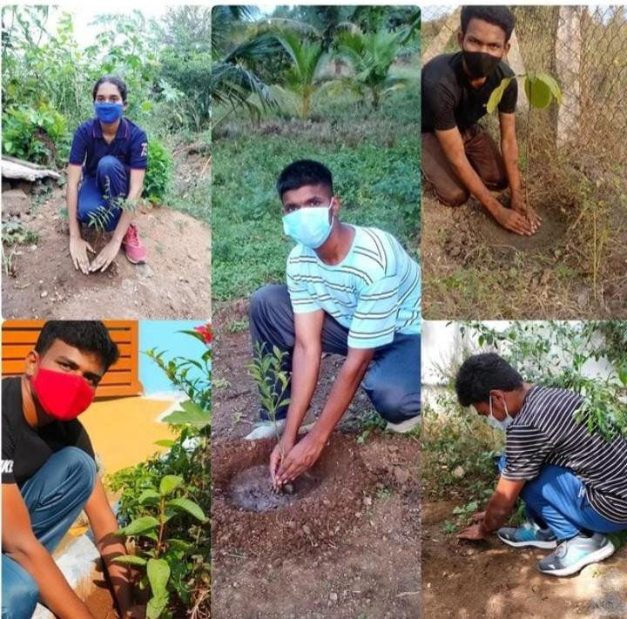
Jingo Green:
The members of Rotaract Club of GCT initiated an event on Independence Day to create awareness to Go Green. In Tiruppur & Cuddalore, about 75 seed paper flags were prepared symbolising 75th Independence day of our country. Such flags were prepared by making paste from papers and sprinkled seeds over it. After it was dried up, the seeds were painted using appropriate food colours to resemble our national flag. After the flag hoisting, the seeds were dispersed into the soil by the rotaract members.
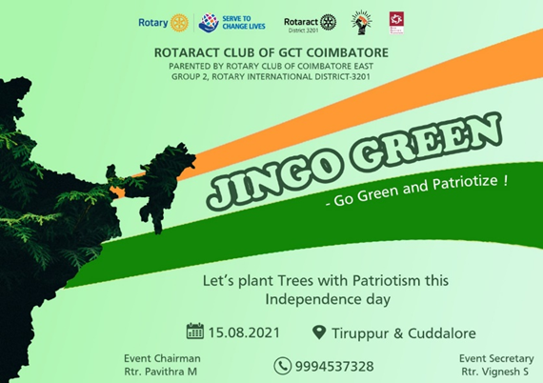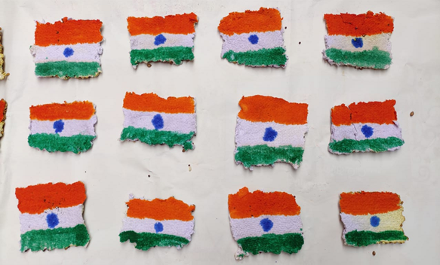

Salute India:
On the event of Republic Day, 26.01.2022, the members of the Rotaract Club of GCT Coimbatore went to Families for Children, an orphanage for children located in Coimbatore and spent time with them. Also donated sports equipment to the children and conducted drawing competition. The best drawings were rewarded with prizes. A consolation prize was given for all the participants which made them happy. The patriotism and self esteem was boosted among the children.
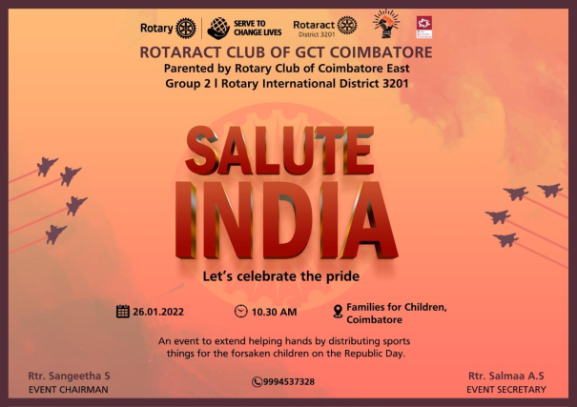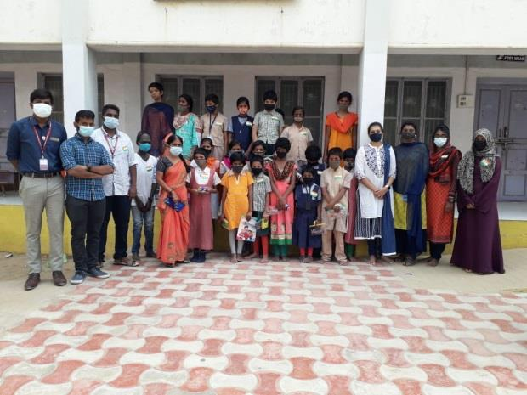
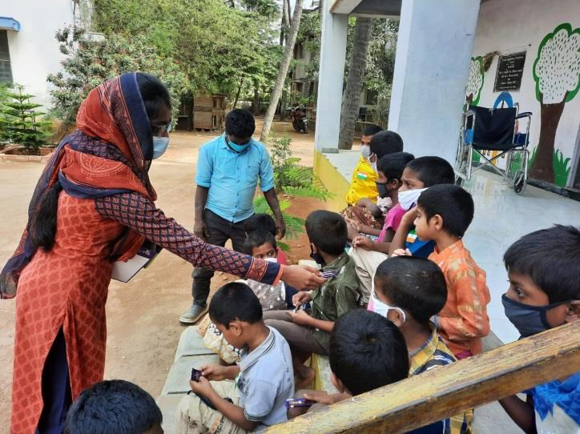

Women Harassment:
IQAC-Women empowerment cell jointly organized an awareness programme about the issues and solutions under the topic of “Recent incidents in connection with Women harassment”. Two different events like, a skit on “Women harassment” and a Mime on “Child trafficking” was conducted to create awareness among the girls students of GCT.

ALL INDIA WOMEN TREKKING CAMP At Ooty From 27 April To 4 May 2023
Participants were able to learn the history and cultural heritage of Ooty. Also the participants visited Different places of ooty such as Forest, Museum, Coonoor garden, Botanical garden etc.

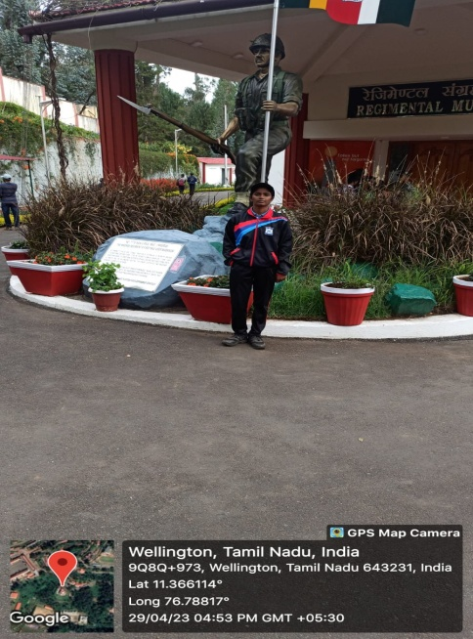
CYCLE RALLY was conducted on 03.06.2022
The day celebrates the uniqueness, durability, and versatility of the bicycle and promotes it as a simple, sustainable means of transportation. Bicycle is good for physical and mental health,also it is good for the environment and the economy.
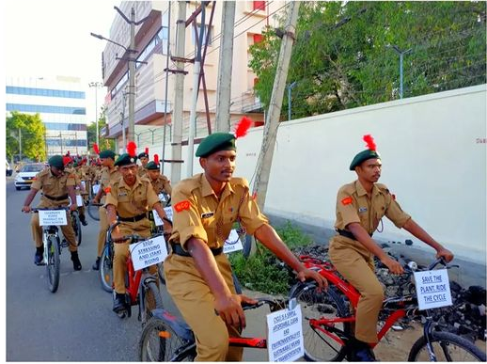

Vision of the Republic Day was celebrated on 26.01.2020

