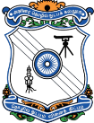
GOVERNMENT COLLEGE OF TECHNOLOGY, COIMBATORE
(An Autonomous Institution & Affiliated to Anna University)
Established in 1945, Thadagam Road, Coimbatore – 641013.

7.1.8 Describe the Institutional efforts/initiatives in providing an inclusive environment i.e., tolerance and harmony towards cultural, regional, linguistic, communal socioeconomic, and other diversities.
The institution has been endeavoring to create an inclusive environment through various initiatives apart from curricular aspects. The Curriculum has been revised with the inclusion of Professional ethics and mandatory courses like Constitution of India and Environmental Science and engineering. These courses create awareness of the importance of living in harmony with each other and with the environment, act responsibly with ethics towards communal and socio economic diversities of the nation.
Government College of Technology has the repute of nurturing endurance and peace among the students through various activities conducted throughout the year by the Youth Red Cross, Green Club, National Service Scheme, National Cadet Corps, Rotoract Club, etc. Different programs and activities conducted throughout the academic year help students develop mutual understanding and it creates a harmonious environment.
To start with, Literary & Debating Society and Tamil Mandram kindle students' flair for languages and their thirst to develop language skills. Besides, their association with people of different places naturally builds harmony with the people around them. Youth Red Cross helps students create awareness among people on their health and how to bring hygiene to daily life activities. NSS activities motivate students to render their service to people or hamlets in and around Coimbatore which lacks facilities. The camp programs enhance students' inner strength and confidence to tackle odd situations in life. NCC activities aim at strengthening students' character, discipline, and secular outlook besides providing them with chances to involve in adventure sport. Rotoract club activities develop the leadership and professional skills of students.
To build a nation with Young technocrats who are noble in their attitude and morally responsible, the institute organized and conducted a several activities to build and promote an environment for ethical and cultural values among the faculty members and students. The emotional and religious feelings among the students and the faculty are developed by celebrating commemorative days on the campus to create the sense of oneness and social harmony.
Every year rhe faculty members, staff and students jointly celebrate the cultural and regional festivals, like teacher’s day, Induction program, oath, plantation, Youth Day, Women’s day, Yoga day, festivals like Pongal celebration, etc are performed in the campus.
Motivational lectures are conducted by inviting eminent persons from various academic institutions to help the progression of the students for their personality development, and to build them a responsible citizen following the national values and integration.
Besides the academic and cultural activities, the institute also built up many strong infrastructures for a variety of sports activities for the physical development of the students. The following activities were conducted at our institute for the last five years.
S.No. | Date | Name of the event | Objective
1. | 30.09.2018 | Iniyadhor mozhi | Literary festival
2. | 02.10.2018 | Sakthi kodu | Dengue awareness campaign
3. | 12.11.2018 | Succour | Flood relief fund donation
4 | 25.12.2018 | Diversed india | Christmas celebration
5. | 06.01.2019 | Pongalo pongal | Pongal celebration
6. | 12.02.2019 | Elixir | medical camp
7. | 23.02.2019 | Rotasia – goa | International cultural conference
8. | 30.04.2019 | Have a meal | Food donation to orphanage kids
9. | 03.05.2019 | Kutty chutties | event on child care
10. | 06.09.2019 | Kavisudar | To develop the poem writing skills
11. | 17.09.2019 | Tatt zone | Awareness programme on ozone depletion
12. | 2.10.2019 | Neguzhi | An event to encourage not to use plastics
13. | 03.01.2020 | Agni sirage – | Id programme on women empowerment
14. | 05.01.2020 | Ponga-o-pongal | Pongal celebration
15. | 06.02.2020 | Are you aware? | Awareness about the corona virus
16. | 19.02.2020 | Elixir 2020 | medical camp and blood donation camp
17. | 22.03.2020 | Athiyayam | Awareness about water conservation
18. | 28.03.2020 | Neguzhi | Plastic awareness
19. | 22.04.2020 | Boomithai | Id programme on Awareness on the conservation of environment and water
20. | 04.09.2020 | Vizhigal | Awareness on eye donation
21. | 16.01.2021 | Kaanum pongal | Pongal celebration
22. | 19.01.2021 | Greenaric | Trees planting
23. | 30.09.2021 | Defeat diabetes campaign
24. | 20.11.2021 | Blood donation camp
25. | 15.01.2022 | Pongal thiruvizha
26. | 06.04.2022 – 08.04.2022 | Elixir | Medical camp
27. | 9.08.2021 – 11.08.2021 | International youth day | To recognize the youth talents at gct
28. | 04.10.2021 | World animal welfare day | To feed and protect stray animals
29. | 13.10.2021 | Ayudha pooja | To worship the goddess saraswathi
30. | 14.10.2021 | Y’s alm | To serve the needy people
31. | During the month of november | Y’s cancer fund | To raise funds for cancer patients
32. | Feb 3rd,2022 (10 days) | All india trekking camp (ncc)
33. | 20.02.2022 | Catc held at Hindustan Engg college
34. | 07.03.2022 | International women’s day | Celebration of women empowerment
35. | 08.03.2022 | Shooting camp selection
36. | 19.03.2022 | Governor rally
37. | 06.06.2022 | Rally on soil erosion
38. | 29.01.2022 | Go green | To protect the earth and avoid using plastic
39. | 30.01.2022 | Be a reason for solution don’t be reason for pollution | To protect the earth from pollution
40. | 05.09.2021 | Teacher’s day | Celebrating birth anniversary of our former president sarvepalli radhakrishnan
41. | 29.09.2021 | Code: red | Awareness program on heart donation
42. | 30.09.2021 | Defeat diabetes campaign | Awareness and screening test conducted.
43. | 24.10.2021 | Vergal | Cleaning the palyground of a government school.
44. | 20.11.2021 | Blood donation camp | Students donated blood
45. | 26.01.2022 | Salute india | Donated sports equipment to children
46. | 07.04.2022 | Elixir | Medical camp at gct campus
47. | 14.04.2022 | Nalam | Medical camp at era nenjam old age home.
48. | 26.03.2022 | Udhavum karangal | Donated old clothes from gct to children at grace happy home.
49. | 08.03.2022 | ஊக்கமது கைவிடேல் | Awareness programme on self defense for women and girl students of gct
50. | 18.10.2022 - 15.11.2022 | Plasti-compost | Creating a plastic-free campus
51. | 13.01.2023 | Namma pongal | Pongal celebration in school with children
52. | 17.01.2023 | Magizh | Sharing happiness and pongal vibes
53. | 07.01.2023 | Blood donation | Donating blood to save lives
54. | 29.01.2023 | Paware | Building a responsible community, that treats and loves animal equally
55. | 18.04.2023 | Connect4climate | An awareness session on reducing risk and vulnerability of climate change
56. | 24.04.2023 | Serving shine | Creating a clean environment by removing garbages of the public places
57. | 24.04.2023 | Feathers | Setting up bird feeders around gct campus
58. | 03.05.2023 - 05.05.2023 | Elixir | A medical camp for the people of gct with general check-up, dental check-up, eye check-up, gynecology and blood donation

Glimpse of the events: cultural, regional, socio economic and other diversities during the last five year (2018-23)
International women’s day celebration 2020
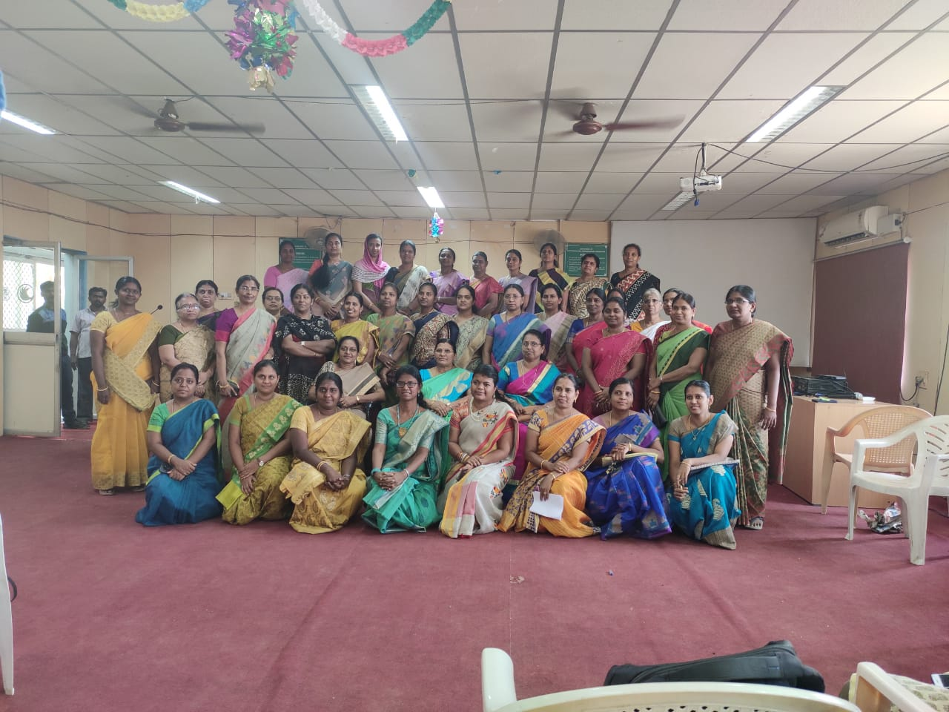
Y’s Club activities
International Youth Day:
All students will have innate or inborn skills that are simply waiting to be unleashed. This event was conducted to bring out the talents of the youths of GCT. Each one of them showed their individual talents and their skills by sharing pictures, videos or audios. Among the talented youths, the best talent was selected and encouraged. Their ability to recognize what unique skills & talents they possessed will help them to overcome barriers and become a success. This event happened on International Youth day between 9th to 11th August, 2021.
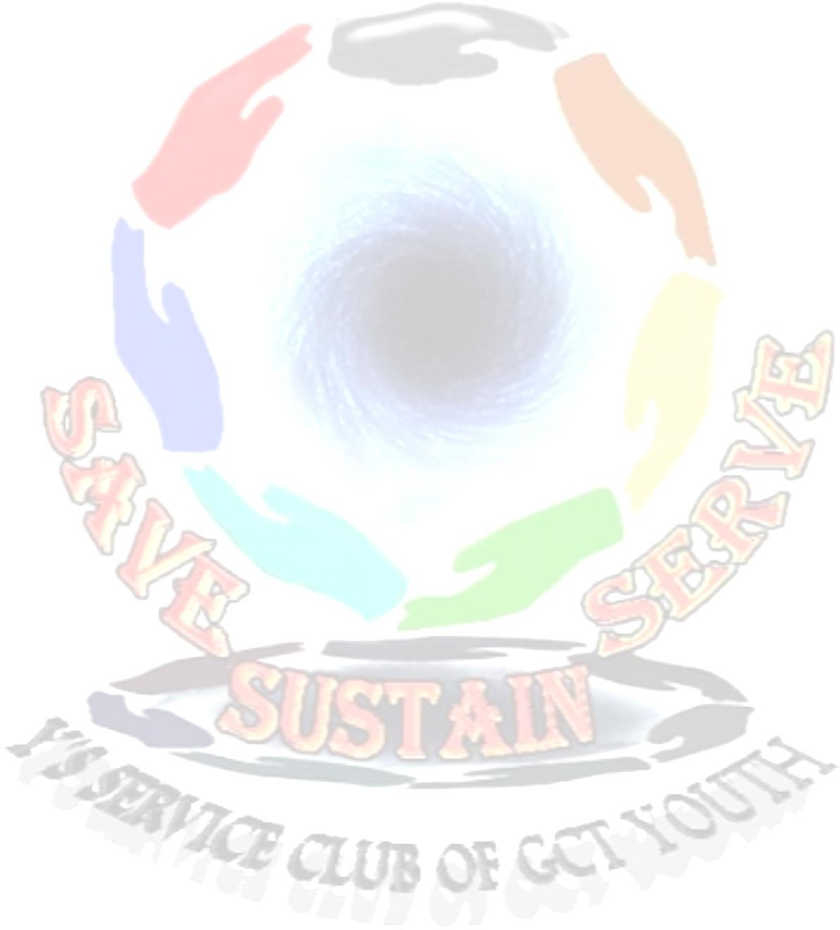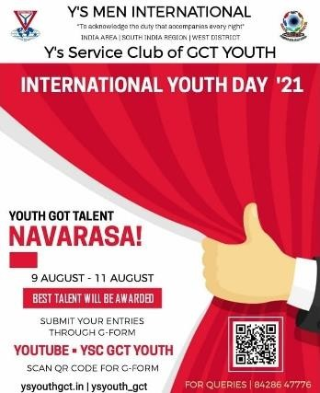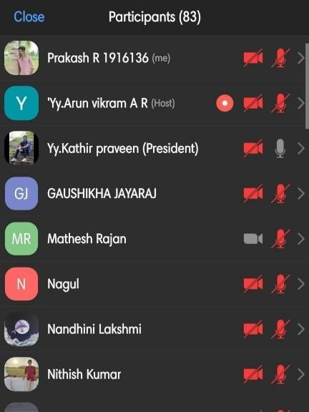

World Animal Welfare Day:
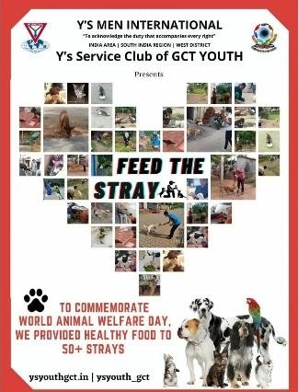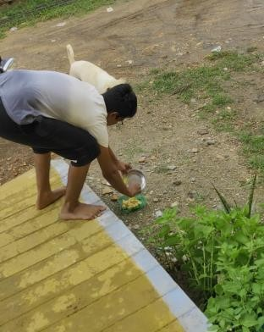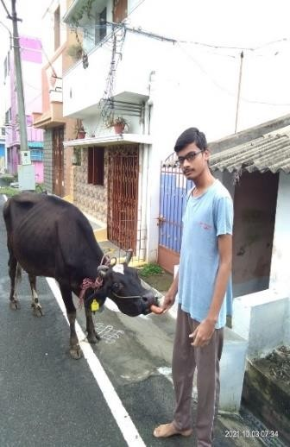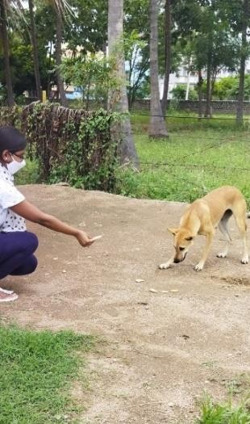This activity was conducted to create awareness on World Animal Welfare Day. Stray animals and domestic animals were fed on this day. Interested common People joined with us to feed the animals. This created an awareness that impacted people in and around Tamilnadu. This event was conducted on the commemorative world Animal Welfare day 4th October, 2021.
Y’s ALM:
Y's Alms is an extraordinary feat by Y’s club in the recent times. Especially during the pandemic times, the starving and needy people from different parts of Coimbatore were fed with healthy food. The Y's Service Club of GCT YOUTH stepped in, to lend their lunch. This event created a responsibility and humanity among the service-minded youths of GCT. This event also inspired many common people to volunteer and provide food to the needy at their locality. This activity was initiated on 14th October, 2021.
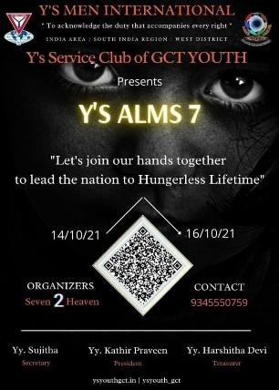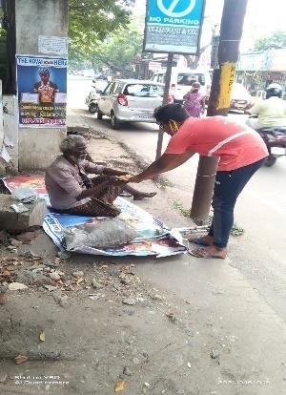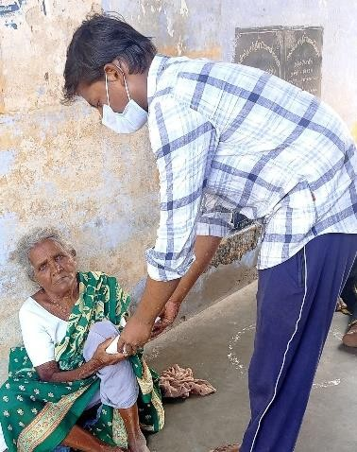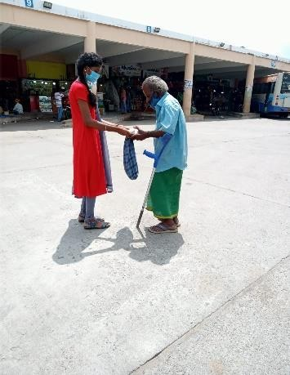

Y’s Cancer Funds:
The Y's club organized a series of fund-raising events to create awareness about cancer during the entire month of November, 2021. The raised funds were donated to the cancer institute. This created awareness and made an impact on the people about cancer issues.

NCC Activities
NCC Day:
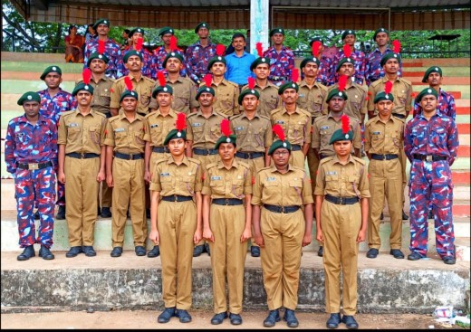
NCC Day was celebrated every year on last Sunday of November. After two years of lockdown, the NCC Day for the year 2021 was celebrated and all our cadets performed Rifle drill and Cane drill. (GCT)

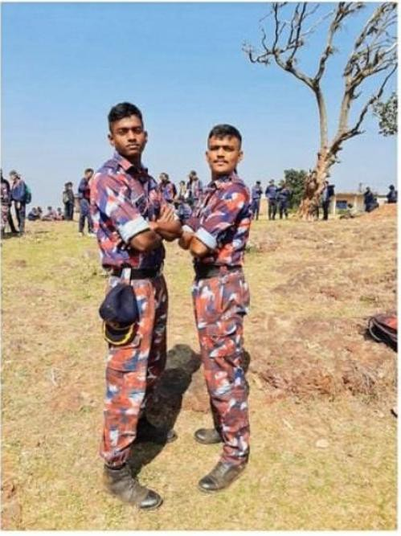
All India Trekking Camp 2022:
All India trekking camp was organized on feb 3rd, 2022.Two of our GCT cadets participated in this camp at Belgam for 10 days.
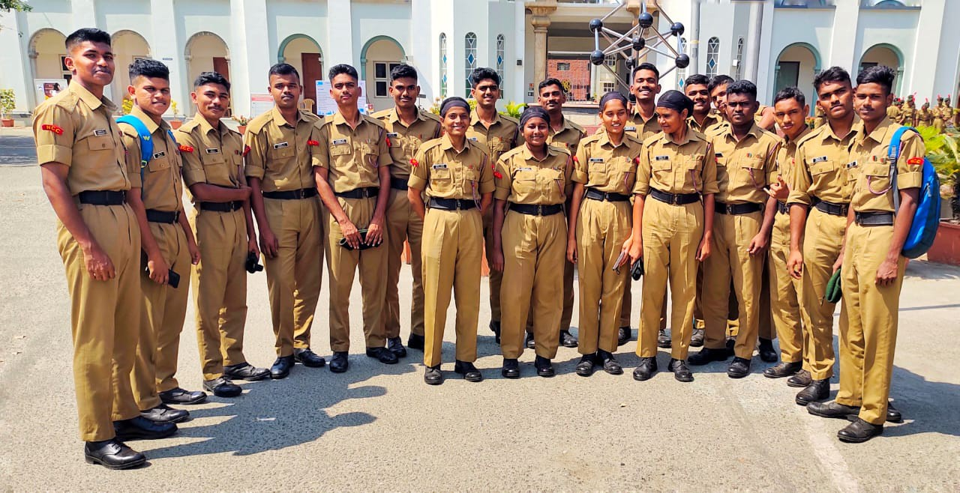
CATC 2022:

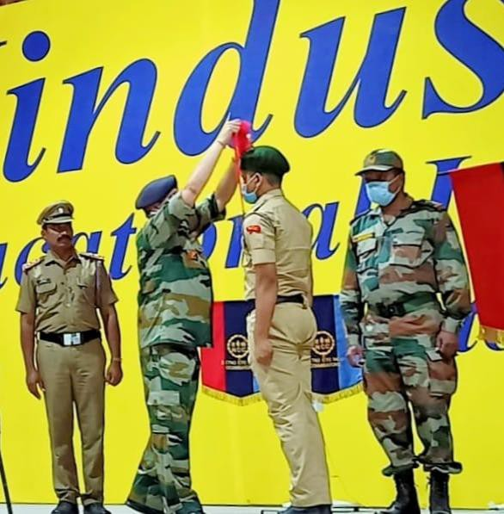
The GCT NCC cadets participated in the CATC, 2022. This event was held at Hindustan Engineering College, Coimbatore on Feb 20th, 2022. All cadets participated in various sports and cultural events. The cadets placed First in volley ball.

Ayudha Pooja:
Ayudha Puja, the dedicated ritual of worship of Universal Mother, the Almighty, the Supreme Power in the form of ‘ayudhas’, the peripherals, the accessories, the tools, the instruments, the machineries which make the human life better without which human life becomes impossible and inefficient. Ayudha Puja is the mode of expressing the gratitude towards the all pervading power which helps human beings in every walk of life in various forms. GCT has a vibrant record of celebrating Ayudha Puja in a magnanimous manner. For the Year 2021, the Ayudha pooja was celebrated at GCT on 13th October, 2021. (Photo required).

Shooting Camp selection 2022:
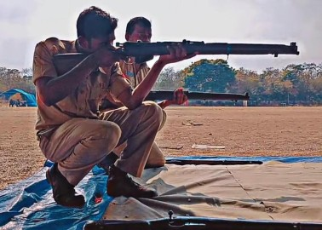
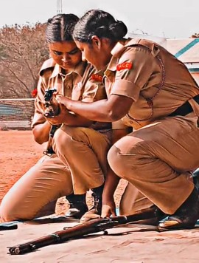
All our cadets participated in the shooting camp selection held at PSG CAS, Coimbatore on march 8th, 2022.

Governor Rally:
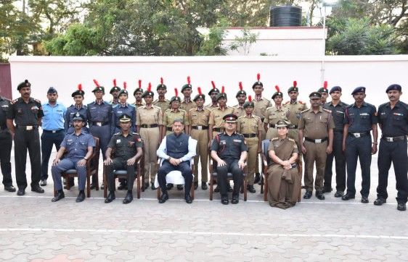
Honourable Governor Mr.R.N.Ravi interacted with the NCC cadets of GCT at the Circuit house on 19.03.2022
in Coimbatore.
Green Club Activities
Webinar:
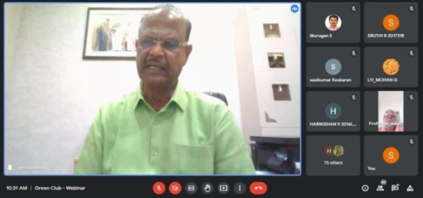
The Green club of GCT organized a webinar on 29.01.2022 and 30.01.2022 for second and third year students. On 29.01.2022 the webinar was conducted on the title “GO GREEN” for the second years and on 30.01.2022 the webinar was conducted on the title “BE A REASON FOR SOLUTION DON’T BE A REASON FOR POLLUTION” for both second and third year students of GCT.
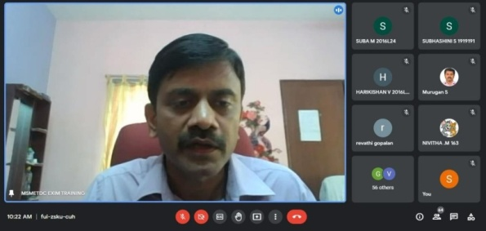
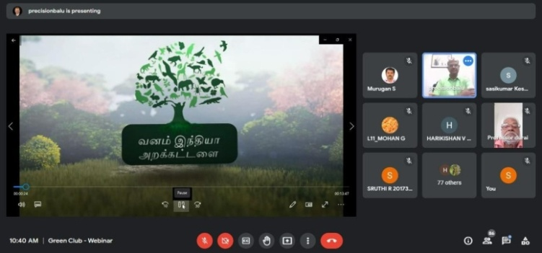
Rotaract Club Activities
Teacher’s day Celebration:
The student members of Rotaract Club of GCT, celebrated the Teacher’s day on behalf of September 5th 2021. As a token of love and respect towards the teachers, the students have shown their gratitude by presenting a momento, which was handmade craft by the students themselves. On the day of the event, the board members of rotaract club distributed the token of love to all faculty members of GCT.
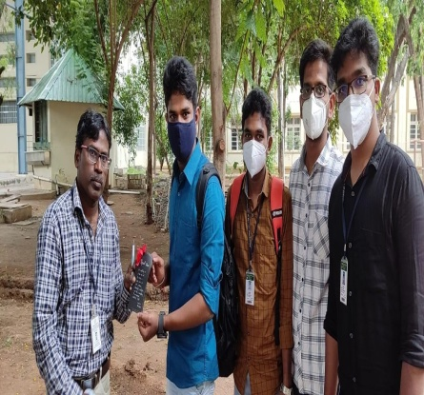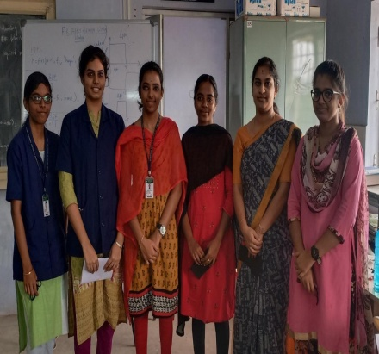

CODE : RED
The Rotaract club members of GCT conducted an online session for students on “Code: Red” held on 29.09.2021. This programme was conducted to create awareness on organ donation. Dr.Ramprakash, cardiologist from GKNM hospital explained the importance and procedure of heart donation. This programme created awareness on heart diseases and saving the life of someone with heart disease in the future.
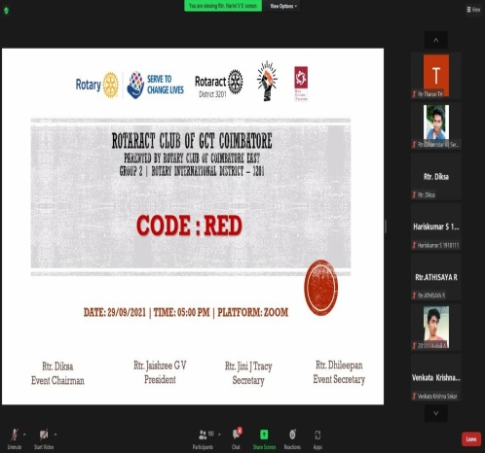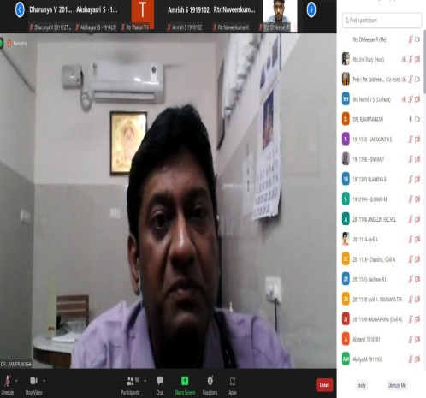

Defeat Diabetes campaign:
The Rotaract club of GCT Coimbatore along with VGM hospital, Rotary club of Coimbatore East, Rotaract club of Coimbatore Unity, Rotaract club of Coimbatore Institute of Technology and Rotaract club of PSGR Krishnammal College for women jointly organized ‘Defeat Diabetes Campaign’on 30.09.2021 at Ukkadam and Peelamedu area of Coimbatore. The glucose screening test to measure blood sugar lever for around 50 common people were tested for free of cost. The rotaract student members helped the Physician from VGM hospital, Singanallur. This one day activity was conducted to create awareness on diabetes among all age group of people and suggestions were provided by the physician about the nutritional diet to avoid diabetes.
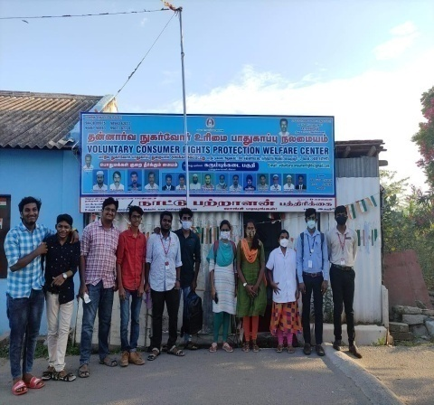
Vergal:
The Rotaract Club of GCT Coimbatore initiated an event, Vergal which was organized as a community service to clean the play ground of a Government middle school located in Kasthurinaickenpalayam, Coimbatore. All the participants enthusiastically joined the event and cleaned the play ground with great effort, tirelessly. This event took place on Oct 24th, 2021.
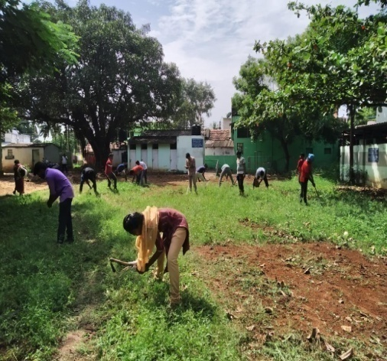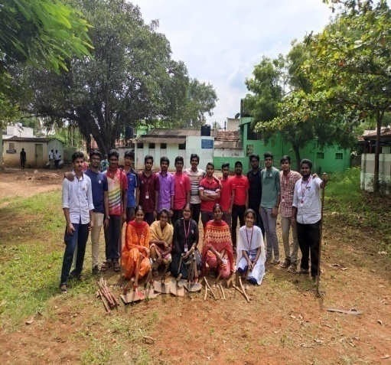

BLOOD DONATION CAMP
Blood donation camp was organized at Rotary texcity hall, Sungam by the members of Rotaract Club GCT Jointly with 123Coimbatore, Tulasi Pharmacy and Rotary club of Coimbatore East, rotaract clubs of CIT, PSGRKC & Unity. Around 13 members from the club donated blood and volunteered themselves in the event on November 20th, 2021.
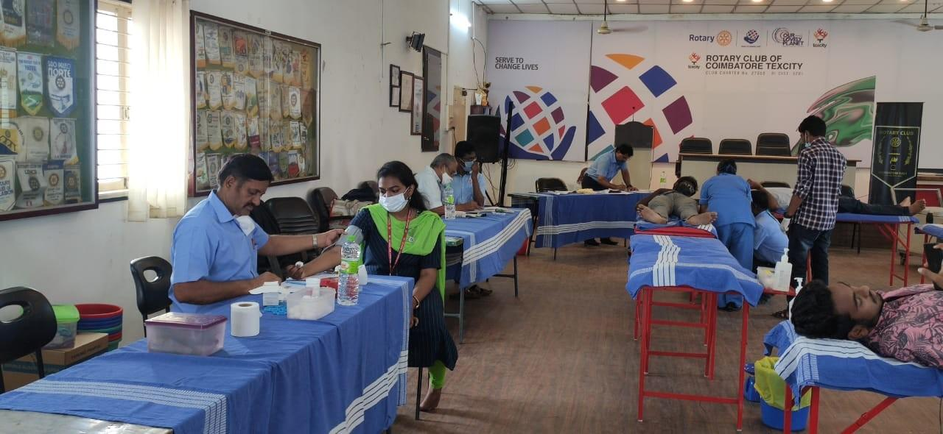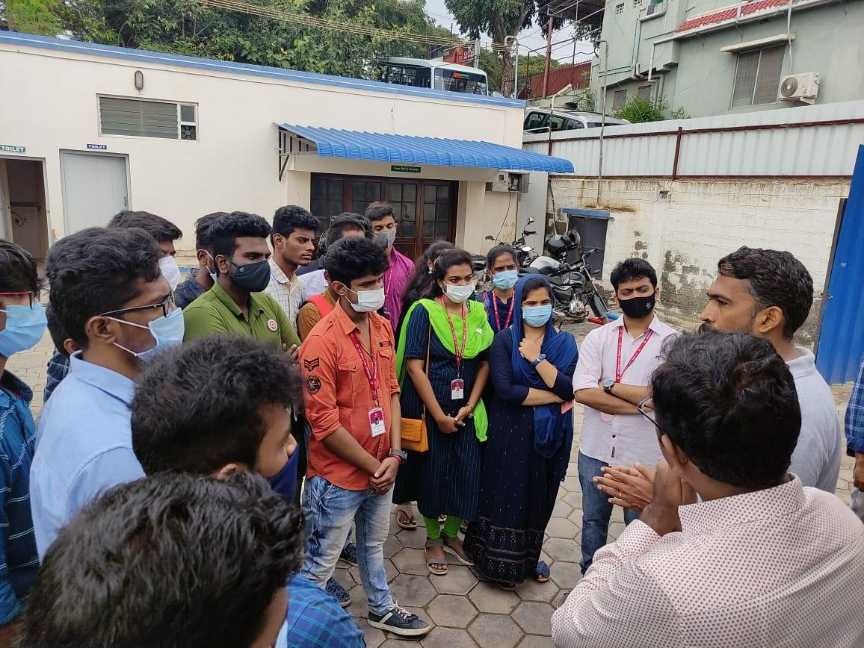
SALUTE INDIA
This activity was held on January 26, 2022 on the occasion of Republic Day at Families for children Orphanage home. This event was conducted on the basis of donating sports equipments to the future pillars of India. A small drawing competition was also conducted on the topic of Republic day. The charts and color pencils were provided, following that the little ones participated with interest and were able to see their interest and budding talents within them. Small gifts were given to the best drawings and all were given a consolation prize for their active participation. The sports equipments (ball, badminton bat, skipping rope, tennikoit corks) were ﬁnally given to them rejoicing happiness in each and everyone’s face.
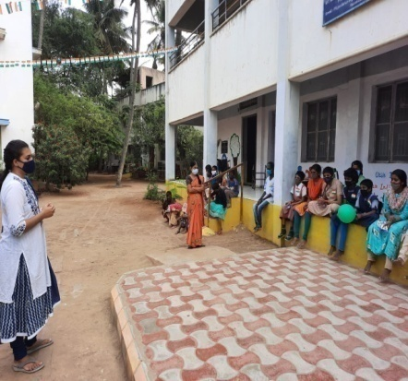
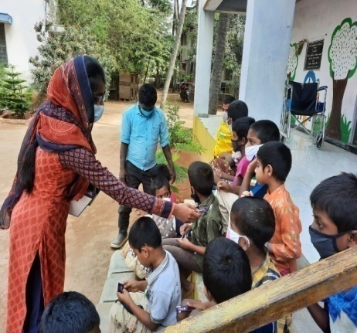

ELIXIR:
An event ‘Elixir’ was conducted at GCT on April 7th, 2022. The medical camp comprised of Eye checkup, Dental checkup and General Body checkup along with blood donation. The partners in this event were Dr.Agarwal’s hospital and team for eye checkup, Ramakrishna Dental Hospital and College and team for dental checkup, Sree Iswarya hospital and team for general body checkup and Government hospital and team for blood donation. The statistics for the event is as follows, Total participants : 1868 Total eye checkup done : 1139 Total dental checkup done : 1155 Total general body checkup done : 1421
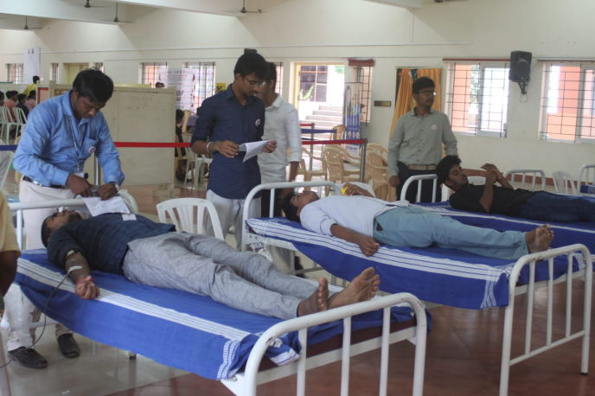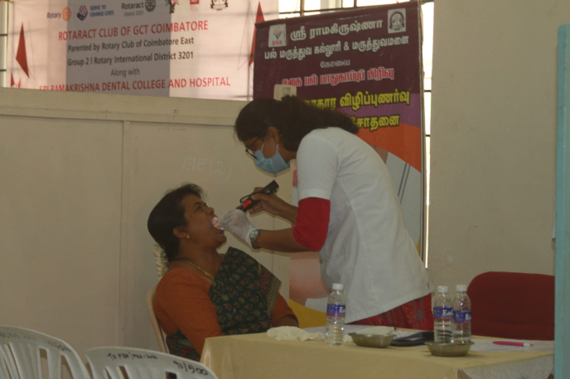
Nalam:
The Rotaract Club of GCT Coimbatore also conducted a free medical camp with a general health awareness programme for the inmates of Eera Nenjam Old-age home. This event was conducted for guiding and making them aware on personal health awareness. This event helped them to become more aware of various diseases as well as their own physical health. The doctor raised health awareness among the inmates and taught them to deal with communicable and non communicable diseases and evaluated the living conditions of the 45 inmates and provided a high quality medical service.
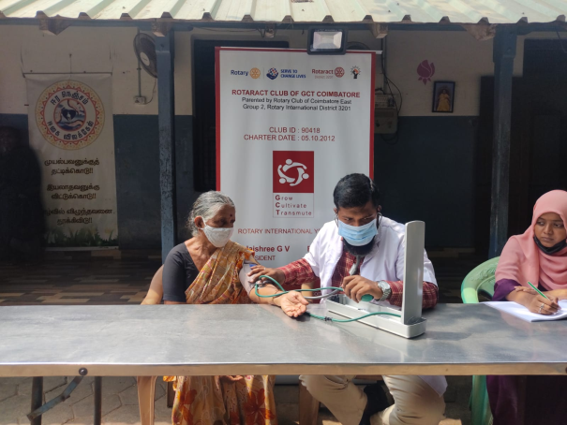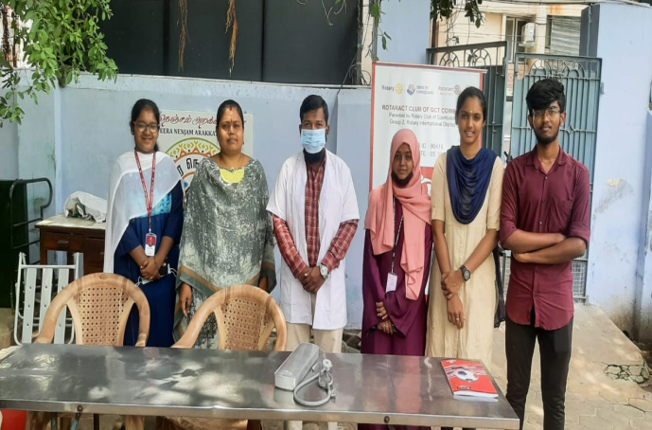
Udhavum Karangal:
Sharing is essential for the growth of any community. As a community service the students of GCT donated their old clothes to the children at Grace Happy Home Trust, Kottaipalayam in Coimbatore on March 26, 2022. This event fulﬁlled the basic needs of the children. 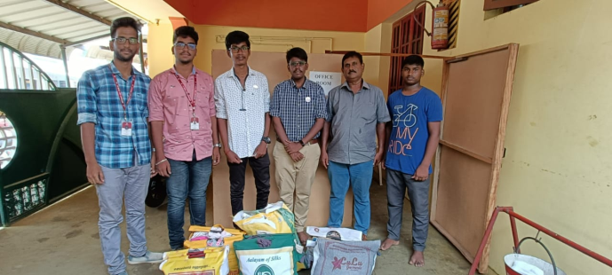
International Women’s Day Celebration:
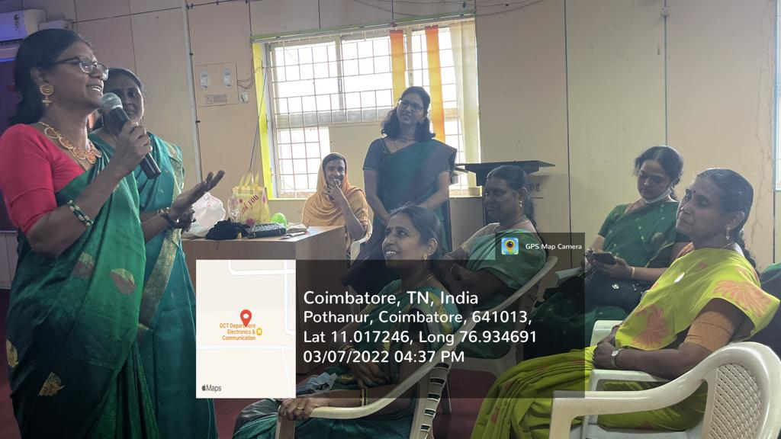
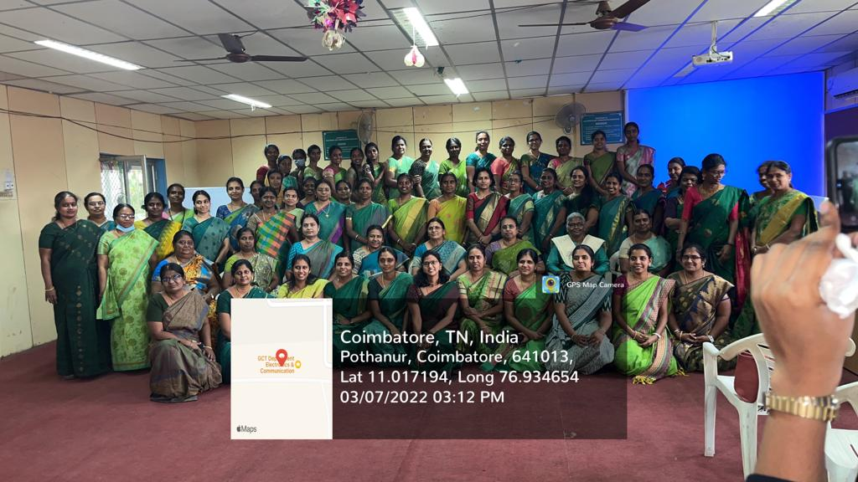
ஊக்கமது கைவிடேல்:
The Women empowerment cell committee of GCT organized a self defence Webinar on “ஊக்கமது கைவிடேல்” for all women teaching, non teaching and ministerial staff members of GCT on March 8th, 2022 at ECE seminar hall. The Guest person was Ms.Malakodi from Gyanodhayam Educational trust, Chennai. The session started with the orientation and discussion on safety precautions at road, home, working place and other public places. The trainer taught many self-defense tricks and techniques to develop self-confidence.

Elixir’23

Pongal Thiruvizha
Pongal is a harvest festival celebrated by the Tamil community. It is a celebration to thank the Sun, Mother Nature and the various farm animals that help to contribute to a bountiful harvest. This festival is celebrated over four days as Bhogi, Thai pongal, Maatu pongal and Kaanum pongal. Pongal also marks the beginning of the Tamil month called Thai, which is considered an auspicious month. It usually falls on the 14th or 15th of January each year. On the occasion of pongal festivals various events such as Ezhil (Rangoli), Oppanai (a Pot decoration) and traditional events like Uriyadi was conducted among the GCT students. All were dressed traditionally, making this event more enthusiastic. The culture was maintained by preparing the delicious sweet pongal with traditional three stone stove and shared among the students and faculty members.
