Innovation & Startup Policy GCT (ISP – GCT)

Vision of ISP – GCT
The vision of Innovation & Startup Policy of GCT is
Create entrepreneurs capable of providing commercially viable and ethically correct technical solutions to societal needs.
Mission of ISP – GCT ;
The mission of Innovation and Start up Policy of GCT are
- Create awareness on innovation, startup, and entrepreneurship to the stakeholders of the institute through systematic academic activity.
- Set up and sustain an ecosystem to identify and nurture innovation and startup activities of students, faculties and alumni.
- Provide funding to viable innovative ideas and Encourage partnership from funding agencies to speedup Innovation and Startup.
College Vision & Mission for Reference
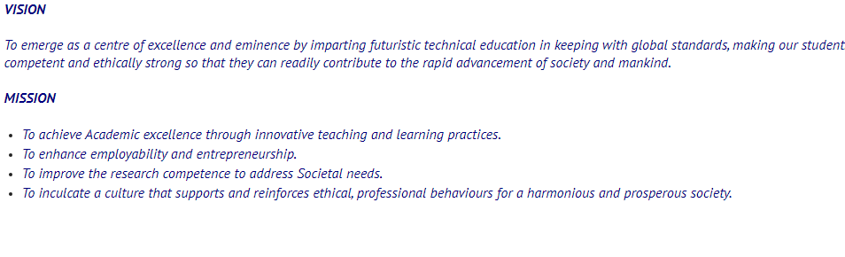
Objectives of ISP- GCT:
The objectives of the Innovation and Startup policy of GCT are
- To impart the skill of innovative thinking through training programs and academic activities like workshops, symposium, etc to students, faculty and other stake holders involved.
- Assess and identify innovative and startup ideas periodically to provide necessary support.
- Collaborate with the inventor, parent institution and the funding agency to market the idea / product.

Impact assessment of objectives (Rough guideline)
Objective | Assessment criteria | Impact measurement
Obj 1 | No of training programs conducted | No of raw ideas originated
Obj 2 | No of assessment meetings / hackathon, bootcamps, pitchfest conducted | - No of raw ideas converted into startup.  - Achievement in state level / national competition
Obj 3 | Collaboration with funding agency | - Agreements / MOU with funding agency.  - Fund received.  - No of startup with other academic institution / industry.

